48 PNL Volume 21 1989 RESEARCH REPORTS
GENOTYPE Le lv: AN EXTREMELY LONG INTERNODE LENGTH TYPE
Reid, J. B. Department of Plant Science, University of Tasmania
Hobart, Tasmania 7001, Australia
Gene lv is a recently described internode length mutation which results in an enhanced response to gibberellin A₁ (GA₁) (4), the endogenous GA thought to control stem elongation in peas (see 3). Gene lv has Little or no effect when plants are grown in darkness or far-red light but results in substantially longer internodes when plants possessing lv are grown in red or white light (2). It may therefore be classified as a photomorphogenic mutant and probably acts by partially blocking some step between phytochrome and elongation (2). This results in lv plants appearing as if they do not de-etiolate fully.
Gene lv was isolated as a mutant (called NEU3) by Drs. T. LaRue and B. Kneen of the Boyce Thompson Institute (Ithaca, N.Y.) from the dwarf (le) cv. Sparkle. Consequently, the effect and action of gene lv has only been determined on an le background (2,4). The effect of this gene on a wild-type (Le) background is therefore of considerable interest since elongated genotypes oi peas are rare, with only the slender (la cry^{s}) and crypto-tall (la cry^{c}) types being well established (see 5). In order to isolate the genotype Le lv and characterise its phenotype the wild-type tall cv. Torsdag (Le Lv) was crossed to the mutant NEU3 (le lv). Plants were grown as described by Reid and Ross (4). Counting of nodes began from the cotyledons as zero.
The F₁ plants from cross Torsdag (Le Lv) x NEU3 (le lv) possessed a wild-type tall phenotype and in the F₂ a relatively clear segregation into 11 dwarf, 35 wild-type tall, and 17 extremely tall plants was obtained (Fig. 1). This segregation is in accord with the ratio 3 (genotype le-Lv): 10 (genotypes Le Lv and le lv) : 3 (putative genotype Le- lv) distribution (X² for 3:10:3 = 3.78, P > 0.1). This segregation suggests that the double recessive and double dominant genotypes have a similar phenotype with the single recessive classes being at the two extremes. The results in Fig. 2 illustrate that this is probably the case since examples of the parental lines NEU3 (le lv) and Torsdag (Le Lv) possess superficially similar length phenotypes while cv. Sparkle (le Lv), the source of the mutant line of NEU3, is a dwarf. An example of the new extremely tall class (putative genotype Le - lv) is shown for comparison. Subsequent results from F₃, F₄, F₅ and F₆ progenies were consistent with those conclusions although segregations were not always clear owing to segregation for the flowering genes Sn (from cv. Torsdag) and sn (from NEU3), For example, in F₆ two pure breeding Sn Le families gave a clear segregation into 16 tall (Lv) and 7 extremely tall (lv) plants (Fig. 3). The lv gene caused a 61 percent increase in stem length between nodes 1 and 10 under these conditions. However, when three F₆ families (all F₆ progenies were derived from the same F₄ plant) pure for Le but segregating at both the lv and sn loci were examined the sn Lv and Sn lv plants merged together (Fig. 3). The sn Lv segregates were 31 percent longer than the Sn lv segregates and 47 percent longer than the sn Lv. segregates. Clearly, under these circumstances gene sn can exert a substantial effect on internode length in its own right (see also 1). Al-
PNL Volume 21 1989 RESEARCH REPORTS 49
though this effect appears largest in the two internodes directly below the flowering node of sn plants (node 10 or 11 in these families) it is still present even early in development (e.g. internode 4 to 5) making separation of Lv and lv plants difficult if genes Sn and sn are segregating.
The presence of gene lv in the extremely tall plants was confirmed by crossing two of the pure breeding putative Sn Le lv plants to both NEU3 (lv) and cv. Sparkle (Lv). The F₁ seeds were grown in a growth cabinet held at 17.5 C and the plants were exposed to continuous light from Thorn cool white fluorescent tubes(200 mkmol m⁻² s^{-l} PAR). In earlier experiments these conditions were shown to maximize the expression of the Lv/lv gene difference. The F₁ plants of crosses to NEU3 were consistently of the extremely tall phenotype, while the F₁ plants of crosses to cv. Sparkle were consistently of the tall or wild-type phenotype (Fig. 4). The genes Cry/cry^{c} were also segregating in the cross Torsdag (Cry, 1) x NEU3 (cry^{c}, 4). The above data preclude the variation observed (i.e. tall versus extremely tall) being due to a Cry/cry^{c} segregation on a La background since crosses to NEU3 and cv. Sparkle should then have produced similar results.
The Le lv plants isolated here arguably possess the internodes with the greatest potential for elongation yet described in peas. They are longer than comparable internodes from slender (Le la cry^{s}) plants except over the first few internodes. The Le lv plants also possess paler foliage (yellower) than comparable Le Lv plants suggesting that the pleiotropic effects of gene lv described on a le background (2,4) also apply on a Le background. The Le lv genotype should therefore be of use for studies on the control and possible extent of internode elongation.
- Murfet, I. C. 1988. Ann. Bot. 61:331-345.
- Nagatini, A., J. B. Reid, J. J. Ross, A. E. Dunnewijk, and M. Furuya. (Unpublished)
- Reid, J. B. 1986. In: Plant Gene Research. A Genetic Approach to Plant Biochemistry. A. D. Blonstein and P. J. King, eds. Springer-Verlag, Wien. pp. 1-34.
- Reid, J. B. and J. J. Ross. 1988. Physiol. Plant. 72:595-604.
- Reid, J. B., I. C. Murfet, and W. C. Potts. 1983. J. Exp. Bot. 34:349-364.

50
PNL Volume 21 1989 RESEARCH REPORTS

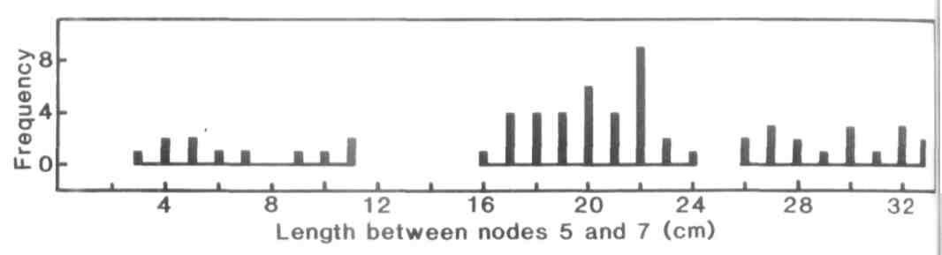
Fig. 1. Distribution of stem length between nodes 5 and 7 (to the nearest cm) for the F₂ plants from cross Torsdag (Le Lv)x NEU3 (le lv). The plants were grown under an 18 h photo-period.
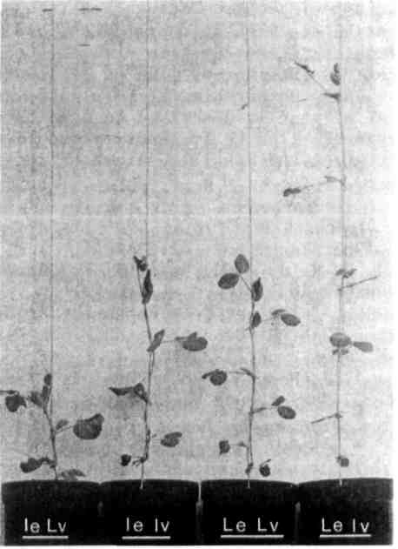
Fig. 2. The phenotype of cv. Sparkle (le Lv) , NEU3 (le lv), cv. Torsdag (Le Lv) and genotype Le lv.

Fig. 3. Distribution of stem length between nodes 1 and 10 (to the nearest cm) for F₆ plants from cross Torsdag x NEU3. A. Parents were pure breeding for genes Sn and Le but segregating for Lv/lv. B. Parents were pure breeding for Le but segregating for Sn_ (■■) and sn_ ( ) and Lv_ and lv. The plants were grown under an 8 h photoperiod.
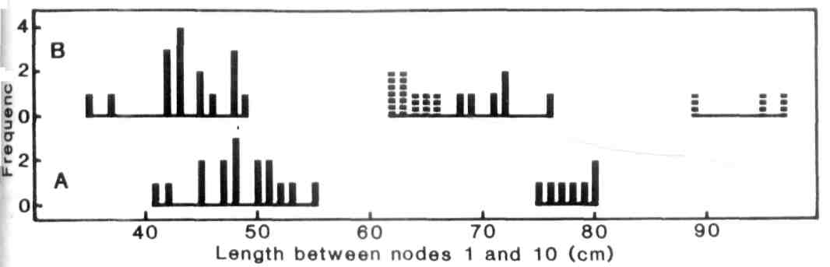
PNL Volume 21 1989 RESEARCH REPORTS 51
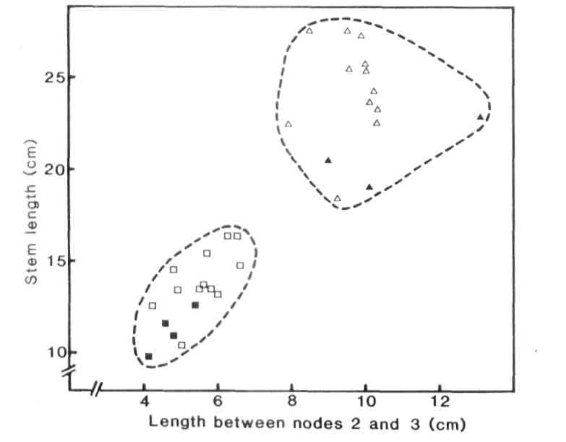
Fig. 4. Stem length between nodes 2 and 3 (cm) versus the total shoot length after 12 days growth for plants of cv. Sparkle ( ■ , le_ Lv) , NEU3 ( , le lv) and the F₁ of crosses Sparkle x Le lv (□) and NEU3 x Le_ lv_ (). The plants were grown under a 24 h photoperiod of fluorescent light.

