PNL Volume 21 1989 RESEARCH REPORTS
INTERACTION OF THE det (DETERMINATE) MUTANT WITH OTHER FLOWERING GENES
Murfet, I.C. Department of Plant Science, University of Tasmania
Hobart, Tasmania 7001, Australia
The recessive gene det (determinate) causes the shoot to terminate in a flower after the formation of a small number of reproductive nodes (1,2,4,5). Whether the det mutant is strictly determinate in the botanical sense requires clarification but the fact that the terminal flower is frequently offset from the vertical (Fig. 1 ) suggests it may have arisen from an axial flower primordium rather than by direct conversion of the apical meristem itself.
The present study examined the interaction between det and several of the other flowering genes in Pisum. The det mutant was received from Dr Peter Matthews of the John Innes Institute in the form of line JI 1358 which is tall (Le) with a late flowering habit indicative of genotype Lf Sn Dne (see 3). Most JI 1358 plants showed a very large response to photoperiod indicating the presence of gene Hr but some displayed only a limited quantitative response to photoperiod indicating genotype hr. Thus JI 1358 may be heterogeneous for the Hr-hr gene pair. Line JI 1358 was crossed with Hobart line 69, which is a very early flowering, day neutral dwarf with genotype lfª E sn Dne hr le, and 96 F₂ plants and several F₃ progenies from lfª or Lf sn det F₂ plants were raised in 9 h short day conditions (day 23°C, night 16°C).
The results of cross 69 x 1358 gave no indication that det altered the effect of gene pairs Lf-lfª, Sn-sn or Hr-hr on node of flower initiation. For example, in the F₂ node of flower initiation ranged from 6-48 for Det segregates and 7-52 for det segregates. However, the results of this small study are not such that they would expose with certainty small quantitative effects of det on node of flower initiation. Nevertheless, the results did provide a very clear answer on several points. For example, segregation for the Lf-lfª gene pair was clearly apparent in both sn det (Fig. 2) and Sn det plants on the basis of node of flower initiation. Likewise segregation of the Sn-sn gene pair was entirely clear on an lfª det background on the basis of time to first open flower (Fig. 2) and several other traits such as flower bud abortion, peduncle length and branching pattern. For example, lfª sn det segregates produced few if any lateral branches while lfª Sn det segregates produced a massive outgrowth of laterals (Fig. 1) and peduncle length was much longer in the Sn plants (Fig. 1 ).
Termination of mainshoot growth in det plants produced several marked effects. With an lfª Sn background det plants showed a more precocious and profuse outgrowth of lateral branches than Det plants (Fig. 1). In lfª Sn det plants these lateral branches arose from both basal nodes (e.g. nodes 1 and 2) as well as aerial nodes further up the stem. In Lf sn plants gene let likewise resulted in the outgrowth of lateral branches but in this case the outgrowth occurred only from aerial nodes, particularly those just below the first flower (Fig. 1). In contrast, Lf sn Det plants were wholly devoid of lateral branches (Fig. 1). Finally, with an lfª Sn background det brought forward the time of first open flower by, on average, 4 days compared with that of Det segregates. This effect was significant at the 0.01 level. The earlier development of the flower buds on the det plants appears to have resulted from the availability of nutrients which in Det segregates were diverted toward the growth of new vegetative organs. Indeed, the forced growth in lfª Sn det plants meant the terminal flower in

PNL Volume 21 1989 RESEARCH REPORTS
45

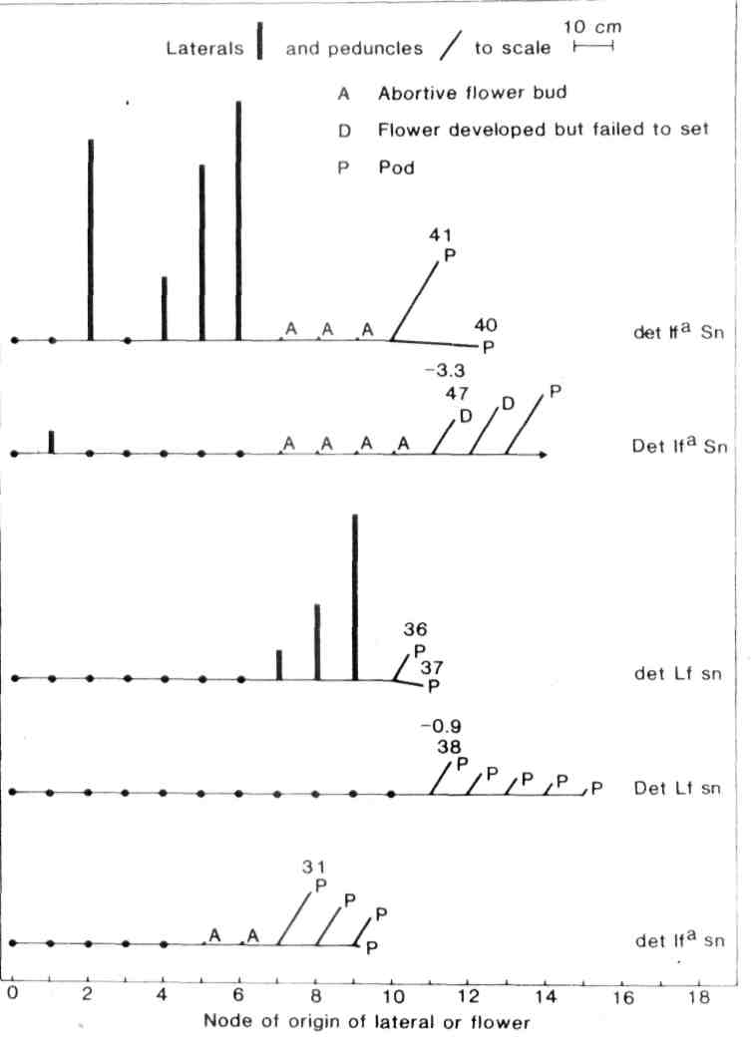
Fig. 1. The characteristics of five individual, 60-day-oLd, tall plants derived from cross 69 x 1358 are used to illustrate some of the differences between det and Det plants. Peduncles and lateral branches are drawn to scale but internodes are shown on a fixed module. Figures above a flower indicate the number of days from sowing to opening of this flower and the flower/leaf relativity (see 3), e.g.. for the Det Ifª Sn plant the flower at node 11 opened on day 47 and there were just over 3 expanded leaves above the flower at that time. The main shoot of the Det Ifª Sn plant was still elongating actively at 60 days but the main shoot of the remaining plants had ceased growth at this time. Photoperiod 9 h. The cotyledonary node is counted as node 0.

46
PNL Volume 21 1989 RESEARCH REPORTS

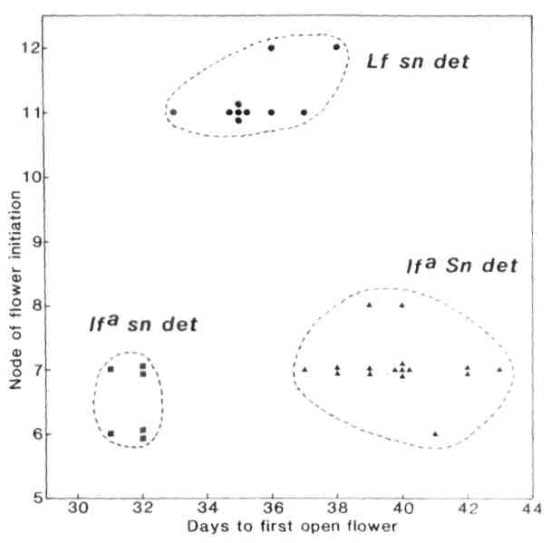
Fig. 2. Node of flower initiation and days to first open flower for 32 tall det plants from several F₃ families of cross 69 x 1358. Note these are combined data and illustrate distributions not ratios.
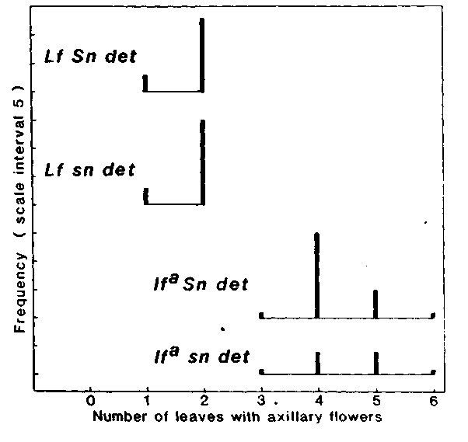
Fig. 3. Combined F₂ and F₃ data for det plants from cross 69 x 1358
showing the frequency distribution for the trait number of leaves (on
the main shoot) with axillary flowers. The node of flower initiation
for genotypes Lf Sn, Lf sn, lfª Sn and lfª sn ranged from 13-52, 10-13, 6-8 and 5-7, respectively.

PNL Volume 21 1989 RESEARCH REPORTS 47
some cases opened one day ahead of the penultimate flower and peduncle length reached a massive 26 cm in some tall lfª Sn det segregates (Fig. 1). The several effects of the det gene detailed in the last paragraph all appear to be correlative phenomena resulting from the loss of hormonal influence of the apical meristem and bud, and the diversion of nutrients and assimilates no longer required for continued growth of the main shoot. One might expect that excision of the apical bud from normal (Det) plants would produce the same result. In contrast, the gene lfª had a totally unexpected effect on the expression of det. Lf det segregates, whether they flowered at node 10 or node 52, produced either one or at most two leaves subtending a flower (Fig. 3). In contrast, lfª det segregates produced between 3 and 6 leaves with axillary flowers before terminating (Fig. 3). Put another way, det plants always produced at least 9 normal leaves on the main shoot (2 scale leaves + 7 foliage leaves) while some lfª plants initiated flowers as early as node 5. Thus while expression of det is triggered by the onset of flower initiation, the interval between the onset of flower initiation and the termination of meristem activity is markedly influenced by the genotype at the Lf locus and is clearly longer in an apex with genotype Ifª than one with genotype Lf. Cross 69 x 1358 appears to be homozygous for gene E and it remains to be seen whether this relationship also holds with background e since lfª e Sn Dne plants are capable of commencing flower initiation above node 9 (3). The expression of det in apices with alleles lf or Lf^{d} also remains to be examined.
Expression of det in lateral shoots tended to follow a similar pattern to that displayed by the main shoot, i.e., the number of leaves with axillary flowers was about the same as in the main shoot and very much dependent on the genotype at the Lf locus. In contrast, the genotype at the Sn locus had little or no effect on the expression of det and Lf sn plants, which commenced flowering at nodes 10-13, displayed a near identical pattern to Lf Sn plants in which the node of flower initiation ranged from 13-52 (Fig. 3). There is perhaps a slight effect in lfª plants resulting from the 9 leaf limit for the expression of det and the slightly lower flowering node of lfª sn compared with lfª Sn plants (Fig. 3).
Some lfª sn det plants produced pods at 5 or even 6 nodes on the main shoot. This reproductive load is similar to that sustained by comparable Det segregates. In such cases the lateral branching characteristic of det plants failed to occur. In contrast, with Lf sn det segregates the small reproductive load on the main shoot was considerably less than that sustained by comparable Lf sn Det segregates and vigorous outgrowth of aerial laterals occurred in the det plants while no laterals arose from their Det counterparts.
The det gene provides an opportunity to restructure the reproductive architecture of the pea plant but correlative changes to other characters such as branching pattern and peduncle length will need to be taken into consideration.
- Makasheva, R. Kh. and A.M. Drozd. 1987. PNL 19:31.
- Marx, G.A. 1986. PNL 18:45-48.
- Murfet, I.C. 1985. In Handbook of Flowering Vol. IV. Ed. A.H. Ha levy, CRC Press, pp. 97-126.
- Popova, I.A. 1975. Trudy po selektsii i semenovodstvu ovoshchnykh kultur VNIISSOC 3:66-72.
- Swiecicki, W.K. 1987. PNL 19:72-73.
*****

