PNL Volume 21 1989 RESEARCH REPORTS 41
LONGEVITY OF PEA SEED IN STORAGE AT HOBART
Murfet, 1. C. and R. Cramp Department of Plant Science
University of Tasmania, Hobart, Tasmania 7001, Australia
Seed longevity is influenced by temperature and humidity during storage (2,4). However, no special seed storage conditions are used at Hobart and we have recently examined seed longevity in our system by testing germination in seed samples of four lines which were among the first incorporated into the Hobart Pisum collection some thirty years ago.
Lines 2 (Lamm line 2, Rasmusson^{T}s grey dwarf), 11 (Barton Pll), and 31 (Lamm line 31) have round seeds (R) with anthocyanin present (A). Line 24 (a single plant selection from 1957 stocks of cv. Greenfeast) has wrinkled seed (r) lacking anthocyanin (a). The seeds have been kept in paper envelopes in cardboard boxes stored in the senior author's office. Since 1965 that office has been in a brick and concrete building heated in winter. Room temperature is generally in the range 17-22 C. Prior to 1965 the office was in a wooden hut where temperature variation was more pronounced. Hobart has a mild, temperate climate (July mean temperature 8 C, humidity 77%; January mean temperature 17 C, humidity 51%).
Seed samples (n=50) ranging in age from 1-30 years were sown 2 cm deep in a sterilized peat/sand mixture and germinated at 17-23 C. Seed coats were knicked to facilitate imbibition and the seed dusted with Thiram. Seedlings were arbitrarily assigned to one of three categories (Fig. 1). Plants which were essentially normal, healthy, and vigorous were assigned to category 1 (good). Seedlings which were still fairly strong but with some signs of damage due to age, e.g. small pale areas on the Leaves and/or abnormalities in leaf morphology, were assigned to category 2 (some damage). Small weak seedlings with slow growth were assigned to category 3 (weak and slow). Cases where a plumule failed to emerge above the soil were assigned to category 4 (failed). We emphasise that categories 1-3 are not sharply delineated but classification in this manner allows a more sensitive insight into the progressive deterioration of the seed with age. Seedlings in category 2 appeared to recover with time and assume an essentially normal appearance above approximately leaf 7. In general, the older seeds germinated more slowly.
The oldest seeds to produce viable seedlings were the 21-year-old seeds of lines 24 and 31 (Fig. 1). Even so, line 24 generally showed a mere rapid deterioration with age than the other three lines all of which produced a high proportion of good seedlings from seed aged 13 to 15 years. Whether the more rapid deterioration of line 24 is related to the recessive condition for genes r and/or a cannot be determined from this one study. Genetic differences in survival can be determined more rapidly using artificial aging conditions, e.g. high temperature and humidity. However, from a practical point of view it is useful to have actual longevity data obtained in normal conditions. Varietal differences in seed longevity have been reported for peas (5) and germination after 31 years has been recorded
With the rise in genebanks and national collections over the past 20 years conditions for the preservation and storage of germplasm have generally been upgraded. Nevertheless, we have found that at least some
42 PNL Volume 21 1989 RESEARCH REPORTS
samples received from overseas genebanks have germinated very poorly compared with seeds of an equivalent age and type from our own collection. Pre-harvest conditions are important (1) and we suspect that in these cases marked deterioration has occurred during the maturation and pre-harvest period.
- Austin, R. B. 1972. In: Viability of Seeds. Ed. E. H. Roberts. Syracuse University Press. pp. 114-149.
- Bass, L. N. 1979. In: The Plant Seed. Eds. I. Rubenstein,
R. L. Phillips, C. E. Green, and B. G. Gengenbach. Academic Press, New York and London. pp. 145-170.
- Haferkamp, M. E., L. Smith, and R. A. Nilan. 1953. Agron. J. 45:434-437.
- Harrington, J. F. 1972. In: Seed Biology. Ed. T. T. Kozlowski. Academic Press, New York and London. pp. 145-245.
- James, E., L. N. Bass, and D. C. Clark. 1967. Proc. Amer. Soc. Hort. Sci. 91:521-528.

Fig. 1.
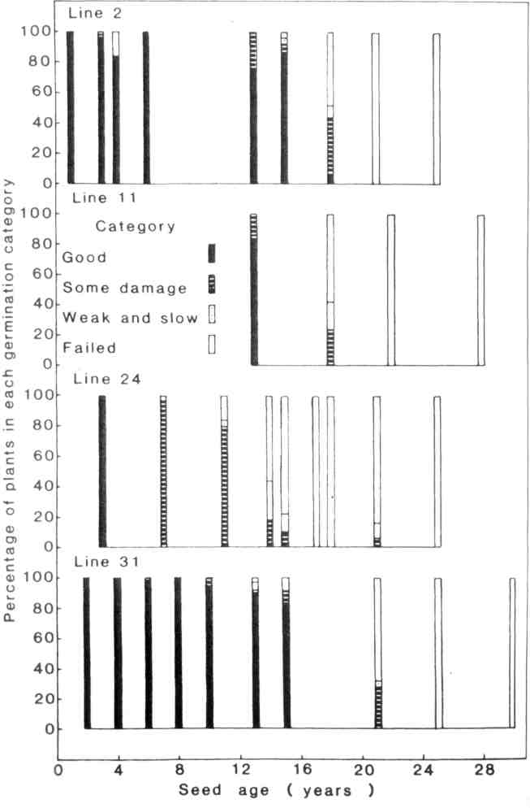
Germination data for seeds of various ages for Hobart Pisum lines 2, 11, 24, and 31.

*****

