PNL Volume 21 1989 RESEARCH REPORTS 37
FLOWERING IN PISUM: SEPARATION OF GENOTYPES Sn Hr, Sn hr, AND sn-ON A lf E Dne BACKGROUND
Murfet., I. C. and S. C. Cayzer Department of Plant Science
University of Tasmania, Hobart, Tasmania 7001, Australia
The genes Sn and Hr were identified individually for the first time by their effects on node of flower initiation (1,6). For example, in short days on an lf e Dne background they generate a dihybrid F₂ ratio 9 high node of flower initiation (Sn Hr) : 3 intermediate (Sn hr) : 4 low node of flower initiation (sn Hr and sn hr_) as illustrated by the F₂ of cross 64 (lf e sn Dne Hr) x 53 (lf e Sn Dne hr) (6, Fig. 1) . The observed numbers of 55 high, 18 intermediate, and 21 low plants (Fig. 1) in excellent agreement with a 9:3:4 ratio (X² =0.36). The correspon-ding phenotypes are 9 G : 3 K : 4 I using Marx' classification (3,4) and 9 LHR : 3 L : 4 ED using Murfet's scheme (5). F₃ data confirmed that the F₂ plant with coordinates 18/70 (Fig. 1) had genotype sn. Plants with genotype lf e sn Hr_ occasionally flower as high as nodes 18 to 20 (6). The gene for seed marbling, M, is closely linked to the Hr locus (6,10) and cross 64 (Hr M) x 53 (hr m) is in the coupling phase. The absence of seed marbling among intermediate segregates (Fig. 1) is consistent with their proposed genotype of Sn hr. Genotypes sn Hr_ and sn hr both belong to the low flowering node class and in that sense sn is epistatic to the Hr-hr gene pair. However, the distribution of seed marbling within the sn group suggests that Hr has quantitatively delayed flowering time in this class as reported elsewhere (6) . Segregation for M-m could not be followed in white flowered (a) segregates in this cross. With background lf E Dne all plants flower at a low node regardless of the genotype for the Sn-sn and Hr-hr gene pairs (9). Thus node to flower initiation can be used in these circumstances to distinguish the several genotypes. Nevertheless, a clear cut three class segregation equivalent to that shown in Fig. 1 can be obtained in plants with a low node by the use of an intermediate photoperiod (14 h) and the two variables number of reproductive nodes and distance (in nodes) the flower opens below the apical bud. [The latter variable is the FLR value with the sign reversed as defined by Murfet (8,9)]. This point is illus-trated in Fig. 2 by some data for early segregates (node of flower initiaation < 16) in the F₂ of cross 59 (lf E sn Dne hr m) x 63 (lf e Sn Dne Hr M) Three groups of plants were clearly distinguishable in these condi-tions. Segregates with genotype Sn Hr had the largest number of re-productive nodes and their flowers opened furthest from the apical bud while sn segregates (sn Hr and sn hr) had the smallest number of reproductive nodes and their flowers opened closest to the apical bud. The Sn hr plants occupied an intermediate but discrete position. The observed numbers of 27 (26.5) Sn Hr, 9 (8.8) Sn hr, and 15 (15.7) sn are very close to the numbers (in brackets) expected on the basis of a 27:9:16 ratio. [Cross 59 x 63 is also segregating for the E-e gene pair and only
52/64ths of the F₂ are expected to have a low node of flower initia-tion]F₃ data have confirmed that the sn segregate in Fig. 2 with coordinates 7/1.5 is correctly classified. As in cross 64 x 53, the ab-sence of seed marbling in intermediate segregates is consistent with their proposed genotypes of Sn hr. Likewise, in the sn group the distribution of seed marbling suggests that sn Hr segregates are somewhat further from
38 PNL Volume 21 1989 RESEARCH REPORTS
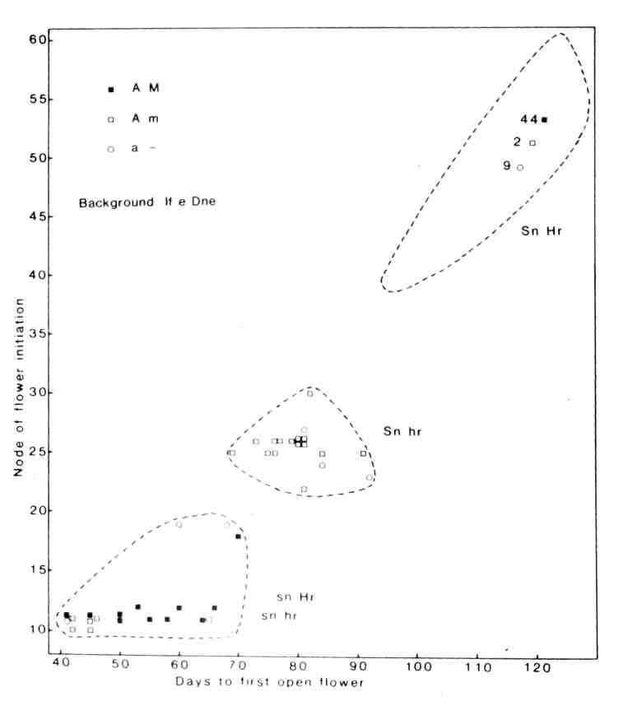
1. Node of flower initiation and days to first open flower for F₂
plants of cross 64 (A lf e sn Dne Hr M) x 53 (a lf e Sn Dne hr m) grown in an 8 h photoperiod; day temperature about 23 C, night 15-18 C. The genotypes for the flowering genes Sn-sn and Hr-hr, flower colour (red A, white a) and seed marbling (present M, absent m) are indicated in the figure.

PNL Volume 21 RESEARCH REPORTS
39

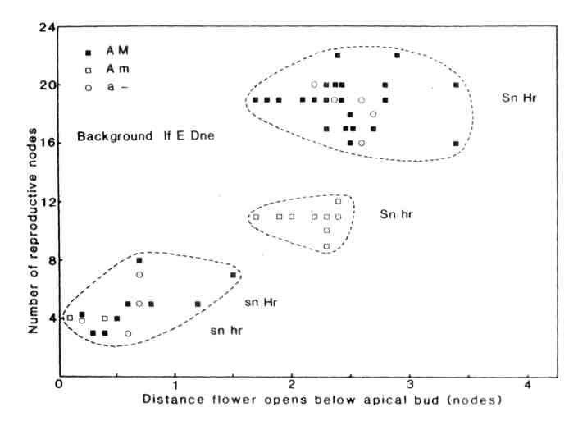
Number of reproductive nodes and distance (nodes) the flower opened below the apical bud for F₂ segregates from cross 59 (a. lf E sn Dne hr_ m) x 63 (A lf e Sn Dne Hr M) with a node of flower Initiation <16. The photoperiod was 14 h comprising 8 h daylight plus 6 h from a mixture of fluorescent tubes (40 W Thorn cool white) and incandescent globes (60 W Mazda) providing 55 mkmol m⁻² s⁻¹ at pot top. The temperature was about 23 C during the 8 h of daylight and 16 C during the remainder of the 24 h cycle. The genotypes are shown as in Fig. 1.

40
PNL Volume 21 RESEARCH REPORTS

the origin than the sn hr segregates, i.e. Hr appears to have a quantitative effect on the two variables.
The positions of the three classes in Figs. 1 and 2 are consistent with the proposed action of the genes Sn and Hr. The Sn gene is postulated to control a step in the synthesis of a graft-transmissible substance which delays flower initiation and which directs assimilate flow away from reproductive growth and toward vegetative growth while Hr prolongs activity of the Sn Dne system (see 9). Thus, for example, in Fig. 2 the number of reproductive nodes increases in the sequence sn, Sn hr, Sn Hr since the time when new leaves are no longer produced is increasingly delayed in this sequence (12,13). Again, the fact that the first flowers of the Sn Hr plants (Fig. 2) open a long way below the apical bud indicates that vegetative growth is being favoured at the expense of reproductive growth in this genotype (2).
Using short days and number of reproductive nodes, Marx (3,A) distinguished two distinct types among plants with a low node of flower initiation; G2 plants produced a much larger number of reproductive nodes than plants belonging to the I (insensitive) class. Using short days, Murfet (5) also identified two distinct early types; in ED (early developing) types the first flower initials developed promptly into open flowers while in EI (early initiating) types the time to open flower was delayed markedly because the first flower initials either aborted or at most developed slowly so that they opened some 2 to 3 nodes below the apical bud. Subsequent tests (7,11) showed that both authors were working with the same genes Sn and Hr. The first scheme partitioned the dihybrid segregation into a 9 G2 (Sn Hr) : 7 I (Sn hr + sn Hr + sn hr) ratio while the second partitioned into a 12 EI (Sn Hr + Sn hr) : 4 ED (sn Hr + sn hr) ratio. The present method (Fig. 2) uses aspects of both schemes and an intermediate photoperiod to identify genotype Sn hr uniquely thus partitioning the dihybrid segregation one step further into a 9:3:4 ratio. While short day conditions maximize activity of the Sn Dne system an intermediate photoperiod appears to optimize simultaneous separation of the three genotypes Sn Hr, Sn hr and sn- on a lf E Dne background.
- Barber, H. N. 1959. Heredity 13:33-60.
- Kelly, M. 0. and P. J. Davies. 1988. Plant Physiol. 86:978-982.
- Marx, G. A. 1968. BioScience 18:505-506.
- Marx, G. A. 1969. Crop Sci. 9:273-276.
- Murfet, I. C. 1971. Heredity 26:243-257.
- Murfet, I. C. 1973. Heredity 31:157-164.
- Murfet, I. C. 1978. PNL 10:48-52.
- Murfet, I. C. 1982. Crop Sci. 22:923-926.
- Murfet, I. C. 1985. Handbook of Flowering, Vol. IV, A. H. Haley, Ed. CRC Press, Baca Raton, pp. 97-126.

- Murfet, I. C. 1988. PNL 20:29.
- Murfet, I. C. and G. A. Marx. 1976. PNL 8:46-47.
- Proebsting, W. M., P. J. Davies, and G. A. Marx. 1977. Planta 135:93-94.
- Reid, J. B. 1980. Ann. Bot. 45:195-201.

