20 PNL Volume 21 1989 RESEARCH REPORTS
HEAT TOLERANCE IN P1SUM
Gottschalk, W. Institute of Genetics, University of Bonn
D-5300 Bonn 1 , West Germany
Fifty four Pisum genotypes were studied under short day phytotron conditions with high temperatures during daytime in order to learn whether there are any differences in the material with regard to the tolerance against these unfavorable conditions. Twelve X-ray induced mutants, 39 recombinants and 2 strains from North Thailand were used for the trials together with the German variety "Dippes Gelbe Viktoria" (DGV), the mother variety of our mutants. The phytotron conditions were as follows:
0800 h to 2000 h full light (30,000 lux)
2000 h to 0800 h darkness
2000 h to 0800 h 15°C
0800 h to 1200 h 1 5°C > 35°C
1200 h to 1800 h 35°C
1800 h to 2000 h 35°C > 15°C
Humidity : 60% The following criteria were evaluated: number of days from sowing to dying, flowering behavior, seed production, number of internodes and plant height. The duration of life of the genotypes
With regard to the duration of life of the material studied, great differences were found among the genotypes. Eight genotypes are considered in Fig. 1. Recombinant RM 831, selected from a cross between the narrow leaved mutant 1 76A and the early flowering recombinant R 46C, was found to be particularly susceptible to the high temperature. RM 831 has the following genotypic constitution:
gene dim for narrow leaflets and stipules (from 176A),
gene lfª for earliness (from 46A via R 46C), gene bif-1 for dichotomous stem bifurcation (from 1201A via R 46C). Most RM 831 plants died very early without producing flowers (mean time from sowing to death 35.7 d). Mutant 1 76A, one of the parents of RM 831, showed a similar behavior.
In contrast, recombinant R 161 and the fasciated mutant 251A showed the opposite behavior: they were found to be very tolerant to the high temperature. A characteristic feature of all the genotypes studied is the extraordinarily broad variation of the single values of each genotype although all the plants are homozygous. This variation is obviously due to non-heritable physiological differences between the plants of the same genotype. This holds true not only with regard to the duration of life but also for the other characters evaluated. The first plant of mutant 251A died 71 d after sowing. At that time all the plants of RM 831 , 176A and some other genotypes tested were already dead. The trial was terminated 140 d after sowing. At that time, 5 plants of mutant 251A were still alive. This behavior was confirmed in a second trial with the same phytotron conditions. The plants of the short-stemmed fasciated recombinant R 161 showed a similar behavior to mutant 251A. The values of all the other genotypes tested, including those of the control material, lay between these two extremes.

PNL Volume 21 1989 RESEARCH REPORTS
21

Mutant 46A, the donor of gene Ifª for earliness (ef r in my former publications) and recombinant R 46C, homozygous for Ifª and bif-1, showed a particularly, interesting behavior. In two successive phytotron trials, the mutant was found to be considerably more heat tolerant than the recombinant. This was obvious not only from the values for the duration of Life (Fig. 1 ) but also from the flowering behavior. Out of 28 plants of mutant 46A, ten flowered and three produced some seeds. However, the 27 plants of recombinant R 46C did not flower although ontogenetically they had reached the flowering stage. The negative reaction of R 46C in comparison with 46A is obviously due to the presence of gene bif-1 for stem bifurcation which, however, is unable to express its action on stem structure under the unfavorable phytotron conditions. Comparison of mutant 176A, the donor of gene dim, with recombinant R 176X, homozygous for dim and a gene for stem fasciation, shows the opposite situation: the recombinant is considerably more heat tolerant than the mutant (Fig. 1). This positive effect seems to be due to the gene for stem fasciation (the heat tolerant genotypes 251A and R 161 are also fasciated but it is not clear whether the three genotypes have the same gene for fasciation). Plant height and seed production
Most of the 54 genotypes tested were unusually small under the unfavorable phytotron conditions. The relationship between plant height and temperature is shown in Fig. 2 for 4 genotypes grown under the following conditions:
Trial 1: 15°C night, 25°C day.
Trial 2: 10°C night, 30°C day.
Trial 3: 15°C night, 35°C day. In trial 1 , very clear differences in the stem length of the 4 genotypes were discernible. The higher the day temperature, the smaller the stem length. This was especially clear in trial 3 where the length differences between the 4 genotypes completely disappeared. Essentially the same situation was found with regard to the number and length of the internodes. Thus the reduction of the plant height with increasing temperature is a consequence of a reduction in both the number and length of internodes. These findings are in agreement with observations on some of our Pisum genotypes which were grown in India in the subtropical climate of Varanasi and Bombay.
Of the 54 genotypes grown at 35°C, only 40 flowered. However, in many cases only a few plants or a single plant reached the flowering stage, sometimes extremely late. Most of the genotypes tested were unable to produce any seeds. Some genotypes, homozygous for alleles of gene dim, showed a relatively good flowering behavior but little or no seed set. In
some dim recombinants, however, most of the plants formed some seeds demonstrating thereby their high degree of heat tolerance.
These experiments will be continued with more genotypes of our collection. In this way, it may be possible to select genotypes which might be suited for cultivation in subtropical countries.

22
PNL Volume 21 1989 RESEARCH REPORTS

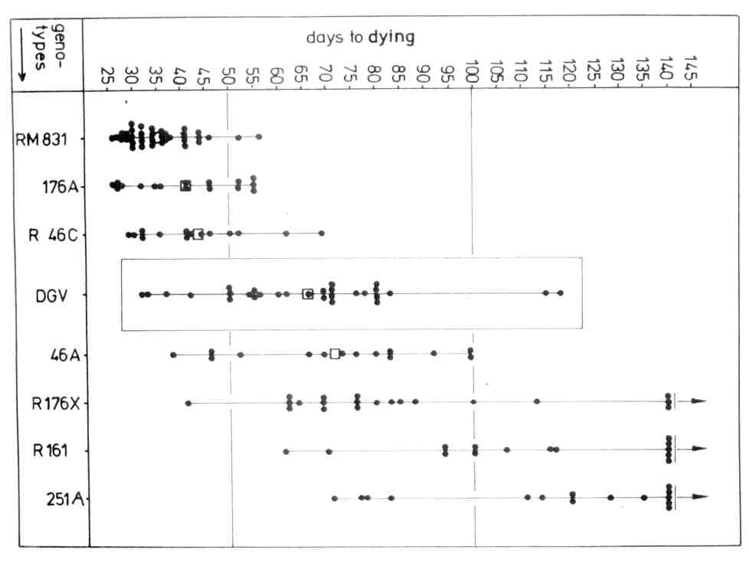
Fig. 1. The duration of life of 3 Pisum mutants, 4 recombinants and the mother variety "Dippes Gelbe Viktoria" (DGV) under short day phytotron conditions with high temperature. Each dot gives the value for one plant; the squares are the mean values.
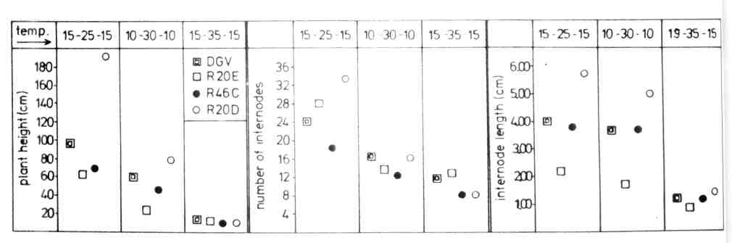
Fig. 2. Plant height, number and length of internodes of 4 Pisum genotypes grown in the phytotron under three different temperature conditions (photoperiod 12 h).

