16
PNL Volume 21 1989 RESEARCH REPORTS

STABLE TRANSFORMATION OF PEA TISSUES AFTER CO-CULTIVATION WITH TWO AGROBACTERIUM TUMEFACIENS STRAINS¹
Filippone, E. C.S. Miglioramento Genetico Ortaggi
CNR, Portici, Italy
and P.F. Lurquin Program in Genetics and Cell Biology
Washington State University, Pullman, USA
DNA transfer in plants is achieved mainly by direct gene transfer using protoplasts or cells, or by co-cultivation of plant tissues with Agrobacterium spp. harboring Ti-plasmid-derived vectors. In both cases plant regeneration is necessary to obtain transformed plants. As the genus Pisum is difficult to regenerate in vitro, there is at present a lag in engineering this genus. To overcome this problem, co-cultivation experiments were tried using tissues showing the highest morphogenic ability, such as meristematic tissues and epicotyl embryonic axes, on the basis of the tissue culture technique and medium already set up by the authors (2).
Seeds of pea cv. Puget were sown in vitro in sterile conditions on PO medium (MS salts, sucrose 10 g/l, agar 7 g/l, pH 5.8) and left to germinate at 24°C under 16 h light/8 h dark in a growth chamber. After three days, germinating embryos were detached from the cotyledons and cut in three parts: apical meristem, epicotyl segment and two cotyledonary node buds. These explants were placed in contact with an overnight culture of Agrobacterium tumefaciens for about two minutes and they were then transferred on P2 medium (MS salts, vitamins as Gamborg B5, sucrose 20 g/1, BAP 5 mg/l, IBA 1 mg/l, agar 7 g/l, pH 5.8). Two Agrobacterium strains were tested, both carrying the pGA472 plasmid (1), containing the chimeric NOS.NPTII.NOS gene which induces resistance to the neomycin antibiotic group in transformed tissues. The 6044 strain was an A281-derived strain that is hypervirulent on several solanaceous plants (3); the 6048 strain is LBA4404, a non-oncogenic derivative of the wild-type strain Ach5, harboring a Ti plasmid deleted of its T-region leaving the vir-region intact (4). The co-cultivation stage was two-days long; after that, explants were washed in P2 liquid medium containing claforan at 500 mg/1, to stop the bacterial growth, and kanamycin at 100 mg/l, to start the selection stage. Explants were subsequently dryed between two sterile paper sheets and left to grow on P2 agarized medium with added antibiotics as above. Explants were transferred monthly on fresh medium and, after 90 days of culture, transformation was scored on the basis of growing calli. The presence of the NPTII gene in transformed tissues and its product were checked, respectively, by dot blot and enzyme assay. The probe for the dot blot was obtained by labeling the NPTII gene isolated from pABDI (kindly supplied by J. Paszkowski) with dCT³²P. As a positive control, a line of Nicotiana tabacum transformed cells with the NPTII gene was used.
As shown in Fig. 1 and Fig. 2, both the dot blot and enzyme assays successfully demonstrated the stable integration of the NPTII gene after
Contribution no. 39 from C.S. Miglioramento Genetico Ortaggi, CNR

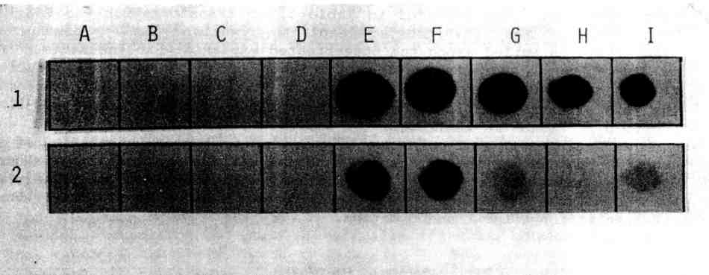
PNL Volume 21 1989 RESEARCH REPORTS 17
Fig. 1. Assay for nptll enzyme activity in pea transformed calli. The figure shows an autoradiograph of a dot blot assay of total callus protein. Legend: N. tabacum NT1 strain (negative control, A1-D1; positive control, E1-I1); pea controls (epicotyl segment, A2; cotyledonary node bud, B2; apical meristem, C2); pea transformed calli (epicotyl segments, E2-F2; cotyledonary node bud, G2; apical meristem, I2).
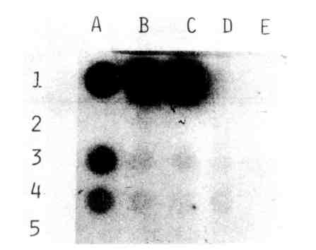
Fig. 2. Identification of the NPTII gene in pea transformed calli. The figure shows a dot blot of callus DNA. Legend: N. tabacum strain (negati ve control, A2—C2; positive control, A1-C1); pea control (epicotyl segments, A5-C5); pea transformed calli (epicotyl segment, A3; cotyledonary node bud, A4).

18
PNL Volume 21 1989 RESEARCH REPORTS

co-cultivation. As reported in Table 1 , no transformation was found in both control and 6048-treated explants, whilst the percentage of transformation varied among the 6044-treated explants with the maximum rate in the epicotyl segments. The efficiency of the 6044 strain could be related to its hypervirulence phenotype. The significant differences in the rate of transformation among the three kinds of explants are probably due to differences in their stage of differentiation.
No regenerants were so far obtained, due to the co-integration of one genes in pea genome, that disturb the normal differentiation of new shoots. Other experiments are now in progress using disarmed hypervirulent Agrobacterium tumefaciens strains in order to induce normal shoot differentiation after transformation.
________________________________
- An, G. 1986. Plant Physiol. 81:86-91.
- Filippone, E. 1985. PNL 17:21.
- Hood, E.E., G.L. Helmer, R.T. Fraley, and M.D. Chilton. 1986. J. Bacteriol. 168:1291-1301.
- Ooms, G., P.J.J. Hooykaas, R.J.M. Van Veen, P. Van Beelen,
A.J.G. Regensburg-Tuink, and R.A. Schilperoot. 1982. Plasmid 7: 15-29.
Table 1. Callus formation after co-cultivation of pea epicotyl segments, cotyledonary node buds and apical meristems with Agrobacterium tumefaciens strain 6044 and 6048. Data were scored after three months of culture on P2 medium containing kanamycin at 100 mg/l. The number and percentage of green calli is shown in brackets.

Explant | A_. | tumefaciens | No. of Transformed callus growth
 |  | strain | explants No. %
Epicotyl |  | Control | 13 0 0
segment |  | 6044 | 37 16* (9) 43 (24)
 |  | 6048 | 10 0 0
Cotyledonary |  | Control | 26 0 0
node bud |  | 6044 | 69 10* (7) 15 (10)
 |  | 6048 | 37 0 0
Apical |  | Control | 19 0 0
meristem |  | 6044 | 174 6* 3
 |  | 6048 | 158 0 0
Differences between explants significant at the 0.001 level.

