10
PNL Volume 21 1989 RESEARCH REPORTS

CHROMOSOME ENGINEERING THROUGH THE TRANSFER OF P. FULVUM SATELLITES INTO P. SATIVUM¹
Errico, A, Istituto di Agronomia Generale e Coltivazioni
Erbacee, Universita di Napoli, Portici, Italy
and C. Conicella C.S. Miglioramento Genetico Ortaggi
CNR, Portici, Italy
The P^. fulvum karyotype differs clearly from that of P. sativum for the arm ratios of some chromosome pairs, for an additional satellite on chromosome 5 and for a very large satellite on chromosome 7 (1).
In this research we have used a P. fulvum accession from John Innes Institute, JI 224, that also had two interchanges (2).
The aim of the present work is the reconstruction of P. sativum chromosomes 5 and 7 through selection for the presence of the two P. fulvum satellites. In crosses between the two species, seeds were obtained only when P. fulvum was used as the male parent. In the F₃ generation 11 plants were selected for the presence of the satellited chromosomes 5 and 1 of P. fulvum. After backcrossing of these plants with P. sativum, 12 plants in the BC1 and 12 plants in the BC2 generation were obtained with either or both the satellites of the chromosomes 5 and 7 of P. fulvum (Table 1). Fig. 1 shows the karyotype of a BC2 plant in comparison with the two parents: one chromosome of pair 7 has the P. fulvum satellite and the P. sativum short arm.
Because genes coding for seed storage proteins have been mapped on chromosome 7, electrophoretic analyses are in progress on these chromosome engineered plants.
- Ben-Ze'ev, N. and D. Zohary. 1973. Israel J. Bot. 22:73-91.
- Conicella, C. and A. Errico. 1985. Proceedings of Eucarpia Meeting on Pea Breeding, Sorrento, 10-13 June.
Contribution no. 38 from C.S. Miglioramento Genetico. Ortaggi, CNR

PNL Volume 21 1989 RESEARCH REPORTS
11

Table 1. Selection of plants with satellites of chromosomes 5 and 7 coming from P. fulvum in a backcross program with P. sativum.

 |  |  | Number | of plants |  | with
 |  | Number | P. ful | vum sa | satellite of
 | Generation | of plants analyzed
Cross | Generation | of plants analyzed | chrom. 5 | chrom | . 7 | chrom's 5
 |  |  |  |  |  | and 7
P. sativum x P. fulvum | F₃ | 18 | 0 | 6 |  | 3
F3 x P. sativum | BC1 | 28 | 2 | 6 |  | 4
BC1 x P. sativum | BC2 | 20 | 2 | 4 |  | 6
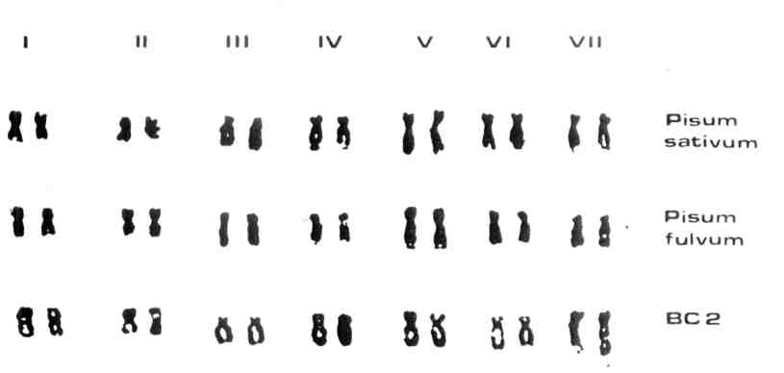
Fig. 1. Karyotype of Pisum sativum, P. fulvum and of a plant coming from the 2nd backcross generation.
*****

