52
PNL Volume 20
1988 RESEARCH REPORTS

LINKAGE BETWEEN Dia-1 AND LOCI ON CHROMOSOME 3
Wolko, B. and N. F. Weeden NYS Agricultural Experiment Station,
Geneva, NY 14456 USA
Enzymes catalyzing the reaction:
NADH + acceptor = NAD + reduced acceptor can be visualized after horizontal starch gel electrophoresis by using an assay consisting of 100 ml 0.1 M Tris HC1 pH 8.5, 40 mg NADH, 40 mg MTT and 1 mg 2,6 dichlorophenol indophenol. At least four NADH diaphorases (DIA) isozymes can be resolved in pea leaf extracts, and we have found variation in the most anodal isozyme DIA-1 and the most intensely staining isozyme DIA-3 (Fig. 1). The DIA-1 polymorphism is best resolved using the pH 6.5 histidine buffer system of Cardy et al. (1), whereas the DIA-3 variation is more clearly observed on a Tris borate-EDTA system (2). In a survey of a wide sample of Pisum germplasm, we identified at least 2 common variants for DIA-1 the more anodal of which we designated "a" and the other "b". We demonstrate here that the variation in DIA-1 phenotype shows monogenic inheritance, being encoded by a locus that exhibits linkage with markers near M on chromosome 3.
Marker lines fixed for DIA-la were crossed with lines fixed for DIA-lb, and the resulting hybrids selfed to form F2 progenies. Segregation for DIA-1 phenotype was observed in each of the four F2 progenies analyzed (Table 1). In three of the four progenies the DIA-1 variants behaved as codominant alleles at a single segregating locus, which we designated Dia-1. The fourth progeny derived from the cross A73-91 x PI 179449 gave all three of the expected phenotypes but the relative number of these was significantly different from the expected 1:2:1 ratio. Joint segregation analysis of the loci segregation in these progenies indicated linkage between Dia-1 and loci near M and chromosome 3 (Table II).
Previous results indicate that Aat-c is about 15 map units from M and Lap-2 (3). Comparative map distances and the lack of linkage between Dia-1 and Acp-3 or St (results not presented) suggest that Dia-1 is located about midway between Lap-2 and Aat-p on the distal side of M from the centromere. The availability of two common alleles at Dia-1 should make this locus very useful in further mapping studies.
This work was supported in part by a grant from the International Board of Plant Genetics Resources (Grant #86/102).
- Cardy, B. J., C. W. Stuber, and M. M. Goodman. 1980. Dept. of Statistics Mimeo Series No. 1317, North Carolina State Univ., Raleigh.
- Shaw, C. R. and R. Prasad. 1970. Biochem. Genet. 4:297-320.
- Weeden, N. F. and G. A. Marx. 1987. J. Hered. 78:153-159.

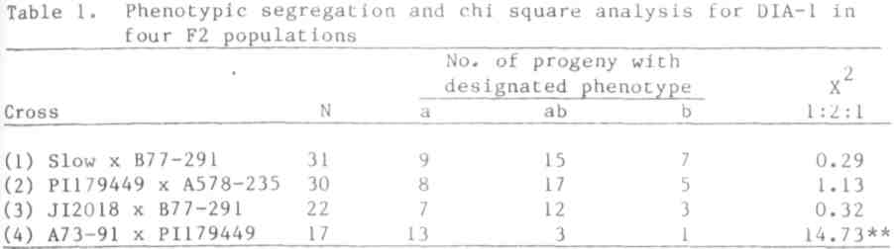
PNL Volume 20 1988 RESEARCH REPORTS 53
**Significant at P<0.01.
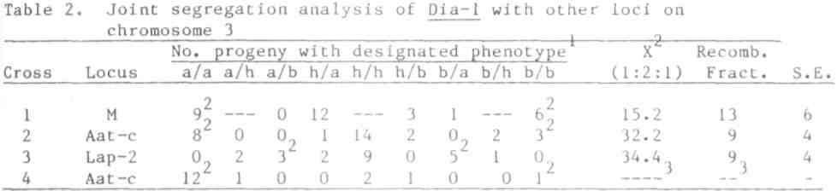
Phenotypic designations: a = allozyme a, b = allozyme b, h = both allozymes „ present. Parental phenotypes. Not calculated because of distorted segregation ratios (see Table I).
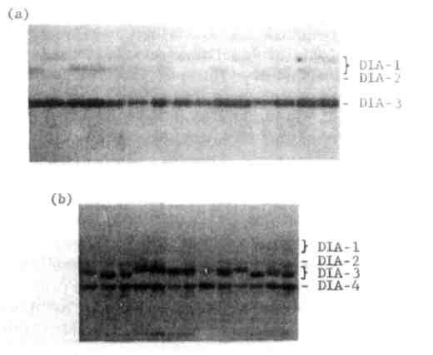
Fig. 1. (a) Diaphorase phenotypes on histidine gel, pH 6.5.
(b) Diaphorase phenotypes on tris-borate-EDTA gel, pH 8.0. Anode is at top of each photograph.
*****

