PNL Volume 20
1988 RESEARCH REPORTS
5

CYTOLOGICAL EVIDENCE FOR BIPARENTAL TRANSMISSION OF PLASTID DNA IN PISUM SATIVUM.
Corriveau, J. L, A. W. Coleman, Division of Biology & Medicine
Brown University, Providence, RI USA
and N. 0. Polans Department of Biological Sciences
Northern Illinois University, DeKalb, IL USA
Genetic evidence is available describing the mode of plastid inheritance for some 60 angiosperm genera (8,9). In the majority of these genera (including Pisum) plastids are inherited maternally. As early as 1930, DeHaan (4) reported that a chlorophyll deficiency was inherited maternally in Pisum sativum. Since then, to our knowledge, DeHaan's observations have been neither corroborated nor challenged.
DNA-fluorochromes are being used increasingly in pollen biology (2,6). Recently, our lab reported a DNA-fluorochrome/epifluorescence microscopy protocol which permits rapid screening for plant species potentially capable of biparental transmission of plastid DNA (1). When pollen was examined from plant species known genetically to display biparental plastid transmission, e.g. Oenothera biennis and Pelargonium zonale (9), plastid DNA aggregates (plastid nucleoids) were detected in the cytoplasm of the generative and/or sperm cells. However, in species known genetically to display strictly maternal transmission, e.g. Mirabilis jalapa and Nicotiana tabacum (9), no plastid nucleoids were observed.
The purpose of the present study is to determine if the cytological evidence for the mode of plastid DNA transmission in Pisum sativum corroborates the earlier genetic report.
Mature pollen grains obtained from greenhouse-grown pea plants were subjected to cytologica] analysis as described by Coleman and Goff (2). Living pollen grains were t irst Incubated at 20-23C for 3 h in depression wells containing 0.5 ml germination medium (20% sucrose plus 0.01% H₃BO₃ and 0.02% CaCl₂ in distilled water). Germinated pollen was then fixed in 95% ethanol:glacial acetic acid (3:1) overnight at 4C, before being transferred to 70% ethanol for storage at 4C. Samples were prepared by allowing a drop of fixed pollen to dry on a slide followed by staining with 0.05 mkg/ml 4',6-diamidino-2-phenylindole (DAPI) in McIlvaine's buffer (pH 4). Observations of DAPI-DNA fluorescence were made using a Zeiss AXI0PH0T epifluorescence microscope equipped with a 50 W mercury lamp and the Zeiss 48-77-02 combination of excitation and emission filters. DNase-treated controls served to monitor the specificity of staining for DNA. Pea plants were scored as potentially capable of biparental transmission of plastid DNA if plastid nucleoids were observed in the cytoplasm of the generative cells of germinated pollen. They were scored as presumably maternal if no plastid nucleoids were observed. At least 100 pollen grains were examined for each pea line.
Cytological evidence obtained from eight pea accessions and cultivar Alaska (Table 1) suggests that plastid DNA can be transmitted biparentally in P. sativum. Plastid nucleoids were observed in the generative cells of germinated pollen grains from each of the pea lines examined. Variability was observed, however, among these lines with regard to both the percentage of pollen grains potentially capable of transmitting plastid DNA (Table 1), and the number of plastid nucleoids found per generative cell

6 PNL Volume 20 1988 RESEARCH REPORTS
(Figs. 1 and 2). The percentage of pollen grains containing plastid nucleoids in generative cells varied from as little as 17%, scored for pea accession A1078-234, to over 50% in accession B78-259 and cultivar Alaska (Table 1). The variability observed in plastid nucleoid number per generative cell is exemplified by cytological observations made on pollen from accession A1078-234 and cultivar Alaska. Among the 17 generative cells which contained plastid nucleoids in A1078-234, the number of plastid nucleoids per generative cell ranged from one to five with an average of only two per generative cell (Fig. 1). in contrast, cultivar Alaska, which had plastid nucleoids in over 50% of the generative cells scored, displayed between one and ten plastid nucleoids per generative cell, with an average of 4.5 nucleoids per generative cell (Fig. 2).
Our lab has developed a DAPI/epifluorescence microscopy protocol which permits the rapid screening of plant species for the purpose of determining potential mode of plastid DNA transmission (1). There is a striking correlation found between the cytological results obtained using our protocol and results obtained through corresponding genetic studies. Thus far, plastid nucleoids have been detected in the generative and/or sperm cells of nine plant species known genetically to display biparental inheritance of plastids, while the absence of plastid nucleoids has been confirmed in 25 species known to exhibit maternal inheritance (3).
With these results in mind, we propose three possible explanations for the conflicting reports of maternal inheritance of plastids by DeHaan (4) and of biparentalism in this study. First, although there is ultra-structural evidence for the presence of proplastids in the male reproductive cells of pea pollen (5), there is also the possibility that plastid DNA is eventually eliminated. This loss could occur during sperm cell formation and/or maturation, during fertilization, or even in the zygote after fertilization (8). If paternal plastid DNA is eliminated at any of these later stages and, therefore, subsequent to our present observations, the final result would be strict maternal inheritance of plastid DNA. Second, there is reason to question the genetic evidence supporting maternal inheritance of plastids in pea. Additional data from self-fertilizations and intercrosses, characterized by both extended generations and larger sample sizes, is necessary to exclude the possibility that the chlorophyll deficiency trait reported by DeHaan was not a nuclear controlled plastid deficiency. In fact, chromosomal irregularities such as the behavior of chromosome fragments and unpaired alien chromosomes can mimic results obtained from authentic plastid DNA mutations (9). To eliminate the possibility of nuclear-controlled plastid deficiency, the cyto-logical identification of mixed cells in variegated plants, i.e. cells with both normal green and chlorophyll-deficient plastids, would have served as a useful control. Third, there is now genetic evidence that variability in plastid DNA inheritance exists within species of Oenothera and Pelargonium (10). Similar genetic variability for plastid inheritance might exist with Pisum as well. If this is the case, DeHaan may have worked with a pea line which happened to follow the maternal mode. Such a Finding would resolve the contradictions between the cytological and genetic evidence. We are currently testing the possibility of paternal plastid DNA inheritance in Pisum by analyzing plastid DNA restriction fragment patterns in F1 progeny of crosses between parents which differ recognizably in their plastid DNA.
Worthy of note is the observation that mitochondrial DNA was not de-

PNL Volume 20
1988 RESEARCH REPORTS
7

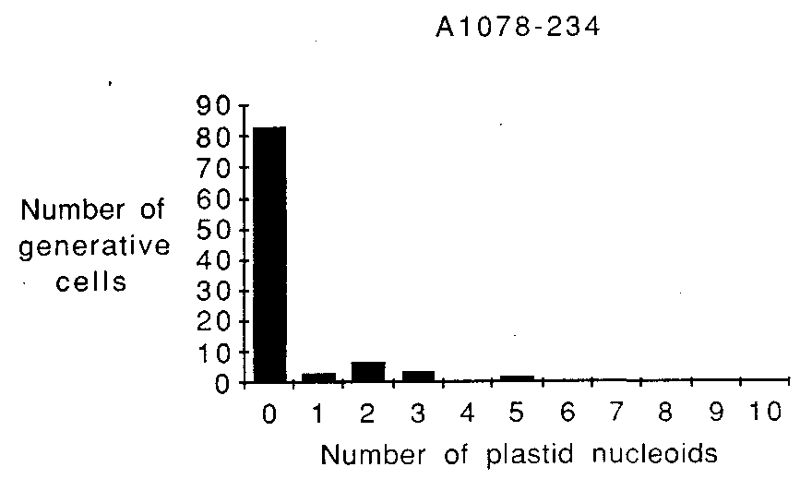
Fig. 1. Plastid nucleoid number per generative cell in germinated pollen from pea accession A1078-234, as revealed by DAPI/epifluorescence microscopy.
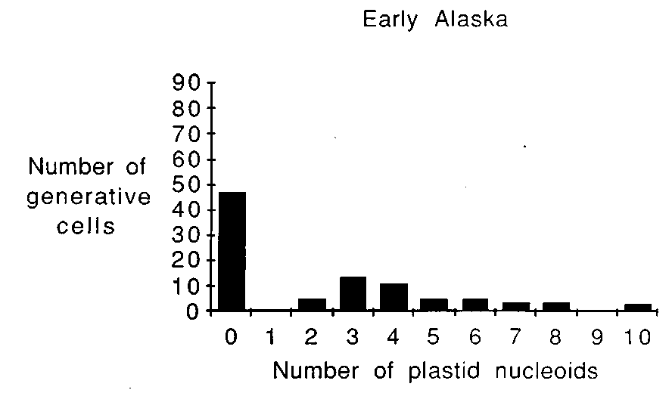
Fig. 2. Plastid nucleoid number per generative cell in germinated pollen from pea cultivar 'Alaska', as revealed by DAPI/epifluorescence microscopy.

8 PNL Volume 20 1988 RESEARCH REPORTS
tected in the generative cells of germinated pea pollen. This cytological observation is in agreement with a recent report which suggests that the cyanide-resistant pathway (which may be under the control of the mitochondrial genome) is inherited maternally in pea (7).
1. Coleman, A W., J. L. Corriveau, and L. J. Goff. 1986. J. Cell Biol. 103:521A.
- Coleman, A. W. and L. J. Goff. 1985. Stain Technol. 60:145-154.
- Corriveau, J. L. and A. W. Coleman. 1987. Submitted to Amer. J. Bot.
- DeHaan, H. 1930. Genetica 12:321-440.
- Hause, G. 1986. Biol Zentralbl. 105:283-288.
- Hough, T., P. Bernard, R. B. Knox, and.E. G. Williams. 1985. Stain Technol. 60:155-162.
- Musgrave, M. E., I. C. Murfet, and J. N. Siedow. 1986. Plant Cell Envir. 9:153-156.
- Sears, B. B. 1980. Plasmid 4:233-255.
- Tilney-Bassett, R. A. E. 1978. The Plastids. J. T. 0. Kirk and R. A. E. Tilney-Bassett, eds. Elsevier/north-Holland, Amsterdam,
pp.251-524; 10. Tilney-Bassett, R. A. E. and 0. A. L. Abdel-Wahab. 1979. Maternal Effects in Development. D. R. Newth and M, Balls, eds. Cambridge Univ. Press, Cambridge, pp. 29-45.
Seed of the pea accessions used in this study were supplied by G. A. Marx and seed of Alaska was obtained from Carolina Biological. Research supported in part by NSF DCB-85-03942 and USDA 87-CRCR-l-2534 to AWC.
Table 1. Cytological evidence for potential plastid DNA transmission by the paternal parent in pea.

Accession no. | Number of pollen grains scored | Percentage of pollen grains containing p lastid nucleoids in geneiative cells
A73-91 | 146 | 24
A578-235 | 129 | 26
A1078-234 | 100 | 17
A1078-239 | 190 | 47
B78-246 | 266 | 44
B78-259 | 145 | 51
B980-686 | 101 | 23
C879-344 | 124 | 46
Cultivar 'Alaska' | 100 | 53
*****

