42 PNL Volume 20 1988 RESEARCH REPORTS
LINKAGE BETWEEN Tpi-p AND Le
Weeden, N. F. and D. M. Hagens NYS Agricultural Experiment Station
Geneva, NY 14456 USA
Two triosephosphate isomerase (TPI) isozymes are present in pea leaf extracts (1). The isozymes can be clearly resolved by electrophoresis on horizontal starch gels using the buffer system of Selander et al. (2). The isozymes were visualized by the assay described previously (1). We identified an electrophoretic variant (designated "a") for the more anodal, plastid-specific isozyme in the line JI 1794 (kindly provided by P. Matthews, John Innes Institute). Hybrids between JI 1794 and several other lines (each fixed for the slower migrating variant "b") displayed a 3-banded "heterozygous" phenotype expected for this dimeric enzyme (Fig. 1). JI 1794 was used as the maternal parent in some of the crosses and as the paternal parent in others. The appearance of the heterozygous phenotype in all hybrids provided evidence that this plastid-specific isozyme was coded by a nuclear gene, Tpi-p. Further evidence for the nuclear location of the coding gene was generated by the Mendelian segregation ratios obtained for the TPI phenotypes in several F2 populations (Table 1).
Two of the F2 progenies were segregating for a considerable number of known marker loci. The JI 1794 x slow segregated at Aat-p , Idh , I, Gal-2 , Amy-1 , Aat-m, Skdh, Oh, S, Wb, Fum, M, Acp-3, Gty, Le, Acp-1, Pgd-c, Pl, Pgd-p, Pep-3, R, and Bt. The JI 1794 x A783-16I progeny segregated for many of the above markers plus Arg, Sil, Pal, and Lap-1. Significant deviation from random assortment was observed between Tpi-p and Le in both of the F2 progenies (Table 2). None of the other markers gave a recombination frequency with Tpi-p of less than 30%.
These results indicate that Tpi-p is located near Le on chromosome 4. The calculated map distance differed considerably between the two crosses, so that we are not able to give a precise estimate of this distance. Nor were we able to determine the position of Tpi-p relative to other markers on chromosome 4. Despite these uncertainties, we feel that these linkages are not caused by karyotype differences between the parents because all other markers displayed normal segregation ratios and the fertility in the F2 plants appeared normal . The position of Tpi-p is far from other isozyme loci, the nearest being an esterase locus described by Hunt and Barnes (3). Other loci coding plastid-specific proteins have been mapped to chromosomes 1, 2, 5, and 7, but none have been previously placed on chromosome 4. Once we have transferred the rare a allele to a dwarf background, it should prove to be an excellent marker because the phenotypes are easily distinguished and there are few other convenient marker loci on that region of the chromosome.
- Weeden, N.F. and L.D. Gottlieb. 1980. Plant Physiol. 66:400-403.
- Selander, R.K., M.H. Smith, S.Y. Yang, W.E. Johnson, and J.B. Gentry. 1971. Studies in Genetics VI. Univ. Texas Pub. 7 103:49-90.
- Hunt, J.S. and M.F. Barnes. 1982. Euphytica 31:341-348.

                - PNL Volume 20
1988
RESEARCH REPORTS 43

Table 1. Segregation of triosephosphate isomerase phenotypes

Cross | TPI phenotype* |  |  | 2 X  (1:2:1)
Cross | a | ab | b | 2 X  (1:2:1)
JI 2018 x JI 1794  JI 1794 x slow  JI 1794 x A783-161 | 9 19  11 | 19  32  26 | 9 12  16 | 0.02 1 .57 0.96
Designations: a = faster migrating variant, ab = 3-banded phenotype, b = slower migrating variant.
Table 2. Joint segregation of Le and Tpi-p.

Cross | N | No. plants with designated phenotype* |  |  |  |  |  | x² | Recomb Fract.
Cross | N | + /aa | +/ab | + /bb | -/aa | -/ab | -/bb | x² | Recomb Fract.
JI 1794 x slow JI 1794 x 161 | 63 53 | 19 11 | 32 23 | 0 5 | 0 0 | 0 3 | 12 11 | 63.0 21.7 | 1 +/- 1 15 +/- 5

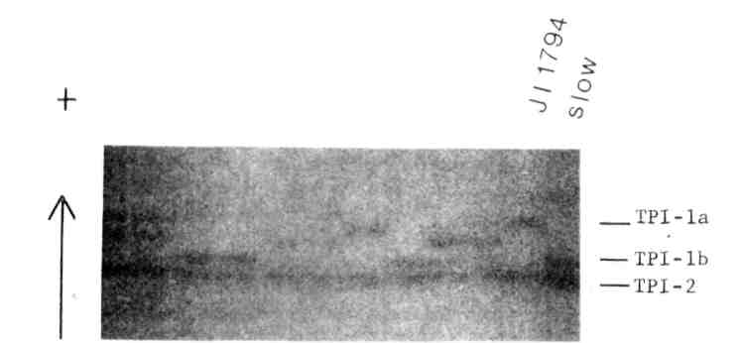
Fig. 1. Segregation of triosephosphate isomerase phenotypes in the JI 1794 x slow progeny. The parental phenotypes are shown on the left side of the gel. Anode is toward top of figure,
*****

