38 PNL Volume 20 1988 RESEARCH REPORTS
RUINOUS (rui): NEW COMPLEX, STERILE GENE

Swiecicki, W. K.
Plant Breeding Station, Wiatrowo, Poland

The pea genome contains a group of mutants characterized as "complex with extensive pleiotropic effects" (1). This group includes mutants that control leaf shape and/or size, or general plant habit, but the main characteristic is complete sterility due to drastically changed generative organs. Lamprecht (2) named them interspecific genes and considered them important from a phylogenetic point of view. In his opinion such genes cannot mutate to a different allele without the loss of reproductive ability . Angustifolius, filiformis, laciniate, obovatus, or unifo-liate—maintained as heterozygotes — are examples of this group of mutants. Using Nf, NEU, and a combined dose of these mutagens on seeds of two lines, Wt 3527 and Wt 4042, a few mutation cases of the same type were found in the M2 (segregating) generation (3). Plants were extremely reduced in length and the stems and leaf petioles look as if burned or pecked by birds (Fig. 1). Mendelian, recessive inheritance with a deficit of recessives was observed in M2, M3, and M4. On this basis I propose the name ruinous and the symbol rui for the mutation type and the gene, respectively. Heterozygous Lines with the gene rui appear in the gene bank under the following numbers:
Wt 15046, from 'Kaliski', 500r Nf,
Wt 15047, from Kaliski, 0.014% NEU,
Wt 15043, from 'Paloma', 0.014% NEU,
Wt 15044, from Paloma, 200r Nf/0.0l4% NEU. Mapping of the complex, sterile mutants presents difficulties. Sterility and the need to cross heterozygotes are only part of the problem. In mutants such as fil and rui, there is also a deficiency of mutant segregants and the phenotype interferes with marker expression. We intend to use isozyme markers to reduce the problem.

- Blixt, S. Agri Hort. Genet. 30.
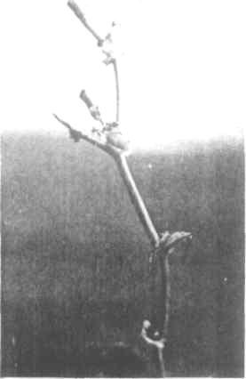
- Lamprecht, H. 1974. Monographic: der Gattung Pisum, Graz.
- Swiecicki, W. K. 1985. PNL 17:
72-74.

Fig. 1. Ruinous mutation type.
*****

