36 PNL Volume 20 1988 RESEARCH REPORTS
A THIRD COSTATA GENE (lum-3) ON CHROMOSOME 5
Swiecicki, W. K. Plant Breeding Station, Wiatrowo, Poland
In earlier studies on mutations induced by combined doses of Nf + NEU (3) several costata mutation cases were found. Locus identity tests showed that three of them, Wt 15307, Wt 14303, Wt 15311 and Monti's gene lum-1 were controlled by different loci. Despite the same general phenotypic effect (i.e. normal green veins with lighter interveinal leal tissue) these mutants had different influences on seed yield (Fig.1) (2). The mutant in the accession Wt 15307 was designated as lum-2 and was mapped to chromosome 3 (4).
I then set out to localize lum-3 i.e. the gene controlling costata character in Wt 15309 (induced by seed treatment of cv. 'Paloma' using 200rNf + 0.014% NEU). Crosses with testerlines WL 851, WL 1143, WL 1288, and WL 1514 did not reveal linkage with A, i (Chr 1); k, wb, s, oh (Chr 2); b, st, M (Chr 3); n, fa, v (Chr 4); wlo, Pl (Chr 6); and tl, r (Chr 7). The F2 population from the cross Wt 15309 (costata) x WL 1238 (testerline) showed monogenic inheritance of lum-3 and most of the marker genes in chromosome 5 (Table 1A). Although the segregation patterns were strongly disturbed, overall the data suggest lum-3 is located in chromosome 5 and I propose the following approximate relationship:
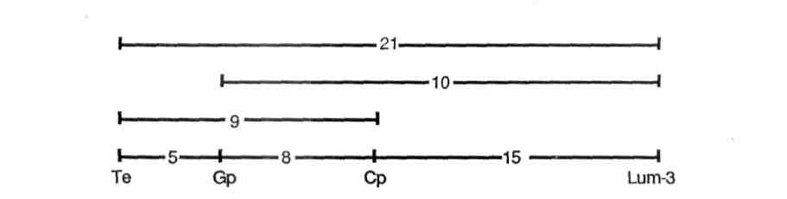
The type lines for lum-1, lum-2, and lum-3 are respectively WL 6011 (1), Wt 15307 (3), and Wt 15309.
- Monti, L. M. 1970. PNL 2:21-22.
- Swiecicki, W. K. 1983. Hod. Ros. Akl. Nas. 27 (4):221-276.
- Swiecicki, W. K. 1984. PNL 16:84-86.
- Swiecicki, W. K. 1987. PNL 19:70-71.
                - PNI. Volume 20 1988 RESEARCH REPORTS 37
Table 1. Phenotypic distribution in an F2 population from a cross between Wt 15309 (costata) and WL 1238 (testerline).

A. | Monohybrid F2' segregation |  |  | Chi-square (3:1)
 | Lum-3 362 | lum-3 122 | Total 484 | Chi-square (3:1)
 | Lum-3 362 | lum-3 122 | Total 484 | 0.01
 | Cp  370 | cp 49 | 419 | 39.56
 | Gp  374 | gp 104 | 478 | 2.68
 | Te 314 | te 105 | 419 | 0.00

B. Joint segregation of Lum-3 with Cp, Gp, and Te |  |  |  |  | Joint Chi-square | Recomb. fract. | S.E.
Cp Te 309 | Cp te  53'. | cp Te 3 | cp te 46 | Total | Joint Chi-square | Recomb. fract. | S.E.
 |  |  |  | 411 | 145.1 | 8.5 | 1.45
Cp Gp  327 | Cp gp  4 '. | cp Gp 3 | ^{C}P 8P 46 | 419 | 183.7 | 7.5 | 1 .35
Cp Lum-3 260 | Cp lurn-3 110 | cp Lum-3 49 | cp lum-3 1 | 419 | 20.1 | 15.1 | 4.75
Te Gp 308 | Te gp  6 | te Gp 16 | te gp 88 | 418 | 312.8 | 4.9 | 1.09
Te Lum-3 210 | le lum-3 104 | te Lum-3 100 | te lum-3 5 | 419 | 32.1 | 21.2 | 4.62
Gp Lum-3  255 | Gp lum-3 1 l'l | gp Lum-3 103 | gp lum-3 1 | 478 | 40.9 | 10.1 | 4.52
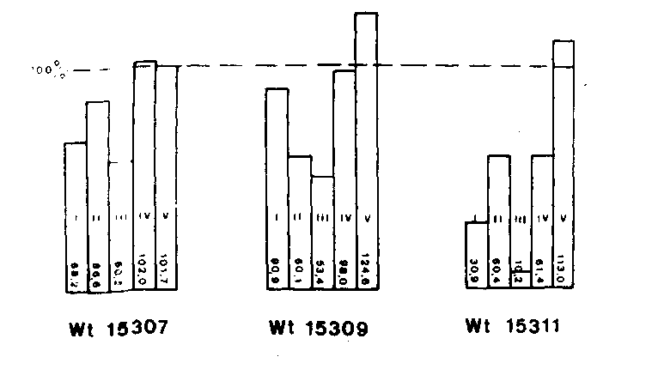
Fig. 1. Yield components and percent protein content for costata mutants in percent of initial line. I-Number of pods per plant; II-Number of seeds per pod; III-Seed yield/plant; IV-TGW; V-Percent protein.
*****

