34 PNL Volume 20 1988 RESEARCH REPORTS
SUPPLEMENTAL MAPPING DATA FOR CHROMOSOME 6
Skarzynska, Aldona Garden Plant Breeding Station, Zielonki, Poland
The gene for resistance to Pea Seedborne Mosaic Virus (PSbMV) in pea has been found in two accessions, PI 193586 and PI 193835 (2). Using these lines as sources of resistance, Hagedorn and Gritton developed hor-ticulturally improved lines designated Wisconsin 7105 and Wisconsin 7106, both resistant to SbMV.
Gritton and Hagedorn (1) then reported the linkage of the gene sbm with wlo in chromosome 6 with recombination fraction of ca. 12%. The linkage was confirmed by Hampton and Marx (3) with the suggestion of using wlo as the marker gene in selection for resistance.
We tested this suggestion in our own breeding work. Two sbm lines, Wis 7105 and Wis 7106, were crossed with wlo lines Wt 11340 and 10341 (from the Wiatrowo pea genebank), a repulsion phase cross. The dihybrid segregation in F2 gave little evidence of linkage:

Wlo Sbm | Wlo sbm | wlo Sbm | wlo sbm | Total
233 | 146 | 90 | 41 | 510
Although those data do not show linkage between sbm and wlo there was an excess of segregants scored as resistant, so there was a possibility that susceptible plants had been misclassified as resistant. Further studies on the localization of sbm therefore were pursued; these studies included other known Loci oi chromosome 6.
In the first step Wt 11778 = PI 193586 (sbm) was crossed with Wt 16140 (wlo art-1 ) . All F1 plants proved susceptible to PSbMV. Monohybrid segregation with no disturbances was observed in F2 (Table 1A). In a population of 906 plants, the dihybrid segregation for sbm-wlo showed deviations from independence and a CrO value = 23.0 (Table IB); for sbm-art-l the calculated CrO value was 41.2.
Wt 12070 == Wis 7106 (sbm) was also crossed with Wt 16141 (art-1 p). Again the F1 plants were susceptible and an undisturbed monohybrid segregation was observed (Table 2A). The dihybrid segregation (about 800 plants) showed a linkage between Sbm and Art-1 with a CrO value of 34.2 +/- 3.1% and between Sbm and P with CrO value of 24.5 +/- 13.3% (Table 2B).
Thus none of the above genes (wlo, art-1, or p) seems to be a closely Linked marker for sbm. On the basis of the gene order presented by Marx (4) and on our own results described above the following situation is proposed :
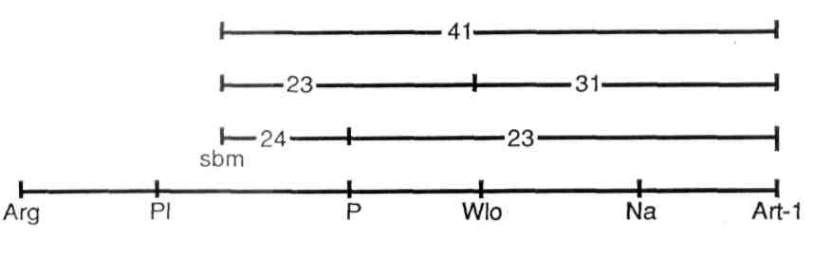

PNL Volume 20
1988 RESEARCH REPORTS
35

Table 1. Phenotypic distribution in an F₂ population segregating for genes on chromosome 6 from Wt 11778 (sbm) x Wt 16140 (wlo, art-1) .
A. Monohybrid F₂ segregation.

Wlo 672 | wlo  238 | Total 910 | Chi-square (3:1)
Wlo 672 | wlo  238 | Total 910 | 0.65
Sbm 690 | sbm 216 | 906 | 0.65
Art-1 701 | art-1 208 | 909 | 2.17

B. Joint segregation of sbm with wlo and art-1.
 |  |  |  |  | Joint  Chi-  square | Phase | R.F. | S.E.
Wlo Sbm 464 | Wlo sbm 204 | wlo Sbm 226 | wlo sbm 12 | Total
 |  |  |  | 906 | 63.42 | R | 23.0 | 3.1
Wlo Art-1 568 | Wlo art-1 102 | wlo Art-1 132 | wlo art-1 106 | 908 | 83.53 | C | 30.5 | 1.9
Sbm Art-1 516 | Sbm art-1  174 | sbm Art-1 183 | sbm art-1 33 | 906 | 8.86 | R | 41 .2 | 2.7
Table 2. Phenotypic distribution in an F₂ population segregating for genes of chromosome 6 from Wt 12070 (sbm) x Wt 16141 (art-1, p).

A. Monohybrid F? segregation.
Sbm 614 | sbm 186 | Total | Chi-square (3:1)
Sbm 614 | sbm 186 | 800 | 1.31
Art-1 620 | art-1 181 | 801 | 2.47
P 611 | P 187 | 798 | 1.04

B. Joint segregation of sbm with art-1 and p. |  |  |  |  | Joint  Chi-  square | Phase | R.F. | S.E.
Sbm Art-1 452 | Sbm art-1 162 | sbm Art-1 167 | sbm art-1 19 | Total
 |  |  |  | 800 | 21.19 | R | 34.2 | 3.1
Sbm P 435 | Sbm p 177 | sbm P 176 | sbm p 10 | 798 | 44.96 | R | 24.5 | 3.3
Art-1 P 536 | Art-1 p 82 | art-1 P 75 | art-1 p 105 | 798 | 159.02 | C | 23.1 | 1.7

36 PNL Volume 20 1988 RESEARCH REPORTS
It appears from these data that sbm is located in the Pl end of chromosome 6.
- Gritton, E. T. and D. J. Hagedorn. 1975. Crop Sci. 15:447-448.
- Hagedorn, D. J. and E. T. Gritton. 1971. PNL 3:16.
- Hampton, R. 0. and G. A. Marx. 1981. PNL 13:16.
- Marx, G. A. 1982. PNL 14:50-52.
I acknowledge the cooperation of Dr. W. K. Swiecicki and K. Leraczyk, M.Sc, for pea lines from the Wiatrowo genebank and for computer facilities to calculate estimates.
*****

