26 PNL Volume 20 1988 RESEARCH REPORTS

TRANSFORMATIONS OF MALE REPRODUCTIVE ORGANS INTO FEMALE ORGANS AND FEMALE STERILITY IN COCHLEATA MUTANTS OF PISUM SATIVUM
Molchova, E., M. Vassileva, and M. Micailova
Institute of Genetics, Sofia, Bulgaria
Nine cochleata mutants were induced in the varieties 'Ronal', 'Virtus', and 'Auralia'. All cochleata mutants, although induced in different genotypes with different mutagens (gamma rays, 5 and 10 krad; fast neutrons - 750 rads at 23.5 rad/min; and DS -0.2%) show approximately the same "classical" phenotype of cochleata, including malformed flowers, partial sterility and, most diagnostic of all, the complete absence of stipules on the first 4 or 5 nodes. The plants also are thinner, somewhat shorter, and have more branches than their initial line (IL). Many of the flowers are smaller and open (Fig. 1). Seed production is strongly reduced. The generative organs of the mutants show different degrees of modification, including stamen pistilloidy. The androceium may be transformed into a gynoecium with a stigma and pappus. Stamens may expand laterally but remain flat and show different degrees of development. Depending on the degree of transformation, the number of stamens may decrease and the whole flower become filled with ovaries (Fig. 2,3).
Cytoembryological studies reveal different abnormalities in the development of the embryosacs and ovules. The pistils of transformed flowers become elongated but most often the embryo sac degenerates (Fig. 4-7).
Ovule development typically is arrested, but some ovules develop two to five nuclear embryosacs with a tendency towards polarization of the nuclei in the lacuna of the sac, but with changes in the vacuolization of the cytoplasm and picnozation and aglutization of the nuclei result in lysis. Occasionally, the otherwise sterile mutants have normally developed embryosacs with a normal sexual apparatus. But in the transformed stamens not one case of normal seed formation has been observed.
Studies of the meiosis in PMC and the development of the male gameto-phyte revealed disturbances which lead to sterility of the pollen, ranging from 25-100%.
The flower anomalies described above were of the same type in all the cochleata mutants obtained from the three varieties, Auralia, Ronal, and Virtus.
xxxxxxxxxxxxxxxxxxxxxxxxxxxxxxxxxxxxx Editor's Note: Interested readers should also consult Gottschalk,
W., 1971. Fortschr. Evol. Forchung 6. Fischer. Stuttgart. 296
pp., and Gottschalk, W. 1973. PNL 5:8-9. xxxxxxxxxxxxxxxxxxxxxxxxxxxxxxxxxxxxx
PNL Volume 20 1988 RESEARCH REPORTS 27

|Fig. l. Flowers of (a) P_. sativum (control) and (b) cochleata mutants.
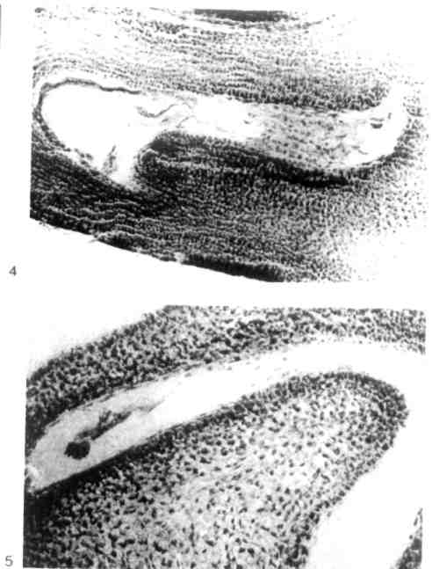
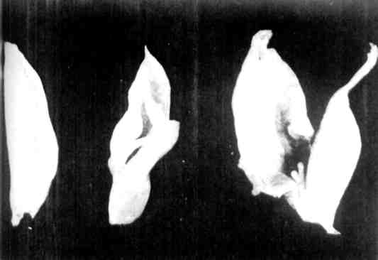
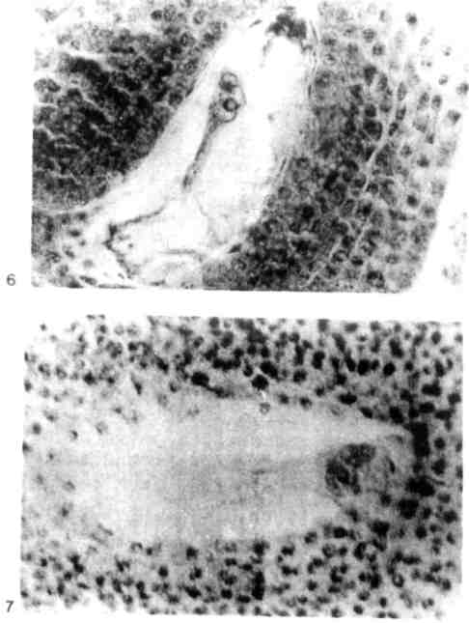
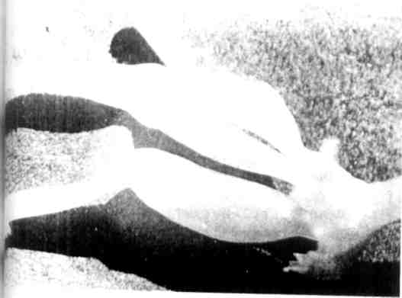
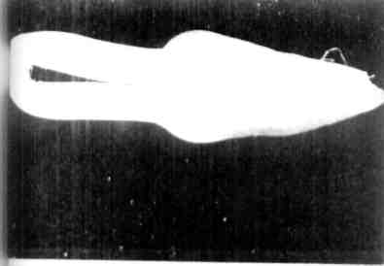
Fig. 2.Feminization of stamens
Fig. 3. Multipistllate (pods) in flower instead of stamens pistils
Fig. 4 and 5. Ovules with empty embryosacs
Fig. 6 and 7. Degenerated embryosacs

