16 PNL Volume 20 1988 RESEARCH REPORTS
ELECTROPHORETIC ANALYSIS OF FIELD PEA CULTIVARS
A. Hussain¹, S. T. Ali-Khan², and W. Bushuk¹
1 - Food Science Dept., University of Manitoba, Winnipeg, MB, Canada 2 - Agriculture Canada, Research Station, Morden, MB ROG 1J0, Canada
A procedure was developed to identify cultivars of field peas (Pisum sativum L.) using electrophoretic patterns of seed proteins as genotype markers. This paper presents the details of this procedure.
Eleven cultivars of field peas registered in Canada ('Bellevue', 'Century', 'Express', 'Fortune', 'Lenca', 'Tara', 'Tipu', 'Titon', 'Trapper', 'Triumph', and 'Victoria') were used for electrophoretic protein analysis. Seeds of each cultivar were cracked manually using mortar and pestle. Testa-free cotyledons were ground on a Udy Cyclone mill (Udy Corporation, Fort Collins, CO), to pass through 1.0 mm mesh screen.
Several different electrophoretic procedures were tested using extracts of cotyledon proteins; isozymes were not considered as they do not provide sufficient intervarietal discrimination (2). In the successful procedure, 0.1 g of seed meal (equivalent to 1/2 - 1. cotyledon) was extracted in 0.45 mL of 5M acetic acid. The mixture was vortexed for 1-2 min and incubated at 40C tor 2 h. Clear supernatant obtained after cen-trifugation at 8800 x g for 20 min at 23C was mixed 1:1 with dye solution (3). Ten microliters of the resulting solution was used for electrophoretic separation. Electrophoresis was carried out in locally designed acid polyacrylamide gel electrophoresis (PACE) unit (3). Gels were prepared by a modification of a previously published procedure (1). Details are available upon request.
Electrophoresis was carried out under the following conditions:
Running buffer Aluminum lactate, pH 3.1
Running current 15 mA
Running time 6 h
Running temperature 20C After electrophoresis, the gel was stained overnight in 12% trichloroacetic acid containing 4% (v/v) Comassie Blue-K solution (3). The stained gel was rinsed with soapy water, destained 1-4 h, and photographed.
Reproducibility of the electrophoregrams was checked by repeating the procedure three times beginning with the raw seed meal. Results were found to be highly reproducible.
Electrophoretic patterns (or the 11 cultivars (Fig. 1) were distinctly different. Electrophoregrams contained 20-23 bands, some of which were genotype specific while others were present in the patterns of several different cultivars.
All the cultivars examined contained one common band. This band can therefore be used as an internal standard to normalize the data from different gels and to estimate relative mobilities.
From the results it was obvious that there were two categories of bands in the electrophoregrams. First those which are clearly present or absent; these bands are useful for genotype identification. A second category of bands were those which were common to several cultivars. These bands may be valuable in plant breeding if they may be linked to specific agronomic or quality characteristics.

PNL Volume 20
1988 RESEARCH REPORTS
17

Hussain, A., W. Bushuk, H. Ramirez, and W. M. Roca. 1987. Centro
Internacional de Agricultura Tropical-CIAT, Cali, Colombia, working
document No. 22/Univ. Man. publ./115.
Przybylska, J., S. Blixt, H. Parzysz, and Z. Zimniak-Pryzbylska.
1982. Genetica Pol. 23:102-121.
Sapirstein, H. D. and W. Bushuk. 1985. Cereal Chem. 62:372-377.
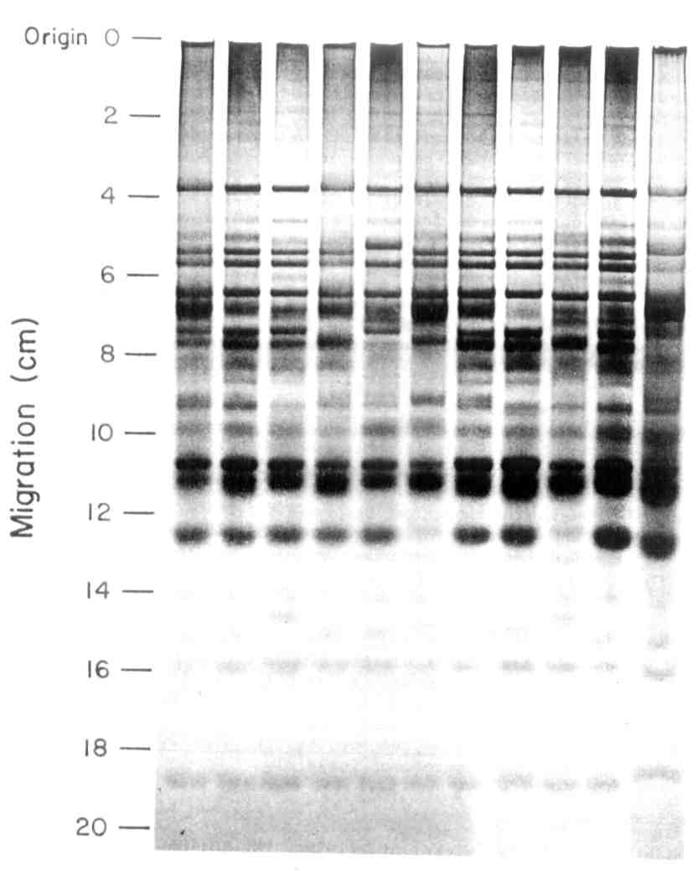
Acid PAGE patterns of seed proteins of pea. From left to right the cultivars are 'Bellevue',• 'Century', 'Express' 'Lenca' J Fortune•, 'Tara', 'Tipu', 'Titan', 'Triumph', 'Victoria', and 'Trapper'.
*****

