14 PNL Volume 20 1988 RESEARCH REPORTS
TETRAPL0IDY FOLLOWING X-IRRADIATION
Gottschalk, W. Institute of Genetics, University of Bonn
Federal Republic of Germany
Very rarely, polyploid mutants arise through mutagens which usually induce gene and chromosome mutation but not genome mutations. Such an event occurred in our X-ray treatments in Pisum sativum after seed irradiation with 9 kr. In a very small M2 family, a plant with reduced fertility was found. It produced only three seeds from which three tetra-ploid M3 plants developed (mutant 408B of our collection). They were morphologically normal but their seed production was considerably lower than expected for "normal" tetraploid individuals. One of them was studied cytologically in order to determine the causes of the strongly reduced fertility.
Unfortunately, the garden pea is cytologically a very unfavorable species. Only a very limited number of pollen mother cells (PMC) was available and it was not possible to analyze the meiotic behavior during the first prophase and metaphase. From the final stages of the first division, however, it could be concluded that, besides bivalents, quadriva-lents had been present in the earlier stages and that the reduction of chiasma frequency had led to univalents in relatively high frequencies. They appeared as laggards in the final stages of the first division. In telophase I, one to four Laggards per PMC were found in almost 50% of all PMCs studied (Fig. 1, left). Between telophase I and interkinesis, about half of the lagging chromosomes were included into the two daughter nuclei and the proportion of PMCs with micronuclei was correspondingly lower. It cannot be expected that these processes occurred in a regulated manner resulting in genomically balanced nuclei. On the contrary, many of the interkinesis nuclei were certainly unbalanced with regard to both chromosome number and genomic constitution.
The proportion of PMCs with disturbances was greater in the final stages of the second meiotic division than at the end of the first division. In 19.2% of all interphase II PMCs studied, one to four separated chromatids were present outside of the "normal" nuclei. In PMCs already containing microspores, the proportion of cells of .this category was higher (31.5%, Fig. 1, right ). It is not c Lear how these additional anomalies between interphase II and microspore formation arose. Some of the chromatids, which apparently belonged to distinct nuclei, obviously were not included in these nuclei; on the contrary, they developed independently into small microspores.
Almost 70% of tho PMCs studied formed four microspores. From the meiotic irregularities observed, it can be concluded that many of them were genomically unbalanced, being unable to produce functional germ cells. This may have been the main reason for the low seed production of the tetraploid M3 plants. All their seeds were sown in the following year but exclusively diploid plants developed from them. Thus, the mutant got lost. Blixt (personal communication) also has observed cytological instability of the tetraploid level of Pisum sativum. Tetraploid peas, obtained after colchicine treatment, lost their tetraploid valence in succeeding generations and their progenies reverted to the diploid level. Similar experiences were reported by Straub (1).

PNL Volume 20
1988 RESEARCH REPORTS
15

1. Straub, J. 1940. Ber. Dtsch. Bot. Gas. 58:430-436.
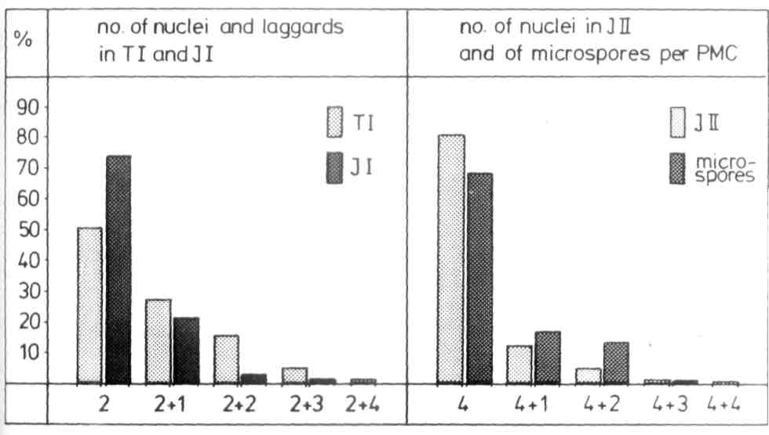
Fig. 1. The meiotic irregularities of the tetraploid Pisum mutant 408B.

