IMPROVEMENT OF THE SELECTION VALUE OF GENE dgl THROUGH
RECOMBINATION

Gottschalk, W. G. Institute of Genetics, University of Bonn
Federal Republic of Germany

Gene dgl of the Pisum genome causes a degeneration of the
leaflets and stipules during ontogenesis. Mutant expression is
progressive during ontogeny. The first foliage leaves of mutant
plants are normal. A few weeks later brown spots appear on the
leaflets and stipules which become progressively larger. Finally
the leaves are dark brown and dry and incapable of photosynthesis.
Since, during development, the newly formed leaves are normal and
functional, the plants are capable of producing some seed but only
between 5 and 55% of the control values of the mother variety over
15 generations (Fig. 1).
The X-ray induced mutant 142B of our collection, homozygous
for dgl, contains at least one mutant gene more. The small pods
of these plants have a characteristic grey-brown color which is
genetically conditioned. In crossing experiments the two charac-
ters could be separated from each other, demonstrating that two
different genes are involved rather than a pleiotropic effect of
one gene. Thus, the genotypic constitution of mutant 142B is as
follows:
-dgl for leaf degeneration,
-gbp for grey-brown pod color,
-possibly a third gene causing a reduced internode length.
The seeds are very small, probably as a consequence of the poor
photosynthetic efficiency. When grown Ln West Germany, the vita-
lity of the mutant varied from year to year in response to dif-
fering environmental conditions, but the effect of dgl was always
clearly visible. In Egypt and India, however, the mutant pheno-
type failed to express.
Mutant 142B was crossed with the fasciated mutant 489C of our
collection homozygous for more than 20 mutant genes. Six dif-
ferent recombinants, homozygous for dgl from 142B and for dif-
ferent genes or gene groups from 489C, were selected in F2 and
developed into pure lines. Another three dgl recombinants were
selected from a cross of mutant 142B with the non-fasciated, tall
recombinant R 142F, the origin of which likewise traces to hybri-
dizations between 142B and 489C. These nine dgl recombinants were
studied with regard to their seed production in relation to the
productivity of the parental mutant 142B. We sought to learn
whether the strongly negative selection value of dgl is a
characteristic feature of that gene or whether it can be overcome
by combining dgl with specific other mutant genes of the genome.
Most of the recombinants were tested over several generations; the
results are given in the righthand part of Fig. 1.
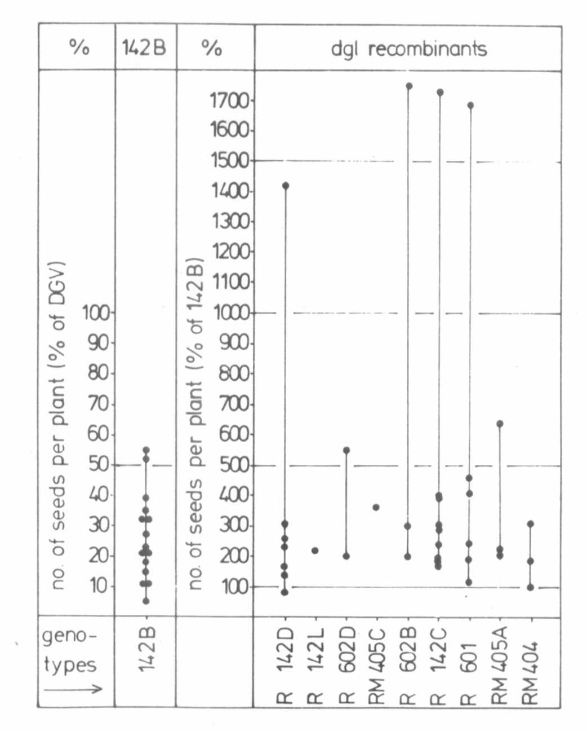
Fig. 1. Seed production of mutant 142B, homozygous for gene dgl,
and of 9 different dgl recombinants. Each dot represents
the mean value for one generation. The means are related
either to the control values of the mother variety
'Dippes Gelbe Viktoria' (DGV) or to those of mutant
142B = 100% (dgl recombinants).
The graph shows that all the dgl recombinants studied were
considerably more productive than the original dgl mutant in most
generations tested. Extraordinarily high values were obtained for
the following genotypes:
-R 142D- dgl and gbp (from 142B)
- short II for strongly shortened internodes (from
489C)
- a gene for linear stem fasciation with reduced
penetrance (from 489C)
-R 142C- dgl and gbp_ (from 142B)
- weak stem fasciation with reduced penetrance (from
489C)
-R 601 - dgl and gbp_ (from 142B)
- long I for increased internode length (from 489C)
- weak stem fasciation (from 489C)

- smaller leaves (from 489C)
-R 602B- dgl and gbp (from 142B)
- weak stem fasciation (from 489C)
All these genotypes, as well as 142B, matured earlier than 'Dippes
Gelbe Viktoria' (DGV).
In 1981 the yield of these four genotypes greatly surpassed
their parental mutant 142B. That summer mutant 142B had a very
low yield, only 5% of the control values of DGV. The four recom-
binants, however, varied between 1400 and 1750 percent of the cor-
responding values of 142B.
Clearly, dgl expression is highly dependent on environmental
factors. Climatic conditions in Germany during May and June,
1981, were very unfavorable for mutant 142B. This, however, does
not mean that gene dgl itself reacted negatively to these condi-
tions. On the contrary, certain dgl recombinants reacted posi-
tively. Moreover, recombinants R 142C, R 142D, and R 602D had
normal leaves in Varanasi, India.
Our results demonstrate that the selection value of mutant
genes depends not only on specific environmental factors but also
to a high degree on the overall genotypic constitution of the
plants, the influence being positive or negative. Although dgl is
not of any agronomic interest, similar improvements have been at-
tained with genes of direct value for pea breeding, for instance
with gene efr conditioning earliness (1).
1. Gottschalk, W. 1983. Int. J. Appl. Radiation. Isot. 34:827-
832.
*****

