APPLICATION OF ELECTROPHORETIC METHODS OF ISOZYME SEPARATION
TO GENETICAL CHARACTERIZATION OF PEA CULTIVARS

Wolko, B. and W. K. Swiecicki
Plant Breeding Station, Wiatrowo, Poland
Determination of varietal distinctness, homogeneity, and sta-
bility (DHS) often proves difficult for individuals and agencies
responsible for providing variety descriptions.
The descriptions of varieties include many imprecise, poly-
genic features, strongly influenced by the environment (e.g. the
hue of green of field-grown plants or classes of stem length [e.g.
tall, medium, short]). Suitable markers for distinguishing doubt-
ful cases are a decided advantage. The most valuable are mono-
genic features with stable expression and full penetrance, so-
called variety markers.
Electrophoretic methods of isozyme separation are highly
suitable for this purpose. In Pisum the studies of Przybylska et
al. on isozymes of different taxa were important (2). Significant
also were studies of Weeden (3,4,5). The main aim of our work was
to study the range of enzyme variation of pea cultivars in three
enzyme systems controlled by at least six loci and to demonstrate
the usefulness of isozyme analyses for cultivar characterization.
Fifty-six cultivars from the Wiatrowo collection were inves-
tigated, including cultivars having different uses (vegetable, dry
edible seed, fodder, and green forage) bred and cultivated in Po-
land as well as other countries.
The group of cultivars initially was characterized according
to morphological features (1). In exceptional cases it was possi-
ble to distinguish the variety from the others without any doubts
(e.g. only cv. 'Novella' has genotype af, fa) . But some varieties
could not be distinguished using the hitherto known methods of
description and identification.
LAP, GOT (=AAT), and 6PGD were investigated using Leaf tissue.
Electrophoretic separation was performed in starch gels (Serva)
using well-known procedures. Electrophoretic phenotypes found
among the cultivars analyzed are presented in Figs. 1, 2, and 3.
Isozyme genes were useful for characterizing and distinguishing
varieties in the following cases:
- Cultivar of different origin with identical phenotype.
Morphological criteria alone could not show a difference between
cultivars 'Neuga' (DDR) and 'Oraniencroon' (ZAF). But in t lie
locus Lap-1 cv. Neuga has the allele A1 and cv. Oraniencroon has
A2. Moreover, polymorphism was observed in cv. Neuga for
6Pgd-2. We have designated this locus 6pgd-c. There were in-
dividuals with the allele E1 (10%) and with E2 (90%).
Therefore, Neuga and Oraniencroon, in spite of the same morpholo-
gical phenotype, have different genotypes. They differ with re-
gard to two monogenic characters, and thereby fulfill the require-
ment for distinctness of cultivars.
- Electrophoretic separation of isozymes can be used for
the description of selected varieties. For example, the Wiatrowo
gene bank contains two cultivars named 'Wonder of Amerika', each
from a different country. They have dissimilar electrophoretic
phenotypes in the zone of enzyme activity of LAP-2 and a different
allele of the 6Pgd-2. The fact that both varieties are monomorphic
for opposed alleles suggests that they possibly were selected from
another, third line which was polymorphic for the gene 6Pgd-2.
3. It is interesting to compare cultivars of close origin,
especially when they were bred from the same parental forms. For
example, 'Aster' and 'Opal', bred in different breeding stations
(Lipie and Wiatrowo), both originated from reciprocal crosses of
cv. 'Auralia' and 'Flavanda'. Analysis of enzyme variation of the
parental varieties showed polymorphism in Auralia for Lap-1
(allele A1 in 63% of the individuals, A2 in 37%) and Lap-2
(a1a3 in 47%, and a2a3 in 53%). Flavanda had the
phenotype a1a3 of Lap-2 and the allele A1 of locus Lap-1.
Moreover, this variety was polymorphic lor the locus 6Pgd-2 (D1
5% and D2 95%). Cultivars bred from crossing Auralia with
Flavanda possessed the allele A1 of Lap-1 and the allele D1 of
6Pgd-2. However, they differ in phenotypes of Lap-2 (Opal
a2a3; Aster - a1a3). Thus, Aster and Opal differ from
each other as well as from the parental varieties by at least one
allele.
A similar analysis can be conducted for strains WTD 583 and
WTD 785 originating from the cross combination WTD 3002 x
'Paloma'. Both parental forms as well as the breeding strains
differ from each other by the electrophoretic pattern in the Lap-2
locus and have different alleles of gene A (anthocyanin synthesis)
(Fig. 4).
4. Since cultivars are developed without regard to enzyme
variation but, instead are selected for uniformity and for horti-
cultural merit, it is of interest how much isozyme polymorphism
developed varieties contain. For example, line Wt 4367 was poly-
morphic for LAP-1, LAP-2, G0T-1, 6PGD-1 6PGD-2. In one population
stable frequency of alleles of polymorphic genes was found in two
consecutive years, 1984 and 1985. Polymorphism was also observed
in 13 other cultivars. Thus, pea varieties, although pure lines
with regard to a number of characters considered during the breed-
ing process, can be polymorphic from the point of view of isozyme
loci. The implications or importance of this is not known. Poly-
morphism of enzyme variants is not an obstacle for variety identi-
fication because a stable frequency of alleles of a given locus in
a population characterizes a cultivar, too.
The results presented above indicate the possibilities of
employing electrophoresis for cultivar description. Together with
a group of monogenic characters of stable expression, recognizable
in seedlings and in seeds, electrophoresis should become a part of
the routine tools used by institutions for registering varieties
and testing seed, especially as a supplement when existing des-
criptions used for establishing DHS are insufficient.
1. Blixt, S. and W. K. Swiecicki. 1980. Post. Nauk Rol. 6:31-38.
- Przybylska, J., S. Blixt, H. Parzysz, and Z. Zimniak-
Przybylska. 1982. Gen. Pol. 23:103-121.
- Weeden, N. F. 1983. PNL 15:58-59.
- Weeden, N. F. 1985. The Pea Crop. P. D. Hebblethwaite,
M. C. Heath, and T. C. K. Dawkins, Eds. Butterworths,London.
pp. 55-66.
5. N. F. Weeden and G. A. Marx. 1984. J. Hered. 75:365-370.
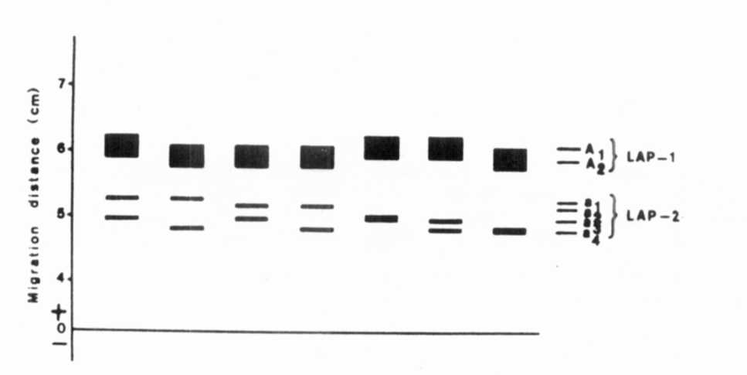
Fig. 1. The range of enzymatic variation of LAP.
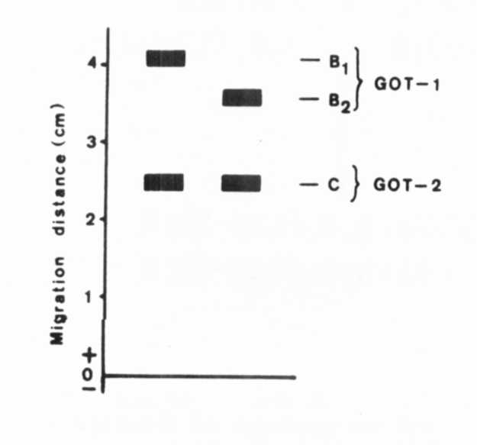
Fig. 2.

The range of enzymatic
variation of GOT.
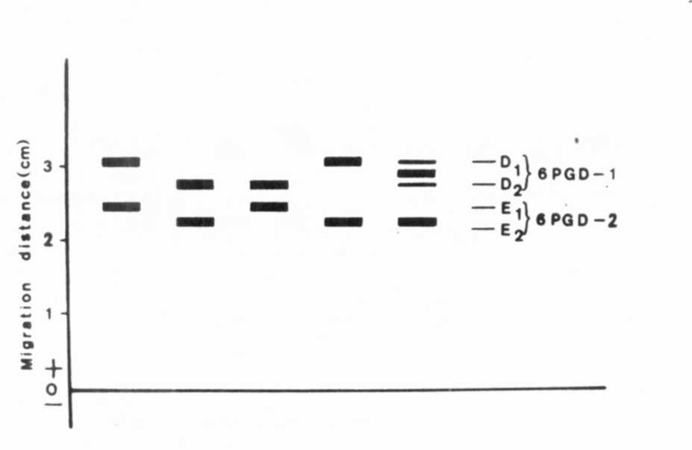
Fig. 3. The range of enzymatic variation of 6PGD.
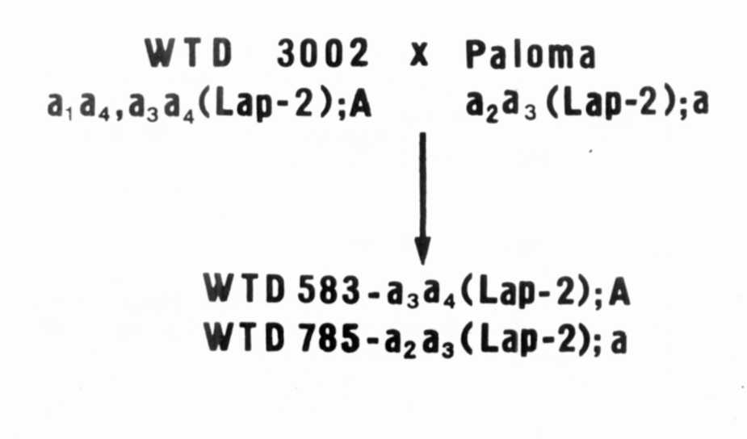
Fig. 4. The origin and the genotype of the strains
WTD 583 and WTD 785.
*****

