PNL Volume 19 1987 RESEARCH REPORTS
84

A NEW GENE (1st) WHICH INFLUENCES STANDARD SHAPE IN PISUM
SATIVUM

Winfield, P. J. Agricultural Scientific Services
Edinburgh, Scotland
A variant with lobed standards ^{1/} (Fig. 1) was first
observed in our 1985 Reference Trial. Four variant plants were
found in a population of approximately 100 plants of accession
69065 of the cultivar 'Alaska'. The lobing was consistently ex-
pressed for all flowers on each variant plant.
Variant and normal plants were tagged and seed harvested from
them were sown in a greenhouse in February 1986. Lobed standards
were clearly observed on the plants grown from seed isolated from
variant plants. Variant and normal plants were reciprocally
crossed. All the F1 progeny had normal flowers. Among 120 F2
seeds sown in the greenhouse in August 1986, 112 survived, and
among these 23 had lobed and 89 had normal standards
(X²(3:1)=l.19). This suggests that the characteristic is
determined by a monogenic recessively inherited gene.
I would like to propose a new gene symbol, 1st (for lobed
standard), for this character.
Some variation was observed in the degree of standard lobing
between plants and sowings. In the field each variant plant con-
sistently produced flowers with lobed standards. This was not the
case in greenhouse grown material. In the F2 population grown
in August, lobing was well expressed on all variant plants up to
the fourth flowering node but many variant plants produced flowers
with normal standards above this node. Normal standards were also
observed on variant plants of the February sowing, although where
this occurred standards at subsequent nodes were lobed.
Generally lobing was more pronounced in the greenhouse than
in the field.
Clearly some environmental factor may influence the expres-
sion of lobing. The change in expression observed in the August
sowing coincided with a period of persistent cool weather (the
plants were grown in an unheated greenhouse). However, it is
early to say what the exact cause of this variation in expression
might be.
^{1/} — Standard = banner = sail = vexillum (Ed.)

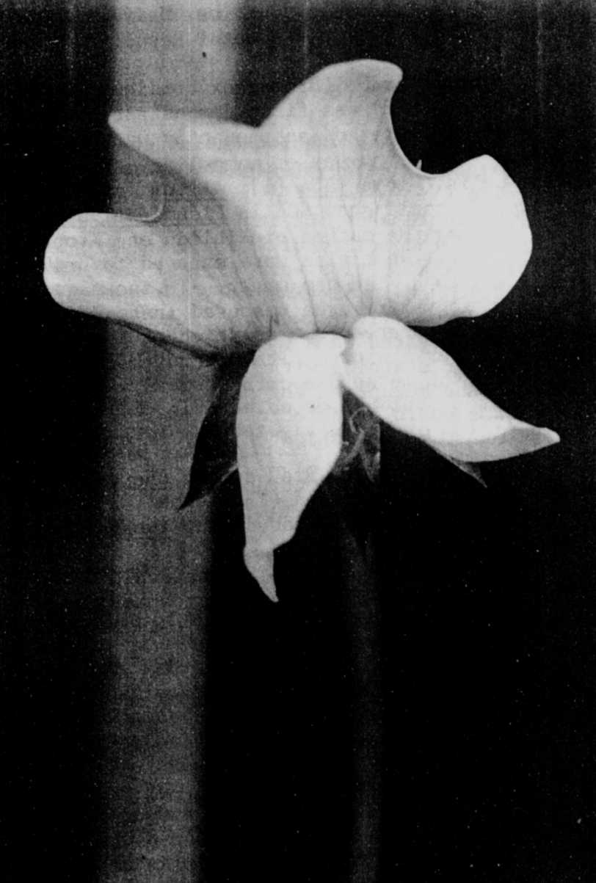
Fig. 1. Mutant phenotype of lst (lobed standard).
PNL. Volume 19 1987 RESEARCH REPORTS 85

