A NEW MUTANT PRODUCING LOBATE LEAFLETS IN PEA (Pisum sativum L.)

Trifu, I. Research Institute for Cereals and Industrial Crops
Fundulea, Romania

A new mutant producing lobate leaflets has been obtained by
gamma irradiation (6 Kr) of seeds of cv. 'Neuga' (Fig. 1) (1).
The line containing the new mutant gene was named MF-14 lol.
F1 plants of a cross of the original variety with mutant
line MF-14 lol had two types of leaflets, most of them having a
normal shape and some exhibiting a single small lobe or a slight
sinuous margin.
Segregation in the F2 population (Table 1) showed that the
inheritance of the lobate leaflets mutant character is monogenic
recessive, but with incomplete dominance.
Since a similar mutant has not been described in the pea
literature, we propose to name the new mutant lobate leaflets with
the symbol lol.
Analysis of crosses between the MF-14 lol line and several
lines carrying markers for different chromosomes revealed evidence
of coupling phase linkage between lol and wlo on chromosome 6
(Table 2).
Since the individuals possessing the recessive mutant lol
could be identified in the seedling stage, this mutant could be a
valuable marker for genetic studies.
1. Trifu, I. 1980. Probl. genet, teor. aplic. XII(6):529-538.
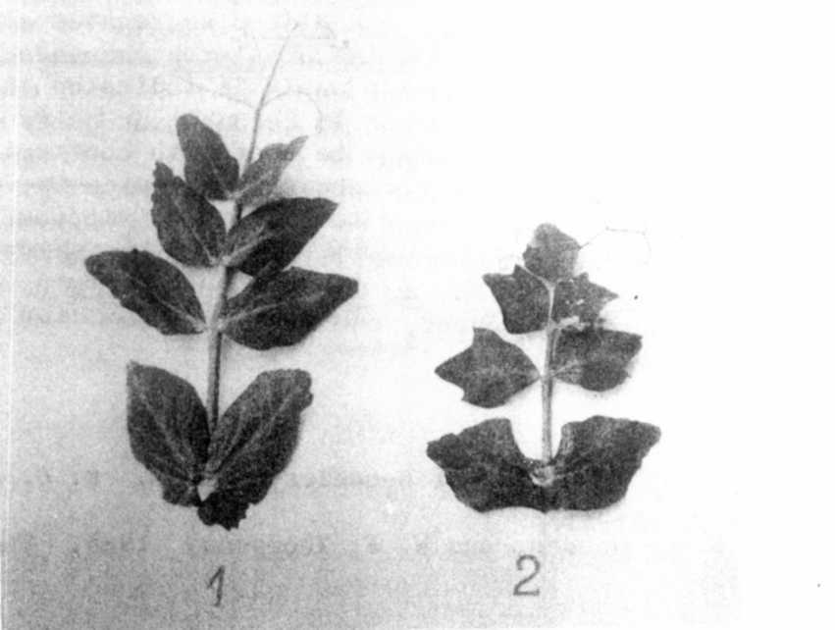
Table 1. Phenotypi c distribution in F2
population from the cross Neuga
x MF-14 lol.

Norma1Lobate
1eafletsTotalCh i - square
(3:1)138481 8b0.0b
Table 2. Analysis of joint segregation in F2 for gene Lol and
different gene markers.
Fig. 1. Normal leaf (left) vs. leaf with lobate leaflets (lol)
* * * * *
C.ene  pair | XY | Xy | xY | xy | Total | Ch i -square |  |  | Recomb .  fract. | S.E.
 |  |  |  |  |  | X | Y | I.inkage | Recomb .  fract. | S.E.
Lol 1 | 2 54 | 89 | 78 | 29 | 450 | 0.36 | 0 . 36 | 0.05 ns
Lol St | 165 | 48 | 52 | 24 | 2 89 | 0.26 | 0 .00 | 2.52 ns
Lol Le | 104 | 29 | 26 | 15 | 174 | 0.19 | 0.01 | 3.50 ns
Lol Gp | 100 | 31 | 35 | 13 | 179 | 0.31 | 0 .02 | 0.22 ns
Lol Wlo | 176 | 2 | 4 | 42 | 224 | 2.38 | 3.4 3 | 142.51 *** | 2.96 | 1.95
Lol Tl_ | 164 | 50 | 54 | 20 | 288 | 0.07 | 0.07 | 0.40 ns
•k -k ~k
Significant at 0.001

