GOLD NECROSIS (gn): A NEW GENE ON CHROMOSOME 5

Plant Breeding Station, Wiatrowo, Poland
Swiecicki, W. K.

Another new mutant has been isolated from an experiment on
induced mutations (1,2). Mutant Wt 16129, selected in an M2
population after seed treatment of cv. 'Paloma' by 200rNf +
0.014%NEU, is characterized by gold-orange color of the lower sur-
face of leaves. Because mutant expression is somewhat interme-
diate between the phenotypes of nec and/or py, orl, locus identity
tests were performed. Wt.16129 was used in diallel crosses with
type lines for genes in the necrotic group, viz. nec, dgl (3) and
also with type lines for py, o, and orl. Normal plants were
obtained in all cases. Mutant Wt.16129 was therefore regarded as
new and was named gold necrosis; the symbol gn is suggested.
For the linkage test Wt.16129 (gn) was crossed with WL. 1238
(testerline). The F1 plants grown in the greenhouse in 1983
were normal and fully fertile. The F2 generation (495 plants)
was grown in the field in 1984. Table 1A shows the segregation
ratios for gn and also for the marker genes. Despite strong de-
viations from 3:1, the cp segregation data was included into the
linkage calculations because the product-ratio method was used.
Linkage was detected between Gn and genes in chromosome 5, viz.
Cp, Te, and Gp_ (Table IB). Gn, together with nec and art-2 (3,4),
extends the number of available loci on this chromosome. For more
precise mapping better markers than cp and te are needed, and a
multi-point analysis should be used.
- Swiecicki, W. K. 1984. PNL 16:70-72.
- Swiecicki, W. K. 1985a. PNL 17:72-74.
- Swiecicki, W. K. 1985b. Gen. Pol. 26(3):351-359.
- Swiecicki, W. K. 1986. Gen. Pol. 27:1-2.

PNL Volume 19 1987 RESEARCH REPORTS
75

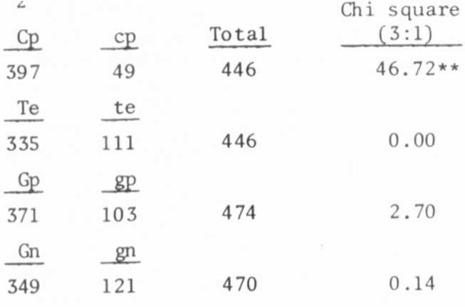
Table 1. Phenotypic distribution in F2 population segregating for
gold necrosis from the cross WT 16129 (mutant) x WL 1238
(testerline).
A. Monohybrid F2 segregation
B. Joint segregation of gold necrosis with cp, te, and gp
Cp Te  330 | Cp te  59 | cp Te  0 | cp te  49 | Total | Joint  chi square | Recomb.  fract. | S.E.
 |  |  |  | 438 | 170.02** | 5.0 | 1.1
Cp Gp  347 | Cp gp  50 | cp Gp  1 | cp gp  48 | 446 | 180.63** | 4.6 | 1.0
Cp Gn  286 | Cp gn  111 | cp Gn  46 | cp gn  3 | 446 | 11.80** | 26. 5 | 4.4
Te Gp  333 | Te gp  2 | te Gp  12 | te gp  99 | 446 | 375.91** | 2.3 | 0.7
Te Gn  225 | Te gn  109 | te Gn  105 | te gn  6 | 445 | 32.98** | 22.7 | 4.4
Gp Gn  250 | Gp gn  117 | gp Gn  99 | gp gn  4 | 470 | 34.12** | 19.8 | 4.4
*****

