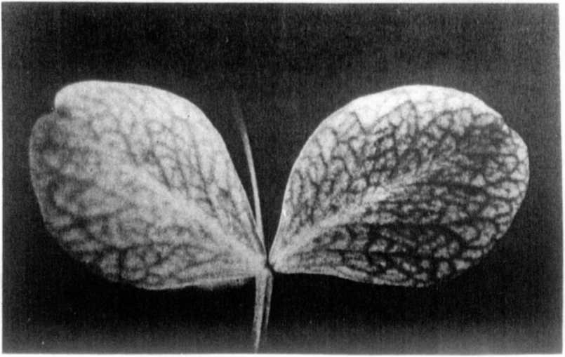
Fig. 1. Costata mutation type.
A SECOND costata GENE (lum-2) ON CHROMOSOME 3

Swiecicki, W. K. Plant Brooding Station, Wiatrowo, Poland
The chlorophyll gene costata (Lum) was Isolated, described,
named, and localized to chromosome 4 by Monti (1). The mutant was
induced in cv. 'Parvus' alter DES treatment and is characterized
by lighter interveinal leaf tissue; veins are normal green (Fig.
1). Linkage between Lum and Le was calculated as 12.0 + 4.6.
Some costata mutants were also recovered from an experiment
with combined treatment 200rNt + 0.014% NEU of cv. 'Paloma' (2),
one of which was designated Wt l5307. A locus Identity test cross
revealed that the mutant in Wt l5307 is different from Wl. 6011,
the type line for lum, i.e. the F1 plants were normal.
Preliminary linkage studies involved the analysis of an F2
population of 202 plants from the cross Wl. 851 (Blixt's tester-
line) x Wt 15307 (costata mutant). Monogenic inheritance was
shown for the mutant character costata and other marker genes
(Table IA). The dihybrid segregation suggested linkage with St in
chromosome 3 (Cr0=28.6) but not with the B segment (Table IB).
For this reason line Wt l5307 was crossed with WL I288, a tester-
line with b, st, and M markers. The dihybrid segregation (480
F2 plants in 1986) confirmed the results of the ear1ier cross
(Table 2): monogenic segregation for the costata mutant, linkage
with St (32.4 + 4.02) and no linkage with B. Additionally, very
close linkage was found between the costata mutant and M (CrO
= 1.74). A multi-point analysis involving eg. Lap-2 and/or uni
should be performed to establish the order of mutants in the M region of chromosome 3.
It is suggested that the symbols lum-1 and lum-2 be applied to the two costata genes located in chromosomes 4 and 3 from Portici and Wiatrowo, respectively.
- Monti, L. M. 1970. PNL 2:21-22.
- Swiecicki, W. K. 1984. PNL 16:84-86.
Table 1. Phenotypic distribution in an F2 population from a cross
between Wt 15307 (costata) x WL 851 (testerline).
A. Monohybrid F2 segregation
Chi-square
B  119 | b  46 | Total  165 | (3:1)  0.73
St  142 | st  60 | 202 | 2.38
Lum-2  161 | lum-2  41 | 202 | 2.38
B. Joint segregation of Lum-2 with B and St
Joint Recomb.
B St  94 | B st  25 | b St  20 | b st  26 | Total  165 | chi-square  20.43 | fract.  29.54 | S.E.  4.37
B-Lum-2  95 | B lum-2  24 | b Lum-2  34 | b lum-2  12 | 165 | 0.71 | 54.66 | 5.52
St Lum-2  105 | St lum-2  37 | st Lum-2  56 | st lum-2  4 | 202 | 9.44 | 28.64 | 6.37
Table 2. Phenotypic distribution in an F2 population segregating for
costata from Wt 15307 (lum-2) x WL 1288 (testerline).
A. Monohybrid F2 segregation
Chi -square
St  350 | st  130 | Total  480 | (3:1)  1.11 •
M  289 | m  71 | 360 | 5. 35
Lum-2  374 | lum-2  106 | 480 | 2.18
B. Joint segregation of Lum-2 with St and M
St M  202 | St m  62 | st M  87 | st m  9 | Total | Joint  chi-square | Re comb.  fract. | S.E.
 |  |  |  | 360 | 8.96** | 34.97 | 4.55
St Lum  256 | St lum  94 | st Lum  118 | st lum  12 | 480 | 17.64** | 32.45 | 4.02
M Lum  287 | M lum  2 | m Lum  4 | m lum  67 | 360 | 313.00** | 1.74 | 0.69
*****

