A SHORT METHOD TO DEMONSTRATE THE LACK OR REDUCTION OF
CHLOROPHYLL b IN DIFFERENT MUTANTS OF PISUM SATIVUM
Schmitz, R. Institute of Genetics
University of Bonn, D-5300 Bonn
Federal Republic of Germany
Chlorophyll b is integrated in several pigment protein com-
plexes of the thylakoid membranes of higher plants. The light
harvesting chlorophyll a/b complex has a great amount of this pig-
ment. To test the pigment composition of the mutants and of
special isolated complexes the spectra of acetone soluble pigments
were measured.
The absorption spectra in acetone from thylakoid membrane
preparation of the initial line (IL: 'Dippes Gelbe Viktoria') and
of mutants 1206C (chlorophyll b-less) and 333 (reduced amount of
chlorophyll b) are shown in Table 1.
Table 1. Chlorophyll a/ chlorophyll b ratio of the genotypes and
of the isolated complex.
- IL, 1206C, 333 : TMP-solution
- LHCP II : light harvesting chlorophyll a/b complex
from IL.
Genotypes | Chlorophyll a / chlorophyll b
IL | 2.69
1206C | -
333 | 5.28
LHCP II | 1.19
Chlorophyll b has absorption maxima at 650 run and 460 nm.
But in acetone extracts of thylakoid membranes the absorption
spectrum of chlorophyll a (maxima at 663 nm and 433 nm) overlaps
that of chlorophyll b. The spectra of the genotypes (Fig. 1) show
only a deviation in the area of 450-470 nm. To demonstrate a loss
or a reduction of chlorophyll b it is necessary to eliminate the
absorption of chlorophyll a. Therefore the absorption of the
thylakoid membrane solution was adjusted to 0.5 at 663 nm and dif-
ference spectra were recorded.
The difference spectrum from the chlorophyll b-less mutant
1206C versus the initial line shows two maxima in the area of 650
nm and 460 nm. The absorption of chlorophyll b in the IL solution
cannot be compensated by the mutant pigment. Therefore, the dif-
ference spectrum shows more or less the spectrum of chlorophyll b.

Comparable results are shown in the difference spectrum of
the mutant 333 (reduced amount of chlorophyll b) versus IL. The
maxima have lower peaks because the mutant has a little chloro-
phyll b.
The light harvesting chlorophyll a/b complex (LHCP II) has a
large amount of chlorophyll b, which can be seen in the spectrum
(Fig. 2). There are two maxima in the area between 400-500 nm
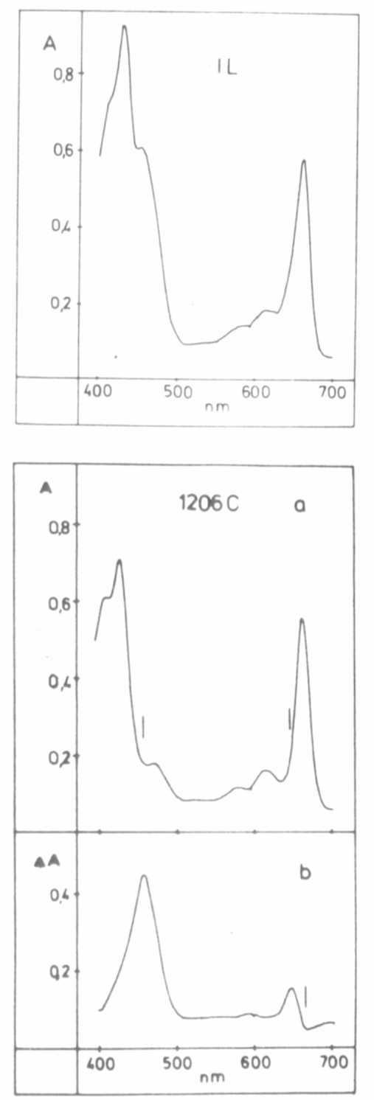
Fig. 1. Absorption spectra and difference spectra from Thylakoid membrane
preparations of different genotypes, a) Absorption spectra from
TMP-preparation, solubilized and measured against 80% acetone,
b) Difference spectra from TMP preparations: - reference cuvette
contains mutant solution, - sample cuvette contains mutant solution.
The chlorophyll a absorption (663 nm) of both solutions have the
same values of about 0.5.
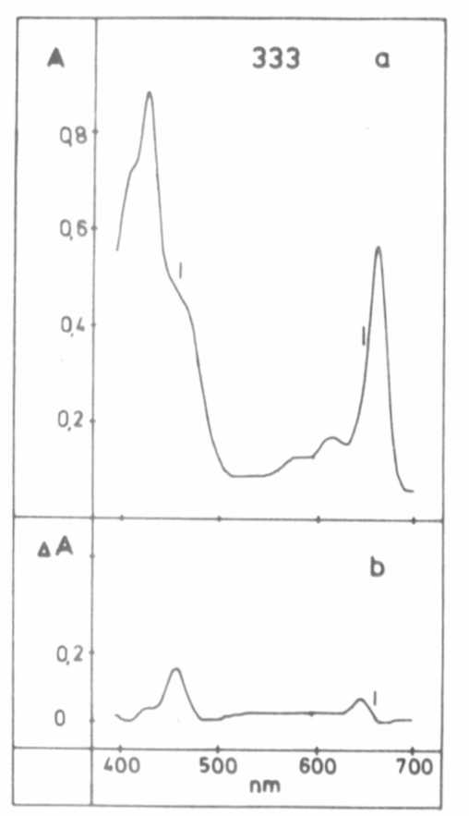
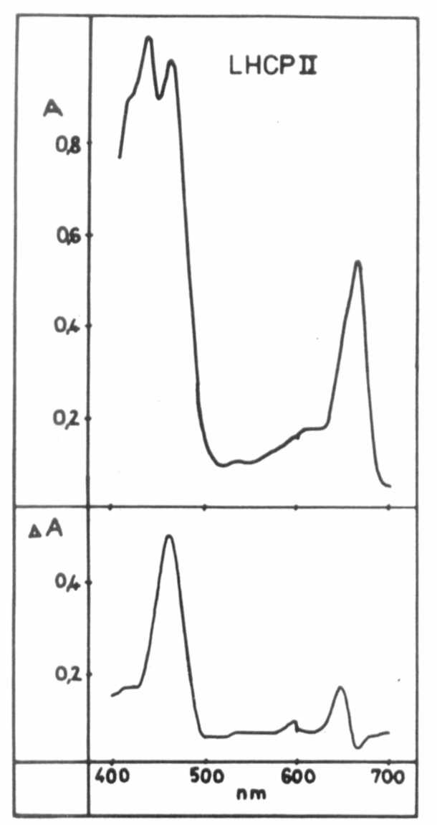
Fig. 2. Absorption spectrum and difference spectrum of the light
harvesting chlorophyll a/b - protein complex of the 1L.
a) absorption specti-um of LHCP II, solubilized and
measured against 80% acetone, b) difference spectrum from
LHCP II complex and TMP preparation of the IL: reference cuvette: TMP (IL), -sample cuvette: LHCP II (IL).
which are caused by the absorption of chlorophyll a and chloro-
phyll b. The difference spectrum shows a higher peak in the area
of 450-470 nm, as expected.
•The absorption spectra and especially the difference spectra
are fast methods to characterize chlorophyll mutants and isolated
pigment protein complexes.
*****

