INTERNODE LENGTH IN PISUM: A FURTHER MUTATION AT THE la LOCUS

Reid, J. B. Department of Botany, University of Tasmania
Hobart, Tasmania, Australia

Dwarfing mutants in peas are relatively common (see 9 for
review). The genes at seven such loci, na, le, lh, ls, lw, lk,
and lm, are well established (6,11). These genes either block
steps in the gibberellin biosynthetic pathway prior to the produc-
tion of the native active gibberellin, GA₁ (e.g. na, le, lh, ls,
see 3,5) or reduce the response produced by a certain level of
GA₁ (e.g. lk, lw, see 6,10). However, relatively few mutants
with increased internode length have been described. The best
examined are the crypto and slender types produced by the dupli-
cate gene combinations la cry^{c} (8,11) and la cry^{s} (1,11),
respectively. These gene combinations cause the plant to behave
as if all the gibberellin mediated responses are either partially
(la cry^{c}) or fully saturated (for la cry^{s}) even though
endogenous gibberellin levels are not markedly altered (2,7).
Consequently, it was of considerable interest when Ms. B. Kneen
and Dr. T. LaRue of the Boyce Thompson Institute provided a new
mutant, R90, derived from cv. 'Sparkle' after gamma radiation
which had increased internode length. The present report examines
the genetic nature of the mutation and its responsiveness to ap-
plied GA₁ and the gibberellin synthesis inhibitor paclobutrazol
(PP333).
Cross Sparkle x R90 indicated that the increased internode
length of R90 was caused by a single recessive mutation since the
Fl was dwarf and the F2 gave a clear 3:1 segregation (X² ⁼
1.7) (Fig. 1). Cross R90 x L133 (slender, le la cry^{s} Na Lh Ls
Lk Lw Lm) resulted in F1 plants with elongated internodes rather
than the expected dwarf habit (Fig. 1). This indicated that R90
possesses recessive alleles at both the la and cry loci. This was
confirmed by cross R90 x L186 (slender, Le la cry^{s} Na Lh Ls Lk
Lw Lm) (Fig. 1). The parental cultivar of R90, Sparkle, possesses
the genotype La cry^{c} since crosses of Sparkle to the le dwarf
lines L53L (La cry^{s}) and L61a (1a Cry) gave, in the F2, either
all dwarfs (93 plants) or an 87 dwarf : 4 cryptodwarf segregation
(X² for 15:1 = 0.54), respectively (Fig. 2). This implies that
the mutation in R90 responsible for the increased elongation has
occurred at the la locus. The present evidence does not indicate
whether this new mutation (which shall be referred to as
la^{(R90)}) results in exactly the same phenotype as the pre-
viously established la allele (1). However R90 (presumed genotype le la^{(R90)} cry^{c}) is phenotypically similar to standard
cryptodwarf lines (e.g. L8, le la cry^{c}, Fig. 1).
Data from the application of GA₁ and paclobutrazol (PP333)
are consistent with the genetic information. R90 only shows a
relatively small promotion of elongation after the application of
10 mkg of GA₁ (40 percent between nodes 5 and 8, Fig. 3) and is
only weakly dwarfed by 20 mkg of paclobutrazol (27 percent) com-
pared with the parental dwarf cv. Sparkle (151 and 67 percent,
respectively). The inhibition caused by paclobutrazol can be
overcome by the application of GA₁ in both lines (Fig. 3).
53
PNL Volume 19 1987 RESEARCH REPORTS

Cryptodwarf (la cry^{c}) types and particularly the more pronounced
slender (la cry^{s}) types have previously been shown to possess
reduced responses to treatments (either chemical or genetic) which
alter the level of active gibberellin (4,7).
In conclusion, the increased internode length of mutant R90
appears to be caused by a mutation at the la locus (la^{(R90)})
which has a similar phenotypic effect to the previously described
la allele.
- De Haan, H. 1927. Genetica 9:481-497.
- Ingram, T. J. and J. B. Reid. 1987. J. Plant Growth
Regulation (in press).
- Ingram, T. J. and J. B. Reid. 1987. Plant Physiol. 83:
in press).
- Ingram, T. J., J. B. Reid, W. C. Potts, and I. C. Murfet.
1983. Physiol. Plant. 59:607-616.
- Ingram, T. J., J. B. Reid, I. C. Murfet, P. Gaskin,
C. L. Willis, and J. MacMillan. 1984. Planta 160:455-463.
- Jolly, C. J., J. B. Reid and J. J. Ross. 1987. Physiol.
Plant. 69:489-498.
- Potts, W. C, J. B. Reid and I. C. Murfet. 1985. Physiol.
Plant. 63:357-364.
- Rasmusson, J. 1927. Hereditas 10:1-150.
- Reid, J. B. 1986. In A Genetic Approach to Plant
Biochemistry, pp. 1-34. Eds. A. D. Blonstein and P. J. King,
Springer-Verlag, Wien.

- Reid, J. B. and W. C. Potts. 1986. Physiol. Plant.
66:417-426.
- Reid, J. B., I. C. Murfet and W. C. Potts. 1983. J. Exp.
Bot. 34:349-364.
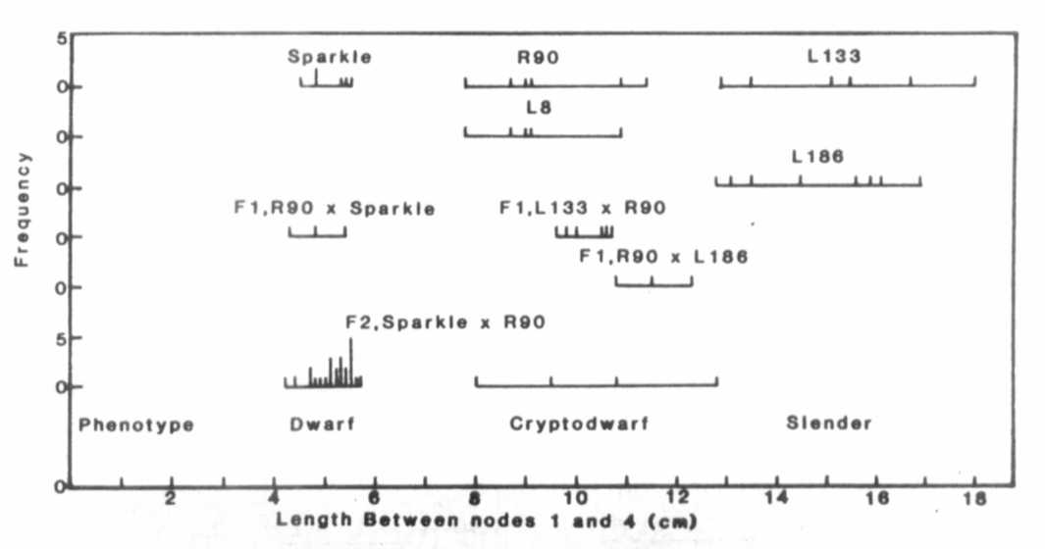
Fig. 1. The distribution of stem length between nodes 1
and 4 for lines Sparkle (le La cry^{c}), R90 (le la cry^{c}),
L133 (le la cry^{s}), L8 (le la cry^{c}) and L186 (Le la cry^{s}),
the F1 and F2 of cross Sparkle x R90 and the F1 of crosses
R90 x L133 and R90 x L186. The plants were grown under an 18 h photoperiod.

3 PNL Volume 19 1987 RESEARCH REPORTS
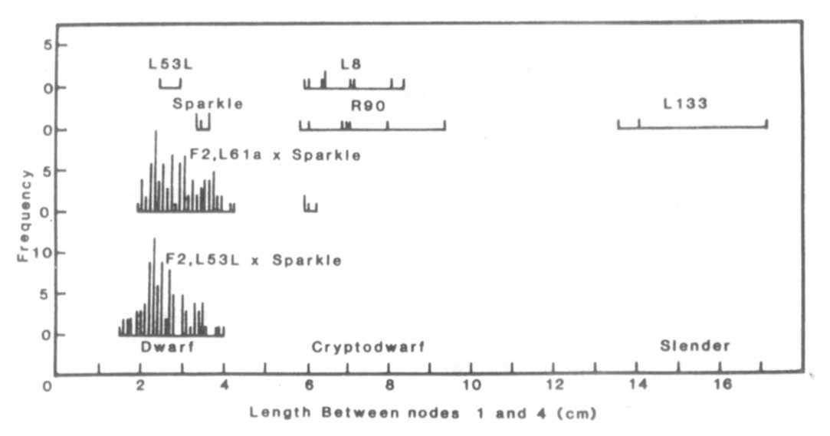
Fig. 2. The distribution of stem length between nodes 1 and
4 for lines Sparkle (le La cry^{c}), L53L (le La cry^{s}), L8
(le la cry^{c}), R90 (le la cryC), L133 (le la cry^{s}) and the
F2 of crosses L61a x Sparkle and L53L x Sparkle. Plants
were grown simultaneously under an 18 h photoperiod.
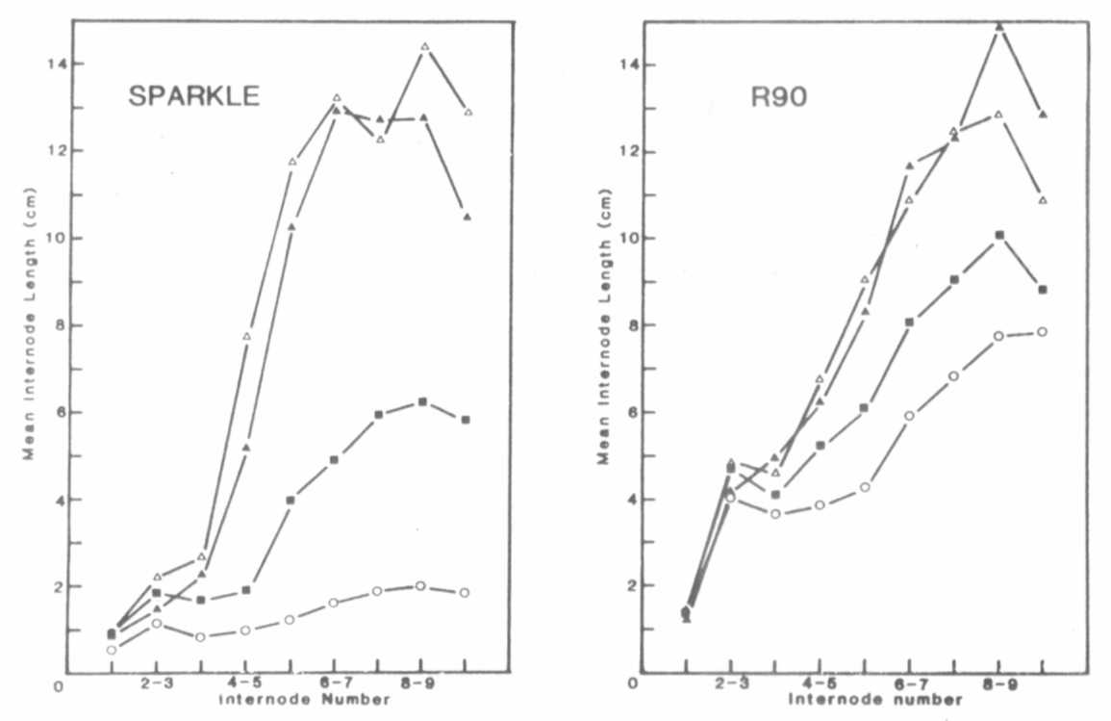
Fig. 3. Internode length plotted against internode number for
lines Sparkle (le La cry^{c}) and R90 (le la cry^{c}) treated with
either 10 mkg of GA₁ ( Δ ), 20 mkg of PP333 (O) or 10 mkg of GA₁
plus 20 mkg of PP333 ( ▲ ) or left untreated ( ■ ). The plants
were treated with PP333 on the dry testa in 10 mkl of ethanol
before planting and with GA₁ in 5 mkl of ethanol on the last
fully expanded leaf 12 days after planting. Plants were grown
under an 18 h photoperiod. n >= 8. SE were frequently too small
to be indicated on the figure but averaged 0.30 for individual
points.
*****

