PNL volume 19 1987 RESEARCH REPORTS
A COMPARISON OF THE OPTICAL PROPERTIES OF gp (YELLOW) AND
Gp (GREEN) FRUITS
Price, D. N., M. E. Donkin, and A. Hull
Rumleigh Experimental Station
Plymouth Polytechnic, Devon, U.K.
The transmission and absorption of light by the pod wall of
Pisum is important both for the photosynthetic capacity of the pod
and the photo-environment in which the pea embryo develops. Pre
vious work (1) has examined the percent transmission of light
through green, yellow, and purple pods. We are now able to extend
this by carrying out a more detailed study of transmission, re-
flection and, by derivation, absorptance on green Gp and yellow gp
podded varieties.
Transmission and total reflectance spectra were measured
using the diffuse reflectance accessory of the Pye Unicam SP 8-100
spectrophotometer. This is an integrating sphere with ports for
measurement of transmitted and reflected light. The spectrophoto
meter was interfaced with a BBC microcomputer so that data could
be transferred to the computer using programs which corrected
baselines and calculated the areas under curves.
The lines of peas chosen as representative were JI 73 (gp)
and JI 141 (Gp). The results are presented as (a) a full spectrum
from 350-750 nm for pods approximately 18 days from anthesis and
(b) a developmental time sequence of integrated PAR (Photosynthe-
tically Active Radiation) from 400-700 nm.
The transmission spectra (Fig. 1A) show qualitative similari-
ties, although there are quantitative differences; for example
there is, overall, a higher transmission by the yellow pod except
in the, near UV. Fig. 1B shows that the differences in transmis-
sion throughout development are greatest in the young stages.
There is a bigger increase in the transmission of the green pod
with age, a feature of pod senescence. Fig. 1C shows the reflec-
tance spectra and Fig. 1D shows the integrated areas under the
reflectance curves with development. In this case the full spec-
tra are quantitatively more similar but there arc qualitative dif-
ferences, for example in the red region, and the curves cross in
the UV. The areas under the reflectance curves rise with ago,
especially in the older stages, but the yellow pods appear to be
more reflective overall. Fig. 1E shows the absorptance spectra
derived by the equation 100-(% transmission + % reflectance).
These spectra show qualitative similarities and compare well with
other published in vivo chlorophyll spectra for leaves (2). The
yellow pods quantitatively show a lower absorptance probably due
to the presence of less chlorophyll. The developmental sequence
(Fig. 1F) again shows a lowering absorptance in the green pods
with age, probably due to chlorophyll breakdown during senescence.
The differences in optical properties measured here corres-
pond to visual differences. The mutant gp pod has been shown to
support a lower pod photosynthesis rate which may have an effect
on pod and seed growth. This is probably compensated for by an
increase in leaf photosynthesis. The presence of this gene is
also associated with a change in the gaseous environment around
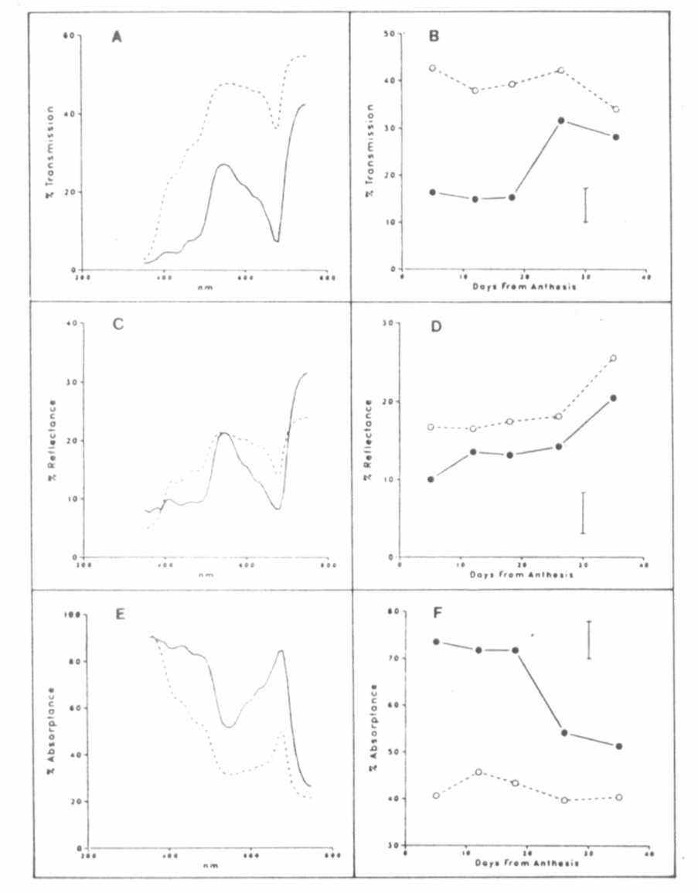
Fig. 1. A-Transmission spectra, C-Reflectance spectra, E-Absorptance
spectra (typical spectra are shown, these were replicated
three times). B, D, and F show the integrated area under
the transmission, reflectance, and absorptance curves from
400-700 nm against Days from Anthesis.
Key: Gp pods; gp pods.
The bars represent the Least Significant Difference at P 0.05.
PNL Volume 19 1987 RESEARCH REPORTS 47
the seed so that higher CO₂ and lower O₂ are found in the gp
pod (personal observation). Finally we have shown here that a
seed in a gp pod will also have a changed photo-environment which
may have photomorphogenic effects on seed development or on the
ability of the testa or cotyledon to produce photosynthetic meta-
bolites.
In conclusion, seeds in gp pods develop in a different nut-
ritional, gaseous, and photo-environment from those in Gp pods.
- Price, D. N., J. E. Hayward, and C. M. Smith. 1983. PNL
15:49-50.
- Loomis, W. E. 1965. Ecology 46(1&2):14-16.
*****

