PNL Volume 19 1987 RESEARCH REPORTS 45
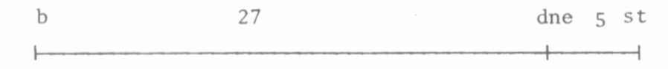
LINKAGE DATA FOR dne AND CHROMOSOME 3 MARKERS b AND st.

Murfet, I. C. Botany Department, University of Tasmania
Hobart 7001, Australia
Locus dne (die neutralis) was reported (1) to show strong
linkage with st but the relative position on chromosome 3 was not
established. F3 progenies have now been used to genotype 31
day-neutral (dne/dne) segregates from a cross between lines L31
(b Dne st) and K218 (B dne St) and to determine the constitution
of the gametes which united to form these F2 plants. The gamete
pool consisted of 42 gametes with genotype B dne St, 17 with
genotype b dne St, and 3 with genotype B dne st. This enables
construction of the following map relationships for chromosome 3:
The above method of determining the linkage relationships was
adopted because the F2 data gave no clear resolution of the
issue. The mutant allele dne had arisen in the repulsion phase
with markers B and St (see 1) and repulsion phase crosses are
grossly inefficient in dealing with close linkages (2). By
growing 16 F3 progeny from each F2 plant of genotype dne/dne
it was possible to ascertain with reasonable certainty the consti-
tution of the two gametes which united to form that F2 plant.
For example, if an F2 plant of genotype B/- dne/dne St/- gave in
F3 11 B/- dne/dne St/- and 5 b/b_ dne/dne St/- plants we can be
about 99% confident that it was homozygous St/St and its con-
stitution was 15 dne St/b dne St. Thus it was derived from one
grandparental type gamete and one gamete recombinant for loci b
and dne. In this way a profile of the dne sub-set of F1 gametes
could be established and the crossover values determined without
recourse to the Product Ratio or Maximum Likelihood methods.
- King, W. M. and I. C. Murfet. 1985. Ann. Bot. 56:835-846.
- Mather, K. 1963. The Measurement of Linkage in Heredity.
Methuen, London.

