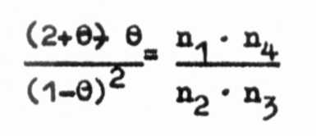
DETERMINATE GROWTH HABIT (det) IN PEAS: ISOLATION, SYMBOLIZATION,
AND LINKAGE

Makasheva, R. Kh. N. I. Vavilov Institute of Plant Industry
and A.. M. Drozd Leningrad, USSR

More than 26 genes are known to control stem characters in
peas, a considerable number of which have implications for
breeding. A mutant conferring a true determinate growth habit was
isolated after chemical mutagenesis and described in 1975 by
Popova (2). Popova's mutant regularly developed two reproductive
nodes, each with a maximum of two flowers and pods, at the top of
the stem.
Segregating populations indicated that the determinate habit
has recessive monogenic inheritance (Table 1), and the gene con-
trolling this character was previously designated as det (3).
An analysis to determine the localization of the new gene was
performed on data from four crosses. Evidence of linkage between
Tl and Det is shown in Table 2.
Estimates of linkage (Rf) intensity were calculated using the
formula:
where rq...^ are the observed frequencies of the XY, Xy, xY,
and xy classes. Linkage in repulsion is shown by 9=rf2 and in
coupling by 9=(l-rf)². Error estimate was calculated by the
formula:
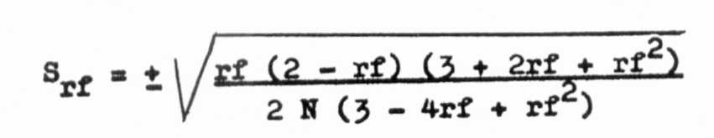
Estimates of linkage intensity in four crosses (Table 2)
were: 0.12, 0.07, 0.14, and 0.18, with an average of 11.1 + 1.1%.
Our results reveal that gene Det-det is located in linkage
group 7 at a distance of 11.1% from Tl tl.
Offspring from separate crosses segregating for smooth (R)
and wrinkled (r_) seeds confirmed the existence of strong linkage
between _r and det alleles reported by Marx (1); we found no plants
with determinate growth habit among the R offspring.
- Marx, G. A. 1986. PNL 18:45-48.
- Popova, I. A. 1975. Trudy po seleccii i semenowodstwu
owoshchnykh cultur VNIISSOC 3:66-72.
- Volchkov, Yu. A. 1986. Sbornic nauchnykh trudov po
pricladnoj botanike, genetike i selectii 101:46-48.
Cross
numberGenerationDet
Observed:det
ExpectedExpected
ratiox²544F2332 :119338:1133:10.42544F3310 :215328:1975:32.63542F2363: 99347 :1153:12.96
Table 1. Segregation for determinate stem growth (det) in
populations derived from two crosses in peas (5).
Table 2. Joint segregation between Tl_ and Det in progenies
from four crosses (3).
Cross no./  phenotypes | Mathematical  model 1/ | Segregation ratio  Observed Expected |  | x²
584  Tl - Det | 0.64 84 | 976 | 1033.5 | 3.13
Tl - det det | 0.1177 | 245 | 187.6 | 17.56
tl tl - Det | 0.1979 | 373 | 315.5 | 10.47
tl tl - det det | 0.0359 | 0 | 57.2 | 56.90
601  Tl - Det | 0.5808 | 355 | 390.9 | 3.30
Tl - det det | 0.1694 | 150 | 114.0 | 11.37
tl tl - Det | 0.1932 | 166 | 130.0 | 9.97
tl tl - det det | 0.0564 | 2 | 37.9 | 34.01
586  Tl - Det | 0.7395 | 556 | 581.0 | 1.16
Tl - det det | 0.1105 | 116 | 86.0 | 10.50
tl tl - Det | 0.1305 | 114 | 102.0 | 1.40
tl tl - det det | 0.0195 | 0 | 16.0 | 16.00
602  Tl - Det | 0.7080 | 375 | 385.2 | 0.27
Tl - det det | 0.0638 | 45 | 34.7 | 3.06
tl tl - Det | 0.2090 | 124 | 113.7 | 0.93
tl tl - det det | 0.0188 | 0 | 10.2 | 10.20
1/ Mathematical model is determined taking into account low
survival of recessive homozygotes in both genes.
*****

