BASES AND PROPOSALS FOR A MODEL IN CONNECTION WITH THE EARLY
PHYLLOMORPHOGENESIS OF PISUM SATIVUM

Lenz, J. Institute of Botany, University of Bonn
and H. W. Ingensiep Federal Republic of Germany

The advantages that leaves of various genotypes of P. sativum
show with regard to the application of morphogenetic models were
discussed previously (1). This article considers some concrete
proposals for a model of phyllomorphogenesis.
A general proposal for a morphogenetic model:
This model combines models for a biochemical pattern forma-
tion in reaction/diffusion systems with others, including the
theory of growing polyautomata. The cormus or one of its organs
is represented by the polyautomaton, and every one of the cells or
group of cells by a corresponding single automaton. Each single
automaton should be able to hold a discrete number of states. For
these and the transitions between them, the following entities are
supposed to be relevant: a) The state of activity of the genome
(given by the pattern of all active genes of the genome), b) The
positions of molecular switches (characterized by two or more
steady states). Irreversible transitions among them are normal.
They elicit a small apparent diffusion constant, which on the one
hand serve as effectors of regulator proteins within gene regula-
tion or on the other hand of allosteric enzymes within synthesis
of signal substances, c) The concentrations of the above-men-
tioned signal substances — they are synthesized via specific path-
ways. Generally they produce a high apparent diffusion constant
and can belong to complex reaction/diffusion systems. They influ-
ence essentially the positions of the molecular switches.
Transitions between the states of an automaton ought to be
understood as changes in the state of differentiation of the cor-
responding cell.
The main points during the development of the shape of the
plant, and above all that of the leaf, are to be found in the for-
mation of the apical tip meristems of the respective organs. The
temporal/spatial coordinated induction of these meristems ought to
be guaranteed by an hierarchic control, in connection with a
mutual communication of the meristems via signal substances. Des-
cendents of the particular meristems form subcompartments in which
certain processes of pattern formation can take place, which then
lead to the formation of new tip meristems.
The initiation of one of more meristems of the same kind may
take the following course. The concentration gradients of signal
substances of hierarchic superior meristems cross certain thres-
holds in a group of cells. Thereupon a molecular switch is turned
on in the cells concerned. This produces the synthesis of an
activator/inhibitor pair, by means of the activation of a gene
set. Hereafter, the activator forms a stable pattern of concen-
tration. In all cells in which the corresponding concentration is
above a threshold, the differentiation towards the tip meristem of
a new organ identity will be started. At the same time a signal
is synthesized there which, in certain surroundings, suppresses
the synthesis of the activator/inhibitor pair. In that way the
newly arisen meristems isolate themselves.
The position of such a meristem depends also on the geometry
of the organ primordium, because it co-determines the patterns of
concentration of the activators. By means of this mutual depen-
dence the space determines the pattern, and the latter, once ari-
sen, alters the space and the form emerges.
An application of the early phyllomorphogenesis of the wild-
type:
During the development of a wildtype pea leaf the following
hierarchy of participating meristems can be observed (Fig. 1):
- meristem of the shoot apex (shoot-tip-meristem=SM);
- tip meristem of the leaf axis (leaf-tip-meristem=LM);
- tip-meristem of the primordium of the stipule (stipule-
meristem=StM);
A) tip meristem of the leaflet/tendril primordium (leaflet/
tendril-meristem=LTM).
As to the model, the development of a leaf can be summarized
as follows:
The newly developed leaf primordium is first polarized in a
way that future meristems can only develop on its upper side. The
SM cooperates in this polarization. During the outgrowth of the
leaf primodium, produced by the activity of the LM, two StM's are
initiated. The StM's together with the LM determine the location
within the leaf primordium where the first two LTM's are initia-
ted. Generally the location at which a pair of LTM's is initiated
is fixed by the next older pair and the LM.
Pisum shows marked anisophylly. Successive leaves formed
during ontogeny become more ramified. The following mechanism is
supposed to be the molecular basis for the phenomenon:
At various nodes the initiation of new ramifications at a
leaf primordium is to be stopped at different points of time after
the formation of the leaf primordium. If the concentration of a
signal produced in the SM, the rate of production of which depends
on the number of already existing nodes, falls short of a certain
threshold in the LM, the furtherance of LTM's is interrupted
there. This occurs at each node at a later point of the develop-
ment of the leaf primordium.
Every leaf, independent of the number of ramifications,
usually shows the same number of leaflets and tendrils on eithei
side of the rachis (i.e. bilateral configuration). It can be sup-
posed that a signal from the LM decides if a leaflet or a tendril
will be developed. Wherever concentration of the signal falls
short of a specific threshold, leaflets will be developed, other-
wise tendrils. The production rate of the signal ought to depend
on the number of the ramifications in a way that the position of
the threshold will not be displaced in relation to the length of
the leaf primordium.
It is also imaginable that the development of leaflets is
predetermined, and once the concentration of the signal exceeds a
certain threshold, tendrils will be developed. The threshold con-
centration of the signal will usually be situated in an internodal
area of the leaf primordium. However, in case it is situated in
the area of a ramification pair, it might happen that on account
of differences in the state of development of the two ramifica-
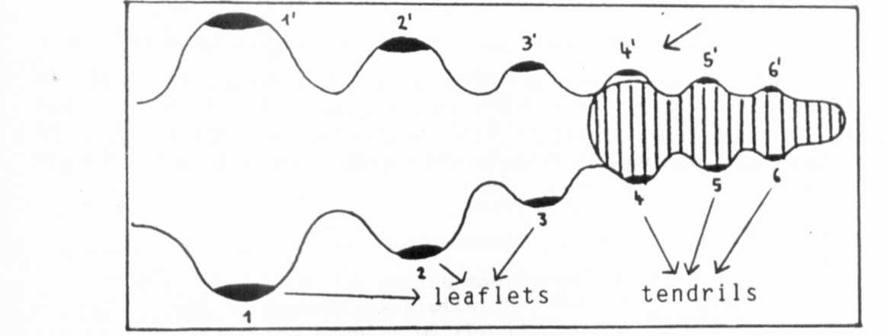
Fig. 2. Explanation of the induction of leaflet-tendril pairs because
of an asymmetric gradient: 4" is induced to become a leaflet
instead of a tendril.
tions or through fluctuations in the concentration gradient of the
signal; one of the two LTM's gets into the area of concentration
above the threshold and the other into the one beneath it. In
this way, a tendril/leaflet pair might develop at once and at the
same leaf nodium (Fig. 2).
Whether or not the series of molecular processes, as des-
cribed in the preceding paragraph, will lead to a certain form has
to be shown in a simulation of a diffentiated elaborated model.
An imaginable general starting point for such a model has been
introduced in the first paragraph. However, the translation of
such a starting point into a concrete model and its simulation
involves numerous theoretical and practical problems. In addi-
tion, quite a number of empiric studies, as well as a statistical
recording of the forms of leaves and their deviations (not pro-
duced by mutations), are necessary.
1. Ingensiep, H. W. 1986. PNL 18:67-68.
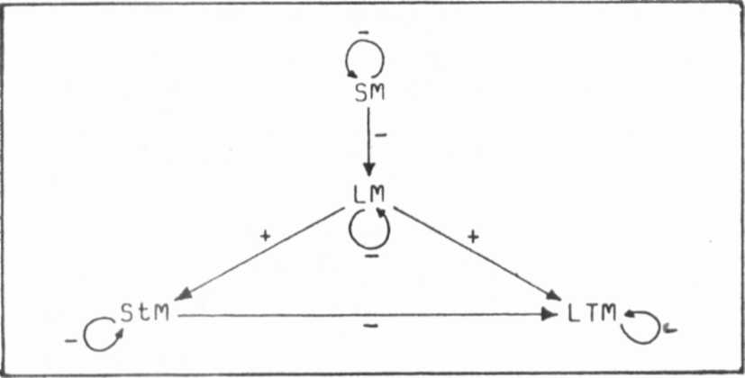
Interactions among the meristems during the development
of a leaf of Pisum sativum. + : Inhibition up to a
certain distance, furtherance from this distance on.
- : Inhibition up to a certain distance, no furtherance
from this distance on. (Further explanations in the text.)
Fig. 1
*****

