COMMENTS ON THE CHROMOSOME MAPS OF PISUM SATIVUM

Lamm, R. The Swedish University of Agricultural Sciences
Alnarp, Sweden

Recent investigations have revealed that earlier conclusions
concerning the identities of the interchange chromosomes of a
translocation tester set of Pisum were erroneous (4,11) . A new
case is L-111, 'Merton-l', earlier interpreted as a T(3-7) inter-
change (6) but in the present paper denoted as T(4-5)a. The
karyotype of L-lll (cf. Fig. 1) deviates from the normal type by
an exchange of the short arms of chromosomes 4 and 5 with proximal
locations of the T-points. Giemsa C-banded mitotic metaphase
plates of L-lll confirm this interpretation.
From the configurations observed at meiotic M I of the F1
hybrids L-84 x L-111, L-112 x L-84, and L-111 x L-112 (12,2), it
may be concluded that the interchange of Winge's L-112 is of the
type T(3-4). In L-108, one of the SAT-chromosomes is involved
(4), the other partner being easily recognized as chromosome 2
(10). In the F1 hybrids L-108 x L-111 and L-108 x L-112, two
rings of four are developed at M I of meiosis (12) . Hence the
interchange of L-108 corresponds to the structure T(2-7) . On the
basis of these new results the structures of the translocations in
eight lines of the tester set are given in Table 1 below.
Table 1. Interpretations of interchanges in the lines of a trans-
location tester set in Pisum.
L-110 | Roi des gourmands N-type. | L-83 | Extra Rapid N IV | T(3-5)b.
L-114 | Nilsson's N I T(l-2)a. | L-84 | Hammarlund's K-line | T(3-6)a.
L-180 | Nilsson's N III T(l-5)a. | L-112 | Winge | T(3-4)a.
L-108 | Nilsson's N II T(2-7)a. | L-lll | Merton 1 | T(4-5)a.
Analysis of the configurations at meiotic M I of the 28 pos-
sible F1 hybrids among these eight lines has confirmed the
structures given in Table 1 (12,2). More drastic interchanges can
be discerned reliably only in a few interchange lines of Pisum.
One of these lines, L-4, produced by Ezhova and Gostimski (1) is
obviously of the type T(1S-3S) . Thus a ring of six at M I of
meiosis of the F1 hybrid between L-4 and L-21 is in agreement
with the new interpretation of L-112 (Table 1) . The structures of
L-21 and L-112 are identical (6). This is a further proof of the
localization of the genes Gp and R in chromosome 3 (cf. Fig. 1) .
The tentative chromosome maps of Fig. 1 demonstrate the ap-
proximate locations of the T-points (arrowed) and the loci of
neighboring marker genes connected by strong linkage with these
T-points. It may appear peculiar that the genes B and St of
chromosome 5 are joined by linkage (5) but this is explained by
the rare formation of chiasmata in the interstitial segment be-
tween the centromere and the T-point of L-83 in the 5L arm (cf.
Fig. 1). In contrast the chiasma frequency is high in the long
interstitial segment proximal to the T-point of L-112 in chromo-
some 3. This explains the weak but significant linkage between
this T-point and the gene Gp_ (12,5). In Fig. 2D the interstitial
chiasma of the F1 hybrid of L-112 x L-488 has been formed in
this segment.
A valuable complement to the translocation tester set was
obtained by Klein's L-488, characterized by two interchanges, of
which one isolated as my L-88 (8) apparently is a T(4L-7S) inter-
change (14) whereas the other, earlier denoted as T(2-3) (8),
should probably rather be T(l-5)b with proximal points of inter-
change. Configurations resulting from crosses between L-488 and
members of the original tester set are illustrated by the meiotic
photos of Fig. 2, and are also listed in Table 2.
Table 2. Maximum configurations in PMCs at M I of meiosis in F1 hybrids
between L-488, T(l-5)b + T(4-7)a and lines of a translocation
tester set in Pisum sativum.
No. of configurations % Sterile
 | Biva- |  | Rings | of |  | gametes
Parental lines | lents | four | six | eight | male female |  | References
L-110, Normal x L-488 | 3 | 2 | 0 | 0 | 70 | 69 | Fig. 2A
L-488 x L-114, T(l-2)a | 2 | 1 | 1 | 0 | 78 | 80 | (7)
L-488 x L-180, T(l-5)a | 3 | 2 | 0 | 0 | 73 | 76 | Fig. 2B
L-488 x L-108, T(2-7)a | 2 | 1 | 1 | 0 | 72 | 81 | Fig. 2C
L-488 x L-83, T(3-5)b | 2 | 1 | 1 | 0 | 81 | 80 | (7)
L-112, T(3-4)a x L-488 | 2 | 1 | 1 | 0 | 72 | 78 | Fig. 2D
L-488 x L-84, T(3-6)a | 1 | 3 | 0 | 0 | 79 | - | (7)
L-488 x L-91, T(3-6)a | 1 | 3 | 0 | 0 | 75 | 77 | Fig. 2E
L-lll T(4-5)a x L-488 | 3 | 0 | 0 | 1 | 74 | — | Fig. 2F
The coordination between chromosomes and marker genes sug-
gested by my results is illustrated by the tentative chromosome
maps of Fig. 1. The cytogenetical investigations of L-83, L-84,
L-91, and L-112 lead to the conclusion that the Fs_, Gp_, and R
genes generally assigned to chromosome 5 are actually located in
chromosome 3 whereas the B and St genes earlier assigned to
chromosome 3 in view of the results in L-83, L-lll, and L-180
rather reside in chromosome 5. Hence a revised linkage map of
chromosome 5 (3) should probably be applied to chromosome 3.
There is strong linkage between Le and V and the T-point of
Lamprecht's L-58, 'Graues Posthornchen' (13) . In the transloca-
tions of L-58 and L-114 the same chromosomes, 1 and 2, are in-
volved (9). Unfortunately, my earlier interpretation of the
interchange of L-58 was wrong (4) and new considerations suggest
that the genes involve viz. Le and V are located in the 1S arm.
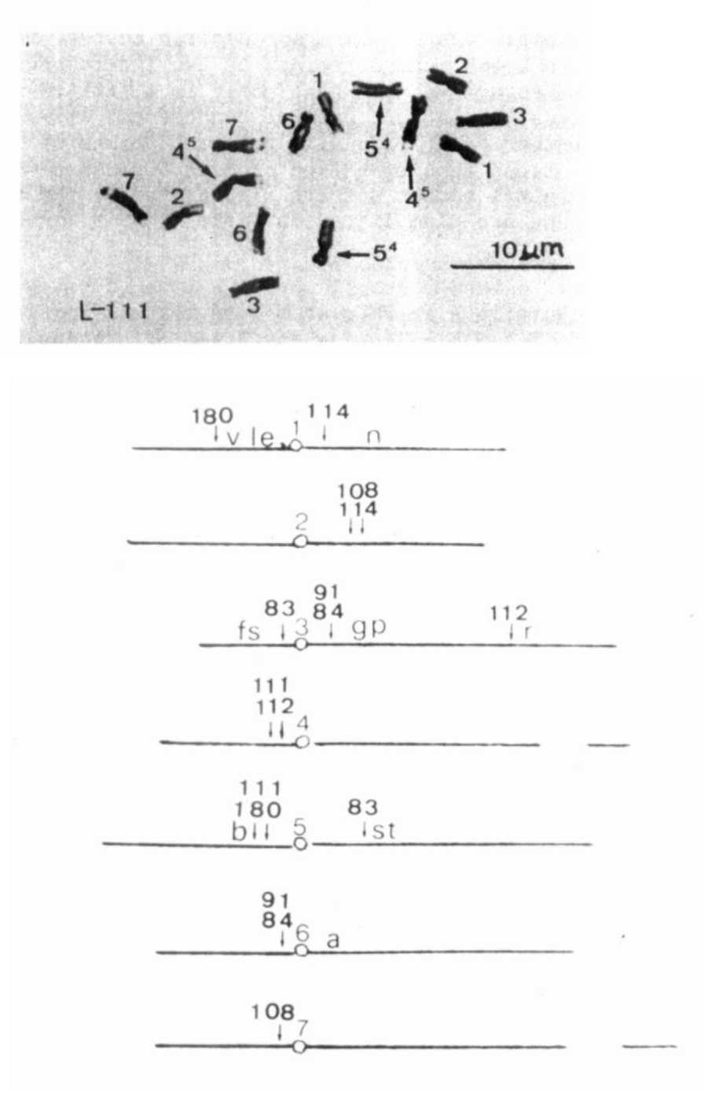
Fig. 1. At the top of this Fig.: Metaphase oi mitosis in
a root tip of L-lll, Merton 1, T(4-5)a. Below:
Tentative chromosome maps with arrows indicating
the approximate positions of T-points in relation
to centromeres and neighboring marker genes.
PNL Volume 19
1987 RESEARCH REPORTS
23

If it could be shown by further studies that my hypothesis
concerning the T(l-5)b interchange of L-488 were true and also
that significant linkage relations between this T-point and genes
of the chromosomes involved, e.g. Le, B, and St, could be
established this would mean an important support for the new
chromosome maps of Fig. 1. Apart from this, the creation of new
reliable chromosome maps will require collection and cytogenetical
investigations of new suitable translocation lines.
The current generally accepted gene maps of Pisum have been
illustrated on the cover of the Supplement to PNL Vol. 9, 1977.
The coordination between chromosomes and marker genes of this map
and the tentative maps on Fig. 1 of the present article is rather
contradictory. From investigations in progress intended to be
finished in the autumn of 1987 new information is expected, which
will render new facts and contribute to a critical estimation of
the results illustrated by Fig. 1.
- Ezhova, T. A. and S. A. Gostimski. 1980. PNL 12:10.
- Folkeson, D. 1984. Hereditas 101:119-121.
- Folkeson, D. 1985. PNL 17:14-15.
- Folkeson, D. 1985. PNL 17:15-16.
- Lamm, R. 1948. Hereditas 34:280-288.
- Lamm, R. 1974. PNL 6:29.
- Lamm, R. 1978. PNL 10:31-32.
- Lamm, R. 1981. Hereditas 94:45-52
- Lamm, R. 1982. PNL 14:32-35.

- Lamm, R. 1983. PNL 15:33-35.
- Lamm, R. 1986. PNL 18:34-36.
- Lamm, R. and R. J. Miravalle. 1959. Hereditas 45:417-440
- Lamprecht, H. 1949. Agri Hort. Genet. 7:85-95.
- Wolff, G. 1986. PNL 18:64-66.

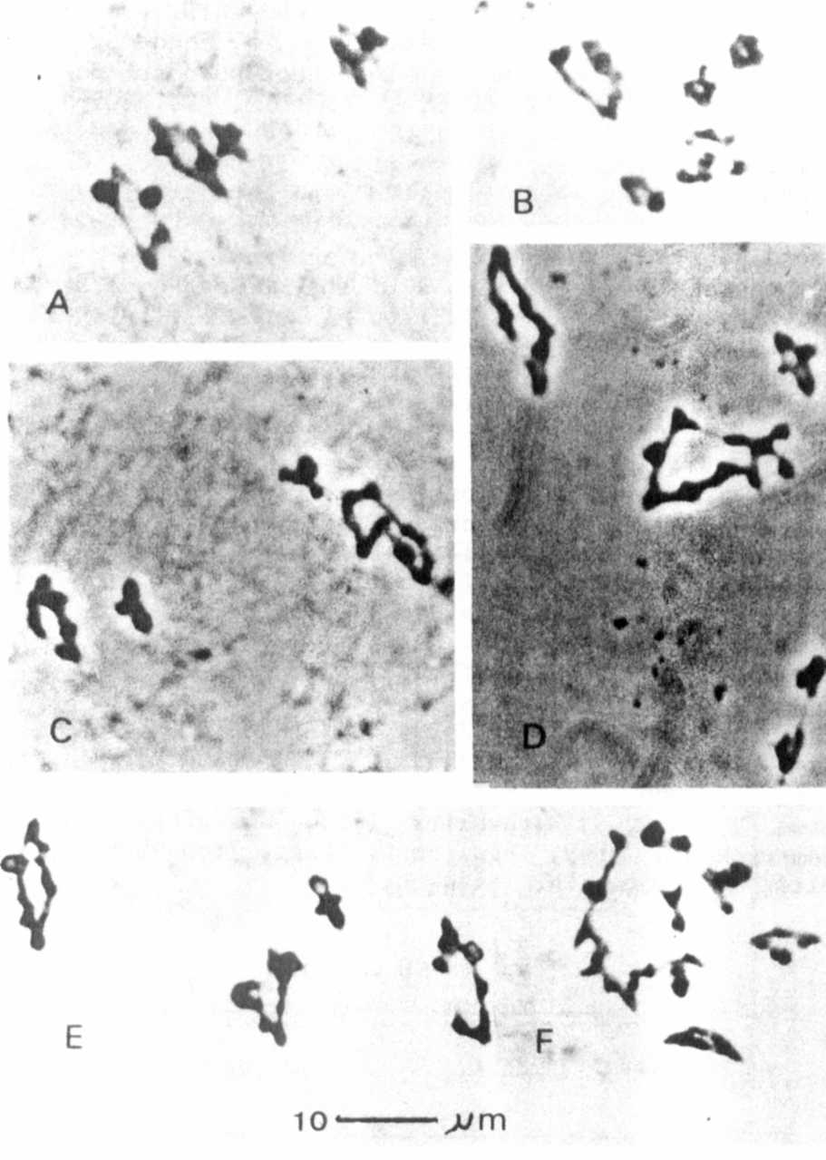
Maximum configurations at H I of meiosis in PMCs
From F1 hybrids between Klein's L-488, T(l-5)b+
T(4-7)a, and six members of a translocation tester
set (cf. Table 2), the T(l-5)b translocation so far
being hypothetical. Partner in crosses with L-488:
A, L-11O, normal structure; B, L-180, T(l-5)a;
C, L-108, T(2-7)a; D, L-112, T(3-4)a; E, L-91,
T(3-6)a; F, L-lll T(4-5)a. The rings of four in C
and D represent the assumed T(l-5)b translocation.
*****
PNL Volume 19 1987 RESEARCH REPORTS

