PNL Volume 19 1987 RESEARCH REPORTS
18

SOMATIC EMBRYOGENESIS IN PEA
Kysely, W. and H.-J. Jacobsen Institute of Genetics
University of Bonn, D-5300 Bonn 1
Federal Republic of Germany

Whole plant regeneration via somatic embryogenesis was ob-
tained in pea using explants from immature embryos or shoot apex
segments. Explants were placed on medium supplemented with MS
salts (3), B5 vitamins (1), 3% sucrose, and 0.7% Phytagar (Gibco).
Among auxin treatments, picloram and 2,4-D at 4.0 mkM in the ab-
sence of any cytokinin were most efficient for producing somatic
embryos. After 25 to 35 days in culture, somatic embryos of dif-
ferent sizes could be observed on explants from immature embryos
and shoot apex segments (Fig. 1,2). The level of auxin necessary
for the induction of somatic embryos apparently prevented further
development of young embryo stages and also repressed the germina-
tion of fully-developed embryos. Consequently, somatic embryos
were transferred to a medium with only cytokinin (1.0 mg/l BAP) or
with cytokinin in combination with a reduced auxin concentration
(0.05 mg/1 NAA and 0.017 each of BAP, kinetin, and zeatin) (Fig.
3). Somatic embryos were obtained from immature zygotic embryos 2
to 9 mm in length. More data are presented in a paper published
elsewhere (2).
Generally somatic embryos arise from the callus derived from
embryogenic axes of zygotic embryos but can also develop directly
from the cotyledon without an intervening callus phase. Somatic
embryos from shoot apex cultures obviously emerge from the main
and axillary shoot meristem regions.
Figs. 4a,b show longitudinal sections of a mature somatic
embryo with a well-defined shoot meristem with leaf primordia
(Fig. 4a) and a root meristem (Fig. 4b). The meristems are con-
nected by procambium strands.
The results obtained so far indicate that there are genotypic
differences in frequency of somatic embryogenesis from immature
embryos and shoot apices, thus indicating that the ability to form
somatic embryos is a quantitative rather than a qualitative trait.
- Gamborg, 0. L., R. A. Miller, and K. Ojima. 1968. Exp.
Cell Res. 50:151-158.
- Kysely, W., J. R. Myers, P. A. Lazzeri, G. B. Collins, and
H.-J. Jacobsen. Plant Cell Rep. (submitted).
- Murashige, T. and F. Skoog. 1962. Physiol. Plant. 15:
473-479.

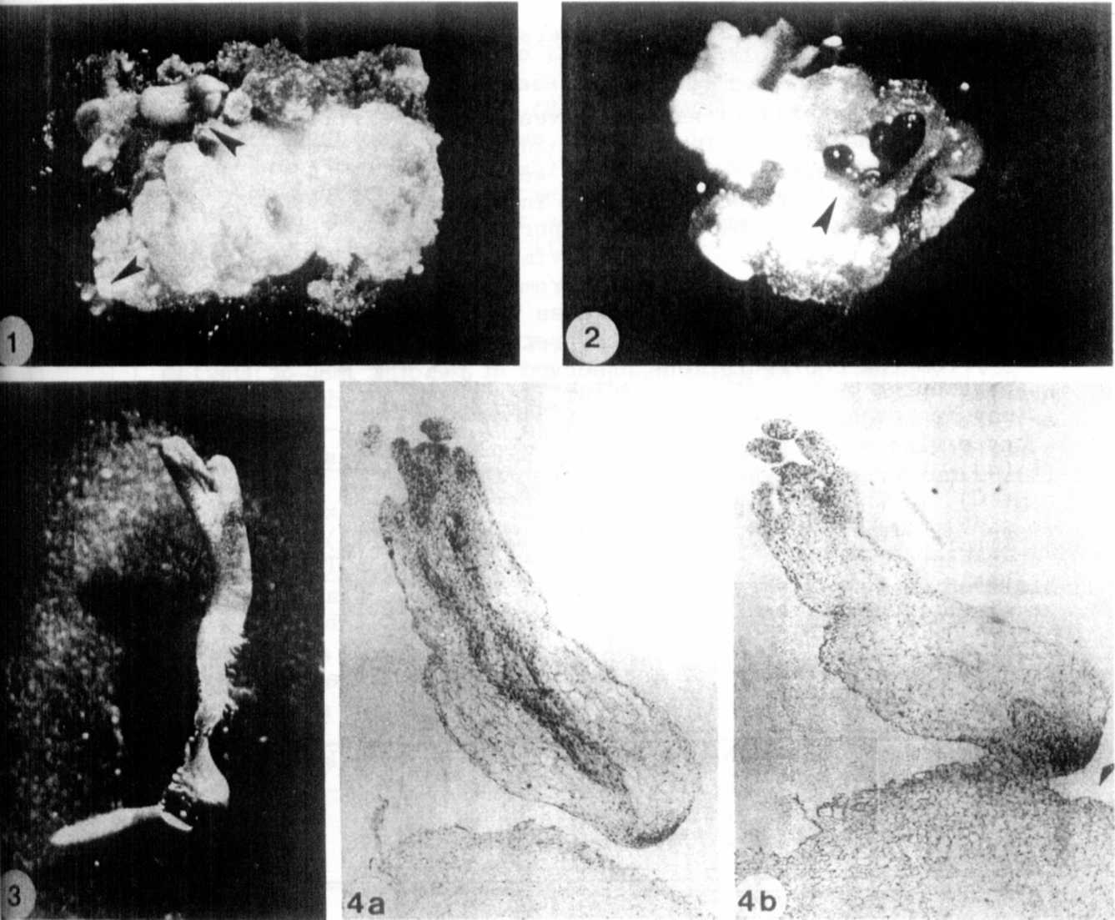
Fig.1. Somatic embryos from immature embryo culture of
genotype R 4111, induced on medium with 4.0 mkM
Picloram.
Fig.2.Somatic embryos from a shoot apex culture of genotype
P. sativum var. arvense, induced on medium with
4.0 mkM Picloram.
Fig.3. A germinating somatic embryo of P. sativum var.
arvense on medium with 1.0 mg/l BAP.
Fig.4. Longitudinal sections of a mature somatic embryo of P_. sativum var. arvense, induced on medium with
0.2 mkM Picloram. Sections were stained with Haeomatoxy-
lin.
aSection demonstrates the shoot meristem with leaf
primordia and procambium strands,
bSection showing the root meristem.
* * * * *

