THE MUTATIONS AF1LA AND ACACIA IN CONNECTION WITH A MODEL FOR THE
EARLY PHYLLOMORPHOGENESIS OF PISUM SATIVUM
Ingensiep, H. W. Institute of Botany, University of Bonn
and J. Lenz Federal Republic of Germany
In a related article (2), proposals for a general model for
plant morphogenesis were summarized. Applications of these propo-
sals were also suggested. We now wish to apply these models to
certain leaf mutations of Pisum. Specifically, we wish to examine
the following question: is it possible to integrate the mutations
afila and acacia into the phyllomorphogenesis model described?
The afila mutation is distinguished from the wild-type by: a)
the number of ramifications per leaf is distinctly increased; b)
the distance between the first ramification and the base of the
leaf is greater; c) only tendrils are formed. These deviations
have their origin in the mutation of only one gene. Fig. 1 shows
schematically an afila leaf.
Since a single gene is responsible for the transition from a
normal leaf to an afila leaf, one has to search for the deviation
of a certain gene product of a kind which produces a series of
causal events, with the altered form of leaf at its end. Follo-
wing is a proposal for such a mechanism; the model assigns an
isolation factor for the formation of leaflet/tendril meristems
(LTM's). With the formation of a new pair of LTM's a signal is
synthesized which suppresses the formation of more LTM's in a
certain area. It is supposed that afila sharply reduces the
synthesis of the signal (e.g. through an enzyme defect). Conse-
quently the LTM's no longer hinder each other and therefore no
longer develop by pairs in intervals, but in a greater number and
in compact form (deviation a). Wherever a new meristem arises, a
new auxin source is added to the leaf primordium. This affects
the extension of growth, especially that of the basic leaf inter-
node (deviation b). Furthermore, it is assumed in the model that
a signal from the leaftip meristem (LM) determines whether a rami-
fication leads to a leaflet or to a tendril. The number of rami-
fications determines the production rate of the signal . Where the
concentration is above a specific threshold, tendrils develop,
otherwise leaflets. Because afila elicits more ratifications, the
production rate of the signal is also higher than that of the
wild-type. Thus, the threshold is shifted so far in the direction
of the base of the leaf primordium that all ramifications form in
the area of the tendril determination (deviation c).
As to the mutation acacia, there are no tendrils; otherwise,
the leaf habit is similar to that of the wild-type (Fig. 2). In
order to reconcile this deviation with the model, it is supposed
that the signal that decides whether leaflets or tendrils are
formed will not be synthesized in the LM (e.g. because of an en-
zyme defect). Thus, its concentration along the leaf primordium
remains under the threshold and only leaflets develop.
Fig. 3 depicts the hypothetical mechanisms and shows the
starting points for the mutations leading to the genotypes afila
and acacia.
If one combines the mechanisms which lead to the deviations
PNL Volume 19 1987 RESEARCH REPORTS

at afila and acacia, a form of leaf arises which shows numerous
ramifications and lengthened leaf internodes, as well as leaflets
only. Such a leaf form corresponds to that of the recombinant
afila/acacia. However, the leaflets of this recombinant, compared
with those of the wild-type and those of acacia, respectively, are
very small. The model does not yet account for this and other
characteristics.
This can only be considered as a first attempt to integrate
the mutations afila and acacia into the phyllomorphogenetic model.
A number of leaf mutations, e.g. apulvinic and cochleata, cannot
be explained on the basis of the hypothetical mechanisms presen-
ted. Perhaps, however, the speculations will supply us with new
starting points for questions of an experimental and theoretical
kind.

- Ingensiep, H. W. 1986. PNL 18:67-68.
- Lenz, J. and H. W. Ingensieg. 1987. PNL 19:25.

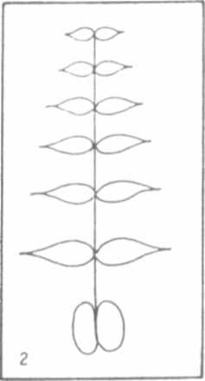
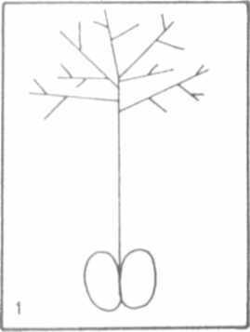

Fig. 2. Schematic of an acacia leaf.
Schematic of
an afila leaf.
Fig. 1.

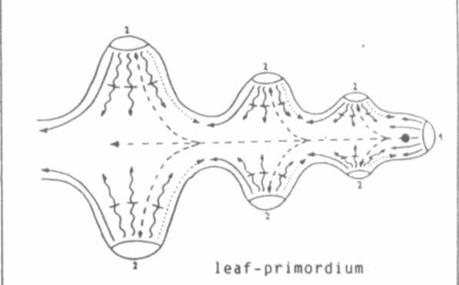

Some basic mechanisms during phyllomorphogenes is and
starting-points for the mutations afila and acacia.
leaf-tip meristem
leaflet/tendril meristem
signal which isolates LTM's
signal which promotes the synthesis of the following signal
signal which decides whether leaflets or tendrils are to be formed
auxin
starting-point of the mutation afila
starting-point of the mutation acacia
Fig. 3




