70
PNL Volume 18 1986 SUPPLEMENTARY LINKAGE DATE

Supplementary Linkage Data

In connection with an ongoing investigation, I acquired the following
segregation data from a three point cross: n Z was x N z Was, which cor-
roborate the order and approximate distances of the three loci as indicated on the present linkage map.
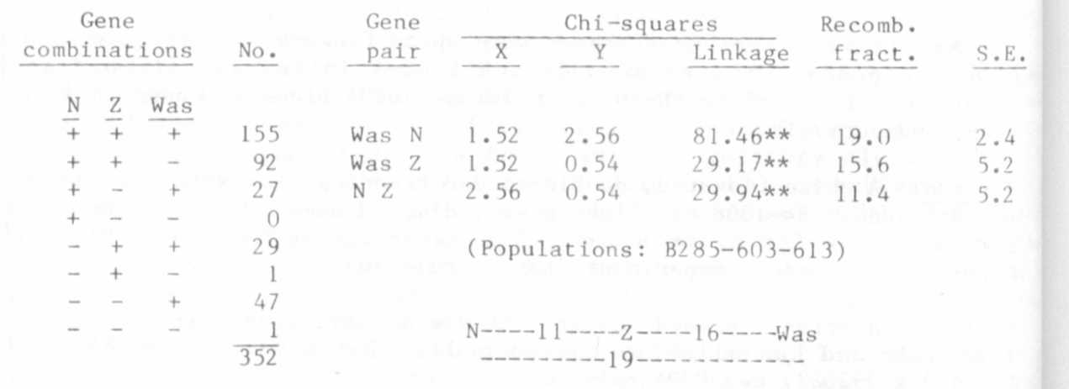
Relevant references for this group:

Lamm, R. 1957. Hereditas 43:541-548.
Lamprecht, H. 1945. Hereditas 31:347-382.
Lamprecht, H. 1955. Agri Hort. Genet. 13:37-84.
Lamprecht, H. 1958. Agri Hort. Genet. 16:9-37.
Lamprecht, H. 1961. Agri Hort. Genet. 19:360-401

G. A. Marx

*****

