medicagini var. pinodella grown on potato dextrose agar containing this
compound. Future studies are planned to map this gene and further quantify
the concentration and chemical properties of this pigment.

1. Fedotov, U. S. 1935. Trudy prikl. botanike, genetike: selektsii,
1935 (1936). Ser. 2.9, 163-174.
2. Fedotov, U. S. 1935. Trudy prikl. botanike, genetike: selektsii,
1935 (1936). Ser. 2.9, 275-286.
3. Kajanus, B. 1913. Fuhlings London Zeit. 62:153-160.
4. Lamprecht, H. 1937. Heredltas 23:91-98.
5. Lamprecht, H. 1948. Agrl Hort. Genet. 7:134-153.
6. Lamprecht, H. 1956. Agri Hort. Genet. 14:19-33.
7. Lamprecht, H. 1958. Agri Hort. Genet. 16:49-53.
8. Lock, R. H. 1904. Ann. Roy. Bot. Garden Peradenlya 2:299-356.
9. Loennig, W. E. 1985. PNL 17:40-47.
10. Vilmorin, Ph. De. 1913. Proc. 4 Intl. Conf. Genet., Paris, 1911, pp
368-372.
11. White, 0. E. 1917. Proc. Amer. Phil. Soc. 56:487-588.
12. Winge, 0. 1936. C. R. Lab. Carlsberg, Copenhagen. Ser. Physiol
2 1:271-393.

*****

1/
THE EFFECT OF THE GENOTYPE ON IN VITRO ROOTING OF PEA SH00TS

Cardi, T. and E. Filippone C.N.R., Centro Studi Miglioramento
Genetico Ortaggi, Portici, Italy

In order to investigate the effect of the genotype on in vitro rooting
ability in peas an experiment was performed using nine genotypes showing
wide variability for growth behavior in vivo.
Shoots were obtained by culturing the buds of the cotyledonary node as
described earlier (3); the production of shoots was examined every week.
The number of transplantable shoots (i.e. 10-15 mm long) produced per bud
and the rate of production varied widely in the genotypes tested. P.
fulvum (JI 224) did not produce any transplantable shoots. Shoots were
induced to form roots on Murisighe Skoog half strength, sucrose 10g/l,
activated charcoal 2g/l, CaCl2 220 mg/1, agar 8g/l, pH 5.7-5.8 (3) in a
growth chamber at 24C and I6h light. The formation of roots, number of
roots formed per shoot, and shoot length were scored after five weeks.
A significant effect of the genotype (X =48.26 P<0.001) on the per-
centage of rooted shoots was found (Table 1). The rooting ability of pea
shoots seemed to decrease progressively in those regenerated from buds
cultured for a longer time, probably as a consequence of the residual effect
of IBA present at high concentration (5mg/l v. lmg/1 of IBA) in the medium
we used for bud culture. These results agree with those reported by other
authors (4,5). Moreover, it is noteworthy that in other experiments per-
formed in our laboratory the cuttings obtained in absence of any hormone
always rooted much more easily.

Table 1. In vitro rooting ability of different genotypes

1/ X² = 48.26 P<0.001
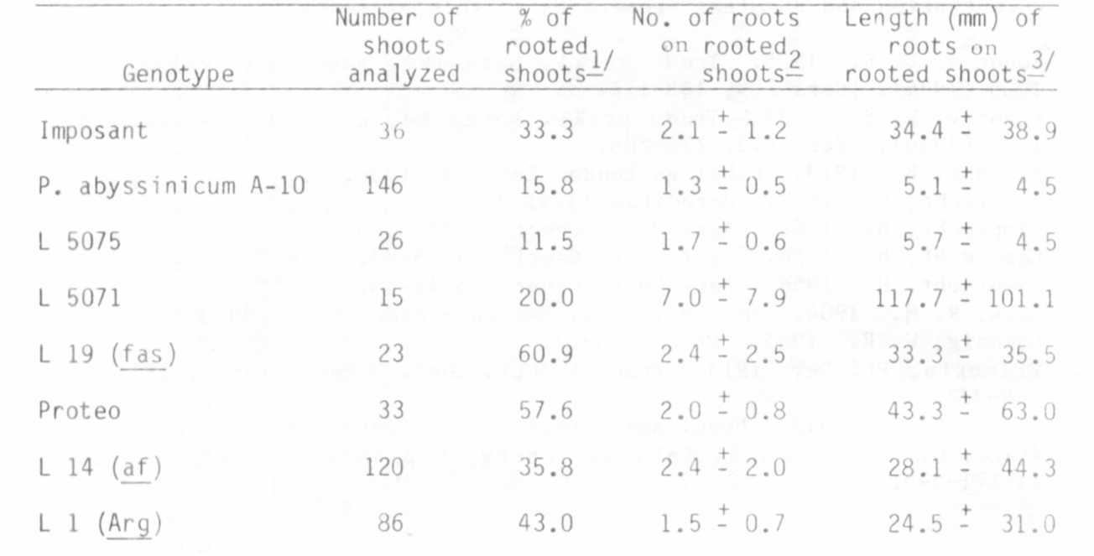
2/Both principal and lateral roots were considered
3/ Mean +/- S.D.

As concerns the number of roots per shoot, and their length, a very
high variability within genotype was found (Table 1) and it was still
present when a separate analysis within each week of bud culture was per-
formed for every genotype (Tables 2,3). As far as the number of roots
formed in each pea cutting is concerned, other authors also reported a
considerable variation (1,2). An effect of the duration of bud culture was
not found for either trait (Tables 2,3).

1. Eliasson, L. 1981. Physiol. Plant. 51:23-26.
2. Eliasson, L. and K. Areblad. 1984. Physiol. Plant. 61:293-297.
3. Filippone, E. 1985. PNL 17:12.
4. Hu, C. Y. and P. J. Wang. 1983. Handbook of Plant Cell Culture,
Vol. 1. (Evans, D. A., Sharp, W. R., Ammirato, P.V., and Yamada, Y.,
eds.). pp 177-227.
5. Kartha, K. K., 0. L. Camborg, and F. Constabel. 1974. Z.
Pflanzenphysiol. 72:1 72-1 76.

1/ Contribution no. 18 from Centro di Studio per il Miglioramento Genetico degli Ortaggi - C.N.R. - Portici (Napoli) - Italy

PNL Volume 18 1986 RESEARCH REPORTS
4

Table 2. Number of roots in rooted shoots (mean - S.D.).
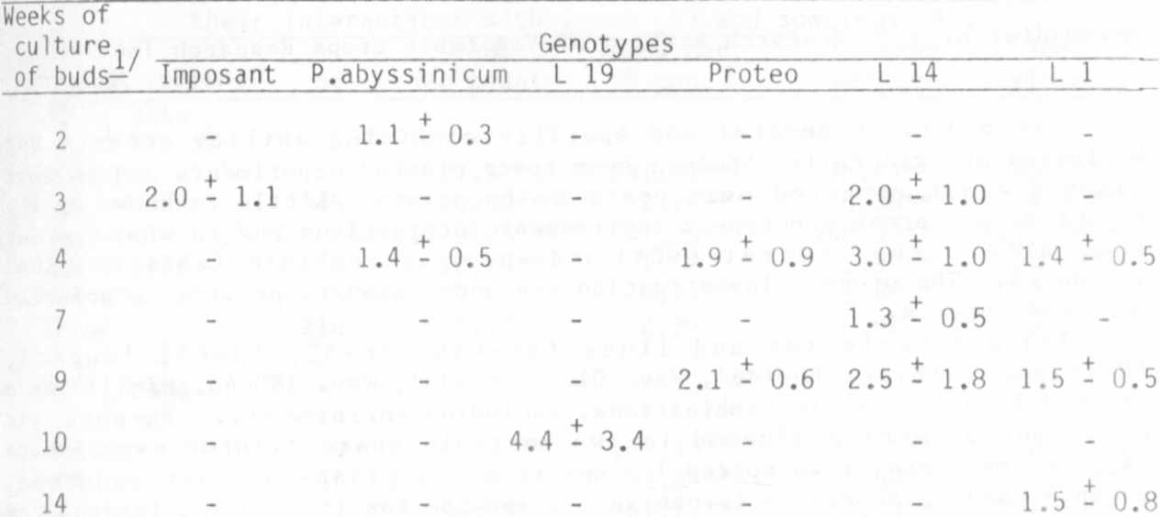

-Only the weeks in which it was possible to analyze at least five shoots per
genotype are reported.

Table 3. Length of roots (in mm) in rooted shoots (Mean - S.D.).
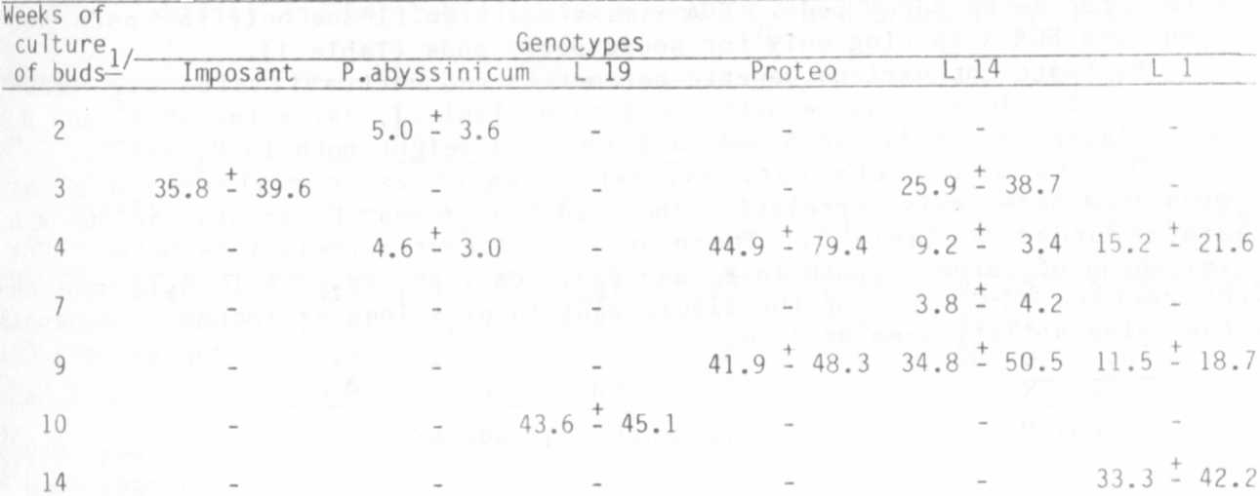

1/ Only the weeks in which it was possible to analyze at least five shoots per
genotype are reported.

