TENTATIVE DESCRIPTION OF THE put GENE WHICH CONDITIONS DARK PURPLE TESTA IN
PEAS

Bland, M., D. L. Auld, M. J. Dial, and J, C. Crock
University of Idaho, Moscow, ID USA
st
The dominant gene U produces a uniformly purple testa, its allele U
a purple-striped testa (1,4,10). Purple spots caused by F, Fs, or F Fs
sometimes coalesce to give a uniformly dark violet testa (3,5,8,11,12).
The phenomenon has been termed obscura and the expression is influenced by
environmental factors (6,7,9); it has been impossible to isolate lines that
breed true for the trait although it may have a genetic basis (6,7).
In the fall of 1978 a spontaneous mutant (S-35) was found in the
cultivar 'Fenn' which produced a solid purple colored testa in all seeds
from the original plant and all subsequent progeny. Fenn is dominant for
the A gene for anthocyanin production and the seedcoats are purple
speckled. Reciprocal crosses were made between S-35 and four cultivars:
Fenn, 'Melrose', 'Romack', and 'Garfield'. Both Melrose and Romack carry
the A gene but Melrose has speckled and mottled seed while Romack has a
light tan seed coat. Garfield is recessive at the A locus, i.e. a/a.
Crosses were made and the F1 generation was thrown in the greenhouse in
1980. The F2 generation was analyzed in separate evaluations in 1981 and
1985.
F2's of crosses with Fenn and Melrose showed a good fit to a 3:1
phenotypic ratio, indicating the dark purple testae observed in S-35 were
conditioned by a single recessive gene (Table 1). The 1985 F2 of S-35 x
Melrose failed to fit a 3:1 F2 ratio. The 82 plants in this population
came from two F2 families. when 2^ families were analyzed separately, one
of the families fit a 3:1 ratio whereas the other showed a slight
deficiency of plants with self-purple testae. The crosses of S-35 with
Romack showed a poor fit to a 3:1 but fit a 13:3 with low X-sq values. This
possibly indicates that the expression of put (tentative symbol for purple
testa) may be dependent upon the presence of the dominant genes F or Fs but
the results may simply be due to chance variation. The crosses with
Garfield fit a 9:4:3 F2 phenotypic ratio which showed that the expression
of put required the dominant A gene, necessary for anthocyanin production.
(Presumably Garfield carried F, Fs, or F Fs which was not expressed due to
the lack of the A gene.).
Additional crosses were made with the type lines WL741 (U-st) and WL582
(U) for allele testing. WL658 was also used as a parent in crosses. As
expected where dominant and recessive alleles condition a similar
phenotype, the recessive gene put was shown to be a separate unlinked gene
and not an allele of U (Table 1). No epistatic interaction was noted in
those seed which carried both genes (put and U) which condition purple
testa.
In separate preliminary studies, the pigment produced by put was shown
by thin layer chromatography to be chemically similar to that found in
Fenn. However, the compound conditioned by put occurs at several times
greater concentration than the compound found in Fenn. This anthocyanin-
like compound was also shown to have a very fungistatic effect on Phoma

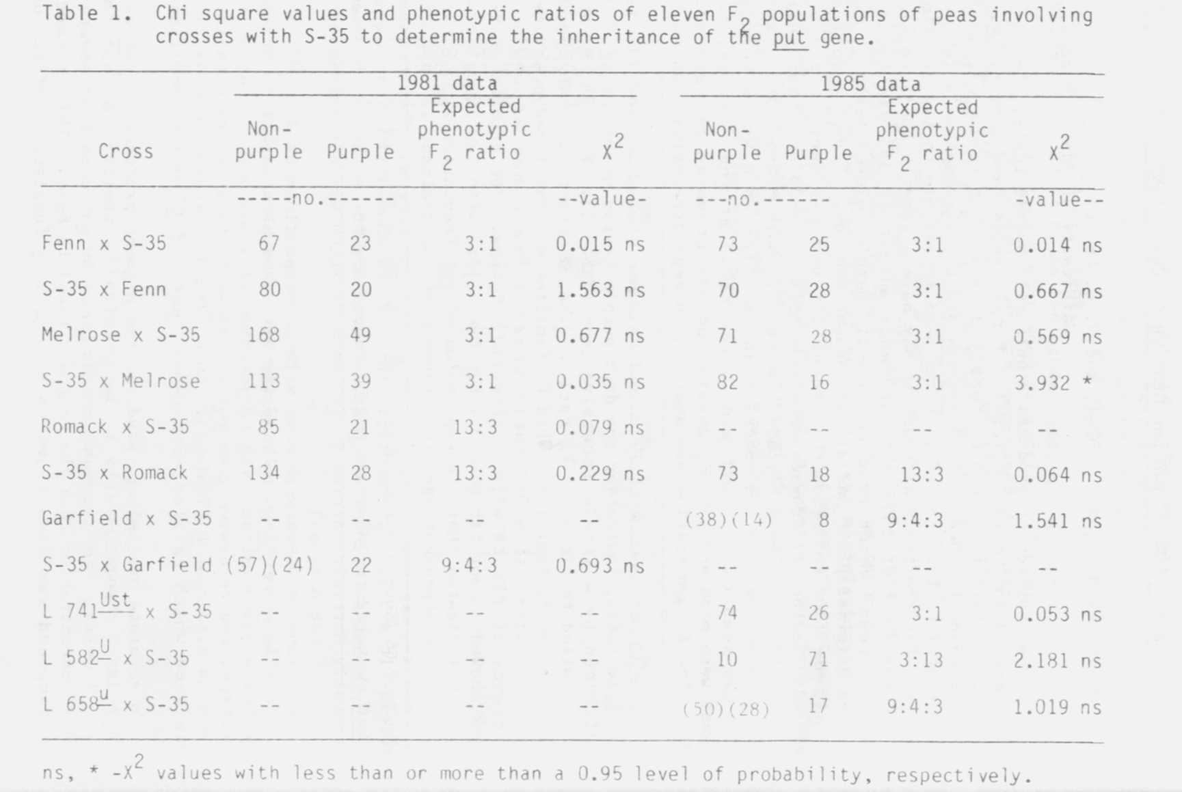
medicagini var. pinodella grown on potato dextrose agar containing this
compound. Future studies are planned to map this gene and further quantify
the concentration and chemical properties of this pigment.

1. Fedotov, U. S. 1935. Trudy prikl. botanike, genetike: selektsii,
1935 (1936). Ser. 2.9, 163-174.
2. Fedotov, U. S. 1935. Trudy prikl. botanike, genetike: selektsii,
1935 (1936). Ser. 2.9, 275-286.
3. Kajanus, B. 1913. Fuhlings London Zeit. 62:153-160.
4. Lamprecht, H. 1937. Heredltas 23:91-98.
5. Lamprecht, H. 1948. Agrl Hort. Genet. 7:134-153.
6. Lamprecht, H. 1956. Agri Hort. Genet. 14:19-33.
7. Lamprecht, H. 1958. Agri Hort. Genet. 16:49-53.
8. Lock, R. H. 1904. Ann. Roy. Bot. Garden Peradenlya 2:299-356.
9. Loennig, W. E. 1985. PNL 17:40-47.
10. Vilmorin, Ph. De. 1913. Proc. 4 Intl. Conf. Genet., Paris, 1911, pp
368-372.
11. White, 0. E. 1917. Proc. Amer. Phil. Soc. 56:487-588.
12. Winge, 0. 1936. C. R. Lab. Carlsberg, Copenhagen. Ser. Physiol
2 1:271-393.

*****

1/
THE EFFECT OF THE GENOTYPE ON IN VITRO ROOTING OF PEA SH00TS

Cardi, T. and E. Filippone C.N.R., Centro Studi Miglioramento
Genetico Ortaggi, Portici, Italy

In order to investigate the effect of the genotype on in vitro rooting
ability in peas an experiment was performed using nine genotypes showing
wide variability for growth behavior in vivo.
Shoots were obtained by culturing the buds of the cotyledonary node as
described earlier (3); the production of shoots was examined every week.
The number of transplantable shoots (i.e. 10-15 mm long) produced per bud
and the rate of production varied widely in the genotypes tested. P.
fulvum (JI 224) did not produce any transplantable shoots. Shoots were
induced to form roots on Murisighe Skoog half strength, sucrose 10g/l,
activated charcoal 2g/l, CaCl2 220 mg/1, agar 8g/l, pH 5.7-5.8 (3) in a
growth chamber at 24C and I6h light. The formation of roots, number of
roots formed per shoot, and shoot length were scored after five weeks.
A significant effect of the genotype (X =48.26 P<0.001) on the per-
centage of rooted shoots was found (Table 1). The rooting ability of pea
shoots seemed to decrease progressively in those regenerated from buds
cultured for a longer time, probably as a consequence of the residual effect
of IBA present at high concentration (5mg/l v. lmg/1 of IBA) in the medium
we used for bud culture. These results agree with those reported by other
authors (4,5). Moreover, it is noteworthy that in other experiments per-
formed in our laboratory the cuttings obtained in absence of any hormone
always rooted much more easily.

