LINKAGE RELATIONS OF Curl, Orc, AND "Det" WITH MARKERS ON CHROMOSOME 7

Marx, G. A. NYS Agricultural Experiment Station, Cornell University
Geneva, NY USA

Plants possessing the EMS-induced recessive mutant curl (6) bear a
clear and distinctive phenotype early in the seedling stage and throughout
their ontogeny. Though curl segregants are weaker and less productive than
Curl/- counterparts, the mutant is a favorable marker for genetic studies.
Preliminary observations made several years ago indicated that curl might
belong to chromosome 7 (data not shown).
In 1984-1985 I constructed populations to verify and refine the
linkage relationship among curl, r, and bt. The results of these crosses,
three in all, are given in Table 1. For one population the F1 seeds were
separated into round (R/-) and wrinkled (r/r) classes before planting but
each F2 plant was also classified for R-r again at the dry seed stage to
ensure the accuracy of the classification.
The data argue persuasively that curl is linked with r and bt in what
is still generally accepted as chromosome 7, the Indicated order being
curl-r-bt. Since, however, there still is controversy concerning the
placement of the r-tl-bt group (2,3) curl is an additional clear marker
which may help to resolve the controversy. Another unsettled matter con-
cerns the placement of wsp on chromosome 7. I have not succeeded in
confirming the reported linkage relationship between wsp and chromosome 7
markers (4). The fact that curl appears to be located toward the wsp end
of chromosome 7 on the current map should aid in the ongoing quest to
settle this issue as well. The linkage relations of two other newly dis-
covered markers may also contribute to a resolution.
Orc, described by Blixt and Swiecicki (1,7), is a dominant mutant that
causes orange cotyledons containing high amounts of lutein (5). My own
experience with Ore indicates that the lower leaves of mutant plants become
orangy yellow about the time the plants begin to flower, thus providing
another diagnostic criterion for scoring Or c plants in segregating
populations. A moderate sized F2 segregating simultaneously for Bt-bt,
Orc-orc, and R-r indicates that the three genes are linked (Table 2).
Accordingly, Orc and curl should show strong linkage, a supposition we are
in the process of testing.
Another mutant that has recently come into my possession, and which I
will provisionally designate det— , also shows linkage with R and Bt. Seed
of the mutant was provided through the courtesy of Dr. Peter Matthews; the
mutant line is maintained in the John Innes Institute Pisum collection
under the number J.I. 1358/B. The mutant behaves as a monogenic recessive
(Table 3a) and is distinguished from normal, wild type plants by its deter-
minate reproductive behavior. The term "determinate" has been used in

1/ It falls to Drs. Matthews and Blixt to accept or reject the gene name and
symbol.
various contexts in the pea literature so it is important to make clear
that the present mutant confers a determinate habit in the botanical sense
i.e. reproductive growth is terminated with an inflorescence. These plants
typically produce two sets of inflorescences on the main stem. The first
peduncle is borne in the leaf axis of the first reproductive node but the
second and final reproductive node bears two peduncles. Further reproduc-
tive activity may occur but, if so, it arises from axillary branches lower
down the stem.
Analysis of various crosses between J.I. 1358 and several marker lines
revealed evidence of linkage between det and r and bt (Table 3b,c).
The det mutant may have important implications for applied breeding as
a means to regulate the balance of reproductive and vegetative growth.
There may be an advantage associated with the limits imposed on the maximal
number of pods at the top of the main stem axis. As a result, photosyn-
thates may be preferentially partitioned to the fruits and seeds because
there is no longer a commitment, or even a potential, to continued apical
development. Because pods borne above the third or fourth reproductive
node on conventional varieties rarely, if ever, contribute significantly to
crop yield under commercial field conditions, continued pod and seed forma-
tion puts a drain on plant metabolites but that drain is not translated
into economic yield. Pods produced on det plants tend to be borne within a
relatively narrow time span and consequently the pods and seeds are rela-
tively uniform in maturity. Pods and seeds borne on axillary branches may
or may not contribute to field yield depending on the level of intra- and
inter-plant competition and on the level of available environmental
resources. It may be possible to enhance yield potential still more by
incorporating genes for multiple podding. Finally, the trait may
facilitate hand harvesting in lines intended for the home and market
garden. The validity, if any, of these speculations must await extensive
breeding, selection, and evaluation.

1. Blixt, S. and W. K. Swiecicki. 1983. PNL 15:9-10.
2. Folkeson, D. 1985. PNL 17:14-15.
3. Lamm, R. 1978. PNL 10:32-33.
4. Lamprecht, H. 1954. Agri Hort. Genet. 12:115-120.
5. Ludwicki, J. and w". K. Swiecicki. 1985. PNL 17:51-53.
6. Sidorova, K. K. and L. P. Uzhlntzeva. 19/5. PNL 7:56.
7. Swiecicki, W. K. and S. Blixt. 1984. PNL 16:70-72.

PNL Volume 18 1986 RESEARCH REPORTS
3

Table 1. (a-c) Analysis of joint segregation in F2, for genes Curl, R,
and Bt in three different three-point crosses (Curl r bt x
curl R Bt); (d) Segregation for Curl and curl in F₂ of a
population not segregating for linked markers.
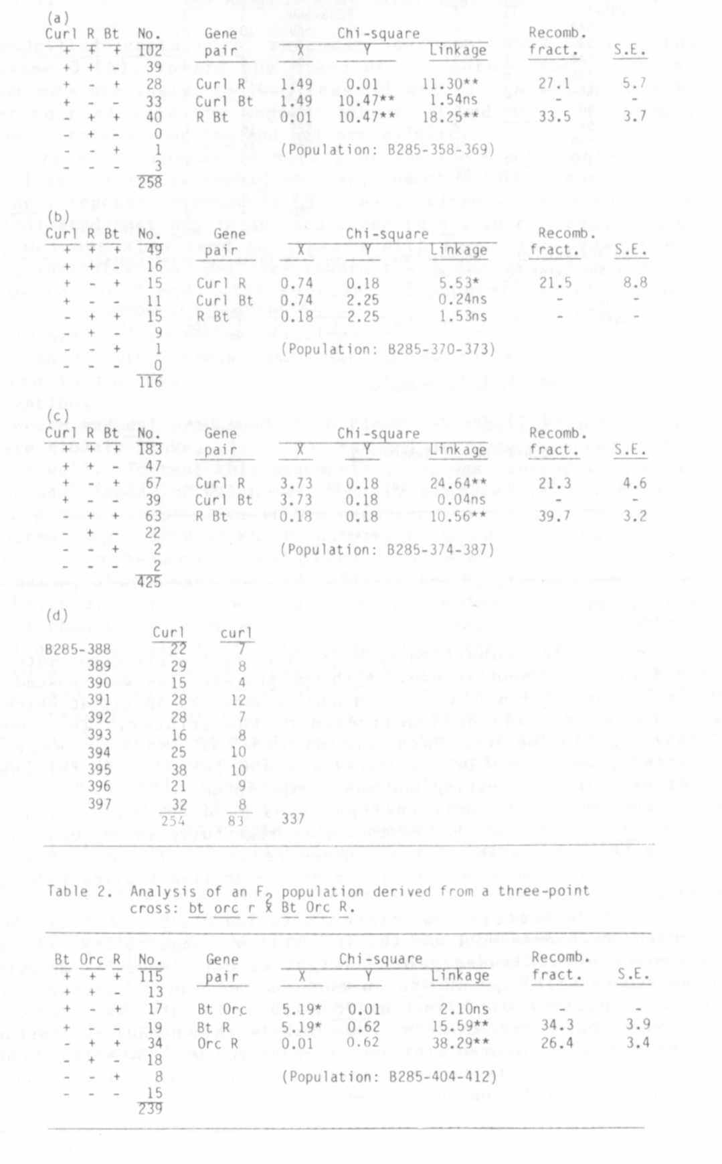

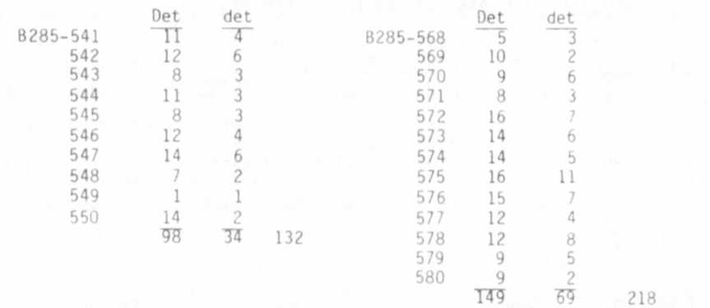
Table 3. (a) Single gene segregation for indeterminate (Det ) and deter-
minate (det) in two F2 populations; and (b) analysis of joint
segregation of Det with Bt and with R.
EDITOR'S NOTE:
(a) Number of normal (Det) and determinate (det) segregants reproductive
habit in two segregating F2 populations.
(b) Analysis of F2 populations derived from three two-point crosses
involving Det, Bt, and R.
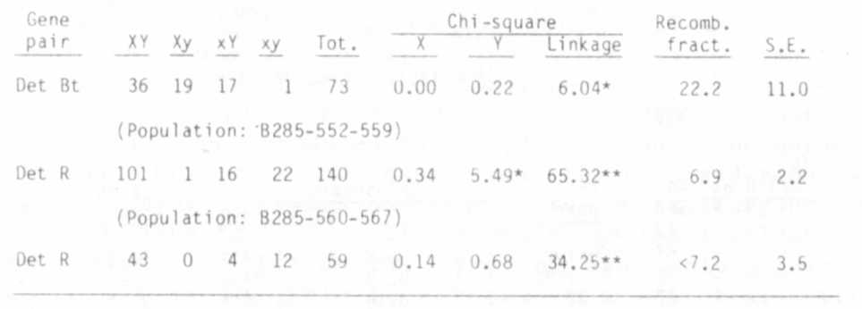

Four articles submitted by W. K. Swlecickl arrived too late to be
included in the present volume. Although the articles were posted on 19
February, they did not arrive in Geneva until 24 April, at which time
the volume had already been delivered to the printer. The envelope
containing the manuscripts was marked "Air Mail", "express",
"Certified", so clearly Dr. Swiecicki was not responsible for the ex-
traordinary delay in getting the manuscript to me.
In one article Dr. Swiecicki provides good evidence for linkage
between det and r and tl. He therefore rightfully shares equal credit
for being first to establish the linkage relations or det. Moreover,
his article also takes note of the possible applied implications of the
det mutant.
In another article, Swiecicki's data led him to conclude that Orc
is located on chromosome 1 and that the yellow orange foliage is caused
by a separate but linked gene, designated orl. However, my evidence
(above) suggests linkage of Orc on chromosome 7 and that the foliage
color is a pleiotropic effect of Orc. Thus, in this case, our conclu-
sions conflict. If Swiecicki's view prevails then he deserves priority.
The third and fourth articles, co-authored with B. Wolko, consider
the use of isozyme markers in identifying cultivars and confirm the
linkage of Aat-p and A on chromosome 1.

