LINKAGE OF AN AEROMACULATA MUTANT ON CHROMOSOME 1

Marx, G. A. NYS Agricultural Experiment Station, Geneva, NY

Aeromaculata mutants are so named because they cause epidermal layers
of leaves to become separated from the subjacent cell layers, creating air
spaces (1). White patches or flecks appear because light is differentially
reflected and refracted (Fig. 1). Fl is one such mutant locus and Arg is
another; the former limits the expression to flecking whereas the latter
results in near complete involvement. In 1982 Dr. Blixt sent me seeds of a
series of aeromaculata lines from his collection. He designated them as
"supaeromaculata" because many show a high degree of phenotypic expression.
The set of lines contained the following numbers: WL-102 (fl), -581 (Fl-v),
-5120, -5136, -51 57 , -5287, -5289, -5349 , -5401, -5534, -5360, -5727,
-5757, -5764, -5837, -5856, -5880, -5904, -5905, -5903, -5959, -5960, and
-5987. Most of the mutants evidently were artificially induced. The lines
differed in degree of expression, ranging from no flecking to moderate
flecking to extreme expression (i.e. resembling Arg expression), and for
that reason the lines were characterized on a basis of a scale from 1 to
10, with fl (no flecking) as 1 and strong expression as 10.
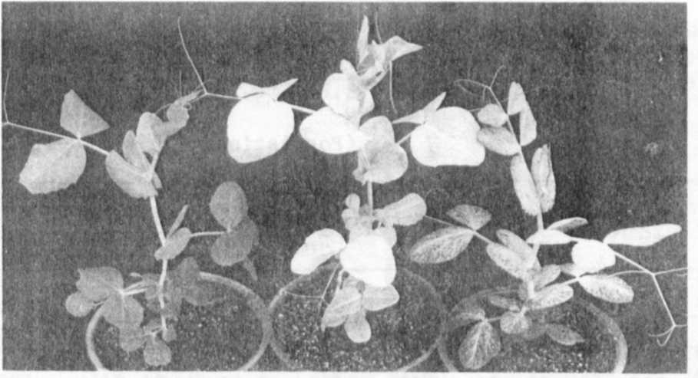

Fig. 1. Seedlings of jfj (left), Arg (middles, and aero (Wl-5880).
As the aero plants grow older they more nearly resemble
the phenotype of Arg plants.

Although it was suggested previously (2) that the phenotypic dif-
ferences in the above lines may result from genes located at loci other
than Fl, as far as I am aware the matter has never been thoroughly
investigated. Dr. Blixt had also informed me that the above mutant(s)show
recessive inheritance, indeed recessive even to fl, a fact confirmed by the
results of my own crosses. Initially, my principal interest in examining
the material was to try to determine the relationship, if any, with Arg.
Of the WL lines listed above I used only three in crosses. WL-5837
and WL-5880 were used because they exhibited strong expression, approaching
that of Arg. WL-102 was used as a source of f1. Hereafter I will
provisionally designate the gene derived from WL-5837 and WL-5880 as aero,
pending official designation by Dr. Blixt.
Our attempts to determine whether or not Arg and aero are alleles at
the same locus proved difficult not only because both mutants have similar
phenotypes but also because Arg shows a certain amount of phenotypic
instability. Moreover, except for the aero x f1 crosses, all the original
crosses were between aero and Arg, so it was difficult to establish linkage
patterns even if aero did not prove to be an allele of Fl or of Arg.
Numerous populations derived from Arg x aero crosses gave no indication
that aero was an allele of Arg (data not shown).
It was not until two small populations were analyzed in 1985 that
evidence was obtained suggesting that aero is situated on chromosome 1 near
I and Af (Table 1). The aero parent in these crosses, an F6 , descended
from an earlier cross with WL-5837. Though the population sizes are un-
desirably small and the genes are in the repulsion phase, the data seem to
support the claim of linkage. Since the aero gene derived from only one
(WL-5837) of several aero lines, it cannot be concluded that the same
linkage relationship applies to all aeromaculata lines in the set. To
ascertain if different degrees of expression among the WL lines reflect the
presence of a series of alleles would require crossing the lines inter se
as well as to a common fl line. Otherwise the wide variation in flecking
which prevails in the gene pool would confound the analysis.
Data in Table 2 show the results of joint segregation between aero and
sil. Although there was no evidence of linkage between the two mutants,
the data are included to show that aero segregated with a good fit to a
3:1. Earlier crosses between aero and fl also gave good monogenic segrega-
tion (data not shown).
Aero is another valuable seedling marker which should help to extend
our knowledge of chromosome 1. How the various aeromaculata genes act to
cause their effect remains an intriguing, unstudied question.

1. Blixt, S. 1962. Agri Hort. Genet. 20:95-110.
2. Blixt, S. 1972. Agri Hort. Genet. 30:1-293.

__pjjjjpjpjpjpjpj____B^

44

PNL Volume 18 1986 RESEARCH REPORTS

Table 1. Joint segregation analysis between an aeromaculata mutant
* * * * *
derived from WL-5837 and two marker lines.
