LOCATION OF er PROVING ELUSIVE

Marx, G. A. NYS Agricultural Experiment Station, Geneva, NY "SA

In 1971 I presented results suggesting that ex, conferring resistance
to powdery mildew, is situated on chromosome 3 (3). There were indications
of linkage between er and several genes presumed or known to reside on
chromosome 3. The evidence for linkage with Gty was particularly convinc-
ing and was supported further by results from F3 progeny tests (4).
Because chromosome 3 is a well marked chromosome with many good seedling
markers, it would seem a routine matter to fix the position of er with some
precision. With that in mind, I constructed populations segregating for er
and for markers along much of the known length of chromosome 3, from chl-6
on one end to tac on the other. Markers used were: tac apu st b bulf
chi-6. Segregating populations were grown under controlled conditions in a
growth chamber. Heavily infected susceptible plants were introduced into
the chamber when the segregating F2 populations were in the early seedling
stage, the fungal spores being spread by air currents generated by fans in
the air handling system. Susceptible and resistant check populations were
distributed throughout the chamber. Disease development was strong and
uniform on susceptible checks and segregants.
The anticipated close linkage between er and one or more of the
markers used did not materialize. Only a slight indication of linkage
between b and er was found in one population (Table 1). A similar experi-
ment was conducted in 1970 and it, too, failed to demonstrate linkage among
er, st, and b (Table 2b, c). If er and Gty reside in chromosome 3 then
presumably they lie distal to b, near gl and rag. However, chi-6 is sup-
posed to be distal to b, yet there was no evidence of linkage between er
and chi-6. This, therefore, calls into question my earlier findings (3)
and further experiments are required to settle the issue. Possible in-
volvement of a chromosomal interchange in the experiment reported in 1971
(3) cannot be excluded.
Our source of er traces to the variety 'Stratagem'. Harland (I) found
a source of powdery mildew resistance in a remote site in the Andes moun-
tains of Peru. Resistance was shown to be monogenic recessive with
evidence of linkage with A on chromosome 1, the recombination fraction in
and F3 being 35%. My calculations of the linkage chi-squares for his
data are 4.80 and 4.42 for the F2 and F3 populations, respectively, both
being significant at 0.05 but not at 0.01. His data also demonstrated the
known and accepted linkage between A and Lf so his populations constituted
a three point test. Because there was no evidence of linkage between Lf
and er, he placed Lf distal to A (viz. Lf -12 -A-35-Er).
Recently I have acquired P.I. 185183 from the Northeast Regional Plant
Introduction Station in Geneva, NY. The accession showed resistance to
powdery mildew in my tests. Available data indicate that S. C. Harland
presented the accession to the USDA in November 1949. Thus it may be the
line representing the source of resistance referred to in liar land's 1948
paper but proof for that supposition is lacking. The F1 , F2, and sub-
sequent progenies from the cross between P.I. 185183 and one of my er lines
were all resistant. It would appear therefore that P.I. 185 183 carries the
same gene for resistance as that carried by Stratagem. My resistant paren-
tal line carried st and bulf among other markers and these of course
segregated In the F of the cross and the data are included to show normal,
expected behavior (Table 3).
Since the er gene in the Geneva material possibly, even likely, is the
same as that discovered by Harland, the same linkage relations should apply

PNL Volume 18 1986 RESEARCH REPORTS
1

to both sources. Since Linkage of er on chromosome 3 is still problemati-
cal, attention quite rightly should again focus on Harland's claim of
linkage between er and A on chromosome 1. However, I have not been able to
corroborate his findings either. For example, the same 42 F3 progenies
from the testcross (A Gty Er x a gty er) x a gty er that demonstrated a
close linkage between Gty and Er (4) showed independence between A and Er,
the distribution of F3 families being as follows: A Er 14 : A er 11 : a Er
9 : a er 8. Moreover, results of the 1970 experiment (Table 2a) give no
indication of linkage between A and Er.
The evidence for a second major gene, er-2, controlling resistance to
powdery mildew (2) is subject to debate. Heringa et al. considered SVP 951
and SVP 952, both from Peru, as resistant but the lines showed heavy stem
attack, so presumably the action of er-2 is individually identifiable on
the basis of the differential disease reaction on leaves vis-a-vis stems.
Yet Table 7 in their paper, showing the results of the cross between SVP
942 (Geneva line) and SVP 9 52, lists the classes as very strong, strong,
weak and healthy, i.e. the plants were not placed in categories based on
stem vs leaf reaction. Solely from the evidence presented in their paper,
therefore, it may be just as reasonable to conclude that SVP 951 and SVP
9 52 carry polygenes for resistance as described by Hammerlund. That dif-
ferences in reaction to powdery mildew exist among susceptible (i.e. Er)
lines is well known to many breeders and others. Combinations of polygenes
with er may therefore account for some of the observed differences in
degree of disease reaction noted by Heringa et al. In my experience with
the er gene derived from Stratagem, disease reaction ranges from complete
absence of disease symptoms to the presence of fungal colonies over much of
the plant, depending on the prevailing environmental conditions.
Nevertheless, whenever susceptible and resistant plants are exposed to the
same conditions, the resistant (i.e. er) plants are qualitatively distin-
guishable from Er plants.

Table 1. Joint segregation analysis of the cross St Chi-6 B Er x
st chi-6 b er.
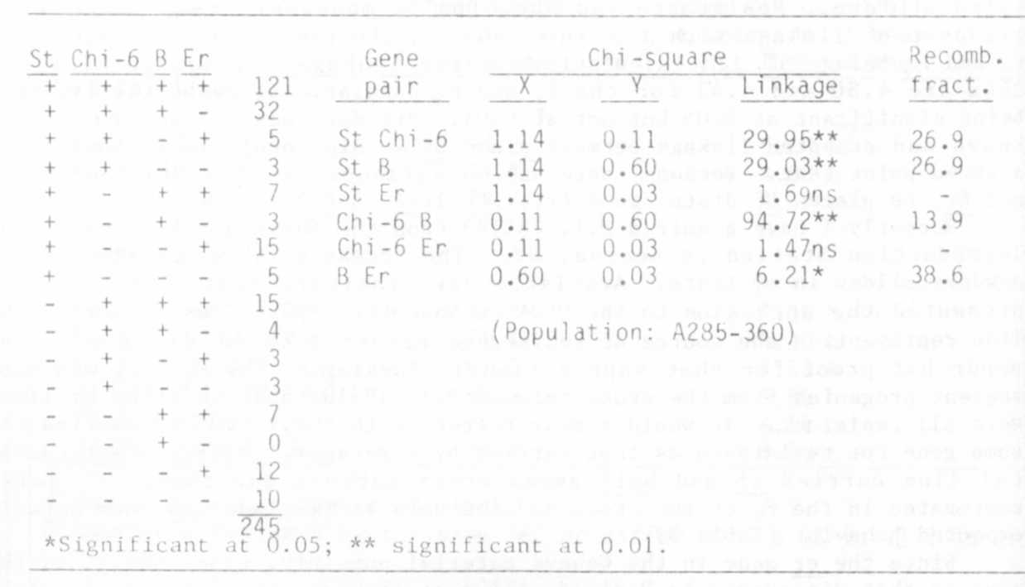

Table 2. Analysis of populations from crosses: a er St _B x A Er St B.

Data are from an experiment conducted in 1970, heretofore un-
reported, in which Er was tested for linkage with A on
chromosome 1 (a), and with St and B on chromosome 3.
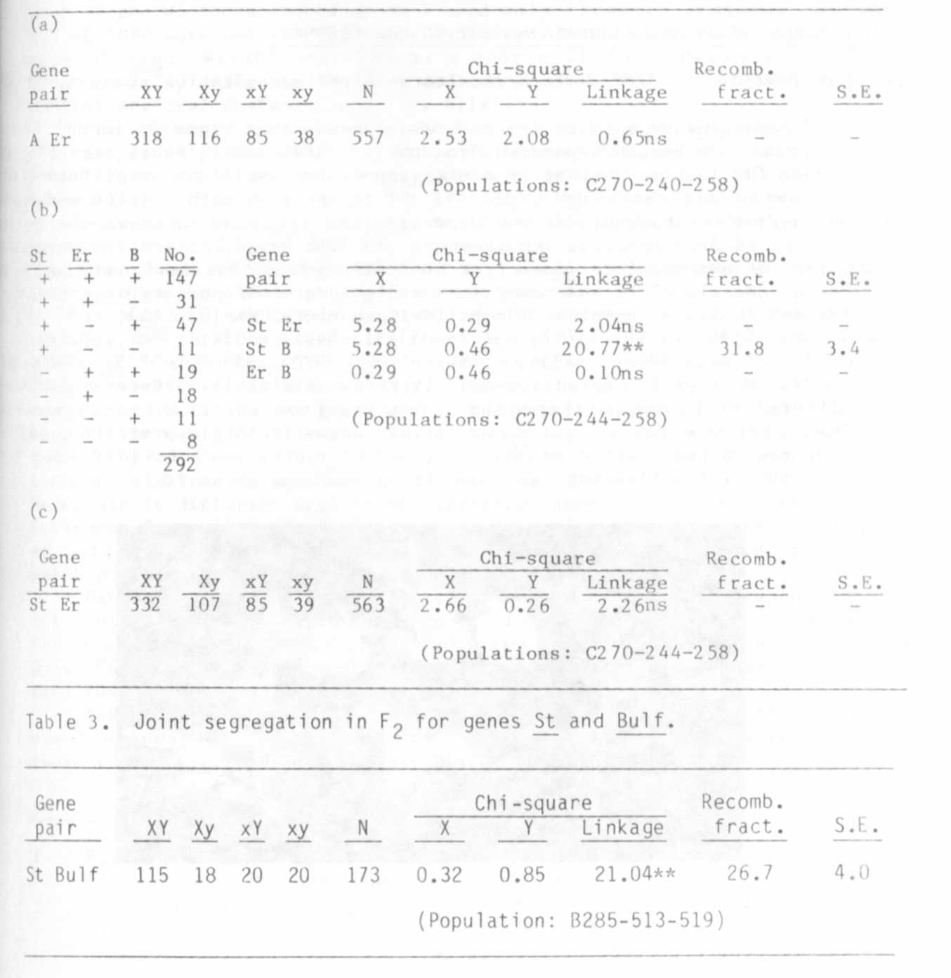

1. Harland, S. C. 1948. Heredity 2:263-269.
2. Heringa, R. J., A. Van Norel, and M. F. Tazelaar. 1969 . Euphytlca
18:163-169.
3. Marx, G. A. 1971. PNL 3:18-19.
4. Marx, G. A. 1974. PNL 6:30-31.

