PNL Volume 18 1986 RESEARCH REPORTS
1

LATERAL ROOT INITIATION IN RHIZOBIUM INOCULATED PEA SEEDLINGS

Lommen, W. J. M. Department of Microbiology, Agricultural University
Wageningen, The Netherlands

Several root characters of seedlings were studied by Ali-Khan and
Snoad (1) and some of these characters were found to be correlated with the
seed weight. In our experiments with different P. fu1vum pea seedlings,
differences were observed in the time of appearance of the first lateral
root. It was not clear whether these differences were caused directly by
genetic variation, or indirectly by differences In seed weight of the lines
studied. Here we report that both can influence the time of appearance of
the first lateral root.
Pea seeds were germinated aseptically on water agar until the root
length was 2-3 cm and the plumule had just emerged. They were then
transplanted into sterile, plastic growth pouches (4) of 10 x 22 cm, con-
taining N-free nutrient solution (5), two seedlings per pouch. The roots
were inoculated with a suspension of Rhizobium leguminosarum, strain TOM,
that forms effective nodules on line Fu 27 and ineffective nodules on lines
Fu 3 and JI 224 (2). Plants were grown in a growth chamber at 22C and the
roots were protected against light by wrapping the growth pouches in
aluminum foil. The plants were inspected daily and the time of first
lateral root formation was recorded.
In the first experiment, three pea lines were studied and within each,
four different seed weight classes were distinguished. Table 1 shows first
that there is a clear Influence of the genotype. Line Fu 3 formed lateral
roots more rapidly than line Fu 27. Line JI 2 2 4 was intermediate.
Secondly, there is an inverse relationship between the seed weight and the
time required to form laterals. Analysis of variance showed that both the
effect of the lines and the effect of the seed weight classes were sig-
nificant at the 0.5% level.
In the second experiment, the same three pea lines and their recipro-
cal Fj hybrids were studied. Seed weight of the F hybrids differed,
depending on which line was used as the maternal parent (Table 2). Again
line Fu 27 showed the slowest lateral root formation. Lines Fu 3 and JI
224 formed lateral roots more rapidly, but in this experiment the slight
difference between these two lines was not significant. The F. hybrids of
these "fast" lines, Fu 3 and JI 224, with the "slow" line Fu 27 also showed
"fast" lateral root formation. There was a synergistic interaction between
the "fast" lines Fu 3 and JI 224, since their hybrids formed lateral roots
even more rapidly than the parental lines. The reciprocal F1 hybrids did
not differ from each other.
These experiments show clearly that both the pea genotype and the
Initial seed weight influence the time of formation of the first lateral
root. However, the seedlings were inoculated with Rhizobium .ind, as found
in red clover, inoculation reduces the number of laterals at an early stage
of development (2). It is not possible to conclude from our experiments
whether inoculation with Rhizobium may influence the time of formation of
the first lateral root In P. fulvum peas.

This investigation was supported by the Foundation for Fundamental
Biological Research (BION) which is subsidized by the Netherlands
Organization for the Advancement of Pure Research (ZWO).

PNL Volume 18 1986 RESEARCH REPORTS
18

1. Ali-Khan, S. T. and B. Snoad. 1977. Ann. Appl. Biol. 85: 131-136.
2. Lie, T. A. 1981. Plant and Soil 61:125-134.
3. Nutman, P. S. 1948. Ann. Bot. 12:81-96.
4. Porter, F. E. , I. S. Nelson, and E. K. Wold. 1966. Crops and Soi
18:10-11.
5. Winarno, R. and T. A. Lie. 1979. Plant and Soil 51:135-142.

Table 1. Time of appearance of the first lateral root (in days after
transplanting into growth pouches) on P. fulvum seedlings from
three lines and four different seed weight classes. Mean of
30 individuals.

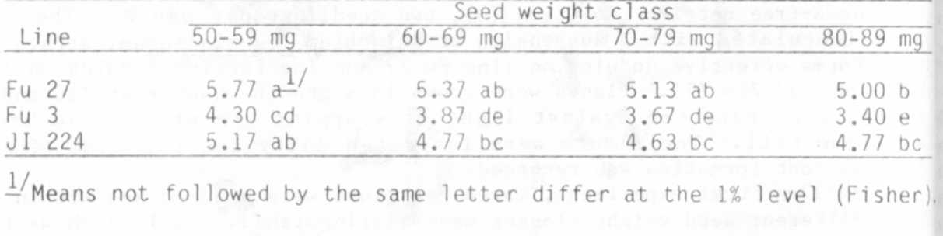

Table 2. Time of appearance of the first lateral root (in days after
transplanting into growth pouches) and initial seed weight of
P. fulvum seedlings from three lines and their F1 hybrids.

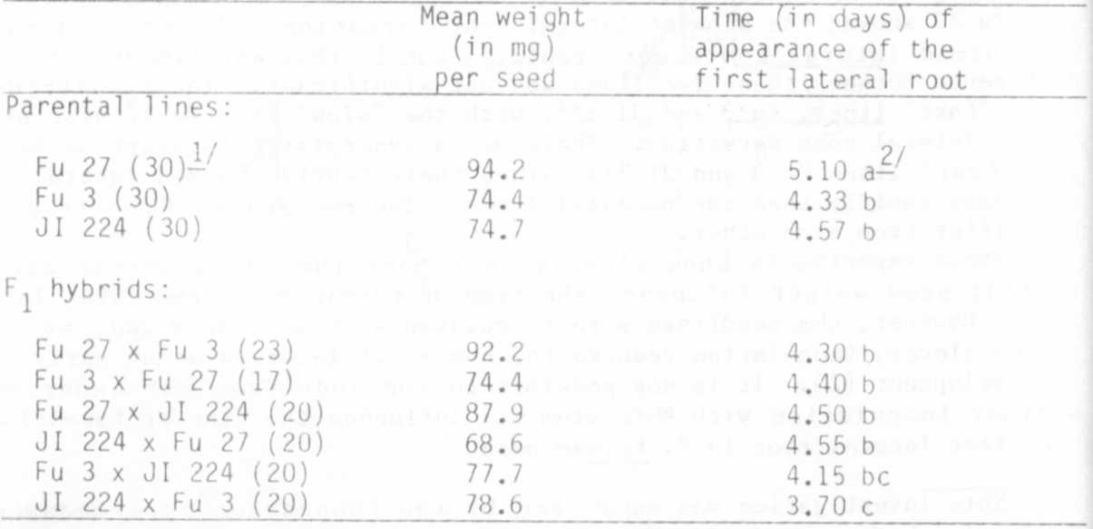

1/
1/ In parentheses: number of plants
2/ Means not followed by the same letter differ at the 1% level (Fisher)

