₁ PNL Volume 18 1986 RESEARCH REPORTS

A NEW INTERPRETATION OF HAMMARLUND¹S K-LINE

Lamm, R.
The Swedish University of Agricultural Sciences!
Alnarp, Swede!

In earlier letters to the PNL (2,3), I have assumed that L—84, the K-
line of Hammarlund, is characterized by a T(l-5) interchange. Later,
however, karyotypic studies of this line (cf. Fig. 1 B) have made me suspi-
cious of this interpretation. Moreover, Folkeson, working with BSG
staining (1), has suggested that chromosome 3 rather than 5 may be involved
In the interchange.
For elucidating this question further, I grew L-91, a gray dwarf N-
type derived from the cross L-84 x L-2 . The structure of L-91 was
identical to that of L-84. Thus the F1 hybrid was perfectly fertile.
Measurements of the interchange chromosomes were made on ten mitotic root
tip plates from each of these lines. An analysis of variance shows that
the results, given below, could be pooled.
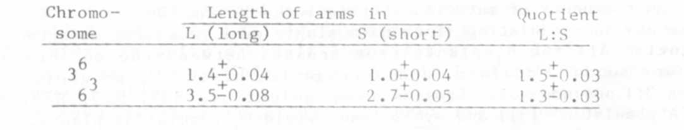
Next, I studied the karyotype of the F1 hybrid between L-741, N-type
(Fig. 1A), and L-91. The hybrid turned out to be a T(3-6) interchange
heterozygote (Fig. 1C) and consequently L-84 and L-91 were of similar
structural type. Measurements on microphotos of twenty root tip metaphases
from this semisterile F1 hybrid gave the following results:
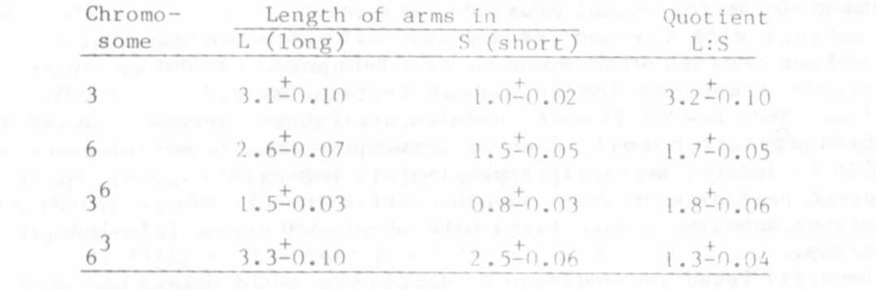
The total length of chromosomes 3+6 was 8.2-0.01 and that of 3+ 6⁶
³ 8.1-0.01 .
In an F2 progeny of this cross in addition to 147 diploid plants-
five trisomies were obtained. Table 1 gives the results from the F2
analysis of the 2n plants. The Fs:fS segregation has been omitted since
the scoring on this point unfortunately was unreliable. In Table 2 the
cytogenetical characters of the trisomies are recorded. Selfed seed har-
vested on these plants was used to score for Fs.

PNL Volume 18 1986 RESEARCH REPORTS
2

As a comment to Table 1, It should be mentioned that among the six
linkage relations between the four genes only Gp-Cp gave a significant
recombination value viz. 14.7-3.19.
In earlier investigations, the karyotypes of the trisomies have all
been of the same structure viz. N-type + 3⁶ (3,4). It is interesting to
note that the trisomic interchange heterozygote represented by plant No.5
of Table 2 had improved pollen fertility in comparison with the semi-
sterile diploid F1 hybrid that had 47% of sterile pollen grains. The
diagram of Fig. 1D illustrates the probable pachytene pairing of the trans-
location heterozygote and the approximate location of some marker genes.
According to Pellew (4) there was about 20% crossing-over between the T-
point and the gene Fs but a recalculation of her data gives a
nonsignificant chi-square value. In future research, all relations between
the T-point and the genes Cri and Ce ought to be investigated.

1. Folkeson, D. 1985. PNL 17:15-16.
2. Lamm, R. 1974. PNL 6:29.
3. Lamm, R. 1976. PNL 8:36-37.
4. Pellew, C. 1940. J. of Genet. 39:363-390.

Table 1. Data concerning the diploid F2 progeny from the Fj of 1.-741,
N-type, U^{st} fs gp cp d x L-91, T(3-6), u Fs Gp Cp D.
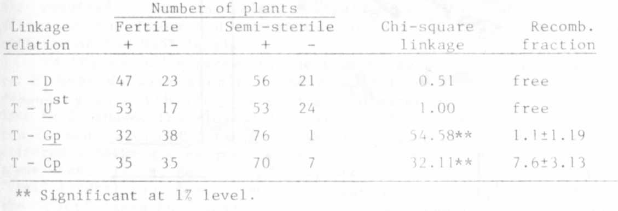

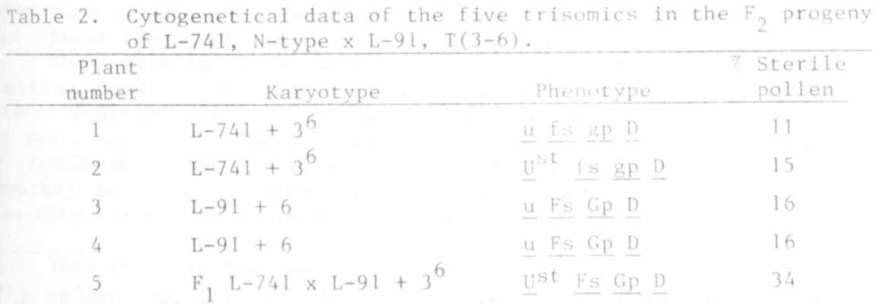

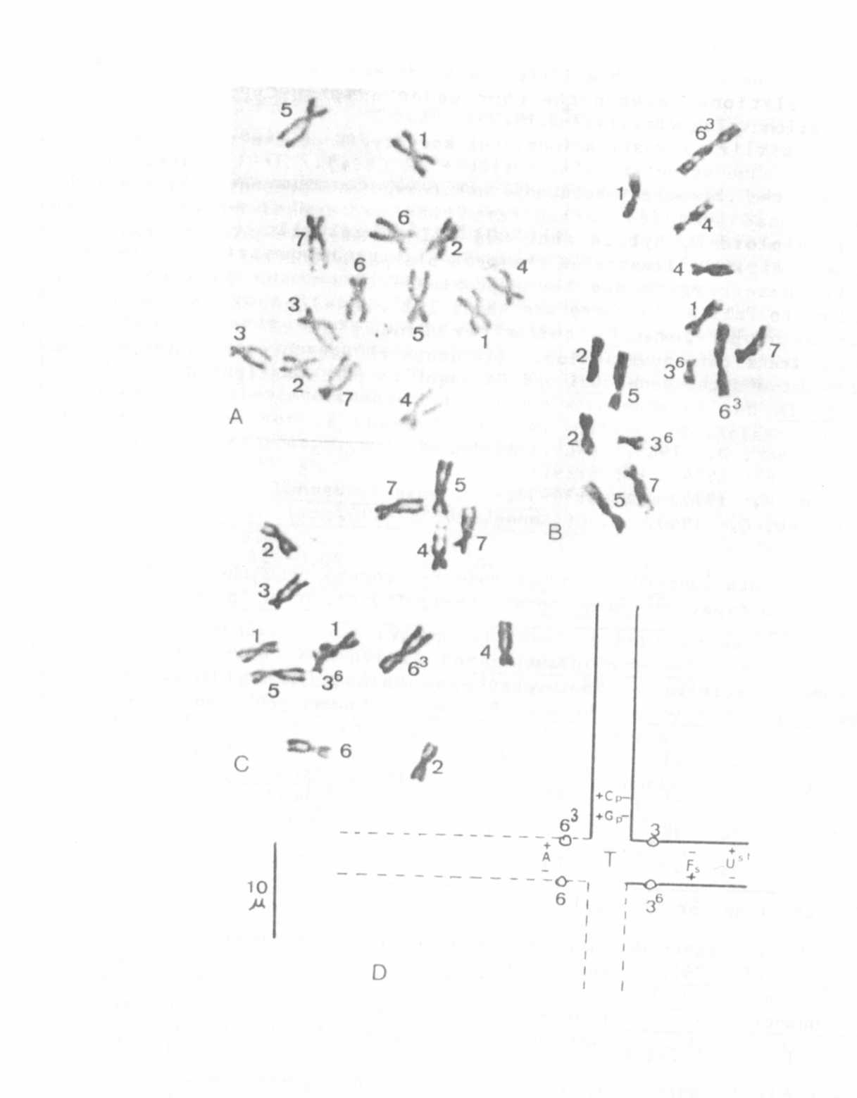

Fig. 1. A-C. mitosis in root tips of (A) [L-741, N-type], (B) [L-84
Hammarlund's K-line, T(3-6)], and (C) F1 of L-741 x L91, T(3-
6). D Indicates the probable pairing at pachytene of the F1
hybrid with tentative locations of five marker genes.

