1 PNL Volume 18 1986 RESEARCH REPORTS

VARIATION IN NODULATION CAPACITY OF PEA VARIETIES
Jensen, F. H. Pajbjergfondan Plant Breeders
Dyngby, DK-8300 Odder, Denmark

In a program to study variability in root development, 398 pe;
varieties and breeding lines were screened at Pa j bjergf onden (3). At the
same time root nodulation was also determined.
The plants were grown in 30 cm long PVC tubes, 10.2 cm diameter,
buried at random in the field with three replicates. The medium was soil
containing natural Rhizobium strains. The experiment included 38 colored
flowered peas, 148 white flowered peas, and 2 12 garden peas. The plants
were harvested after 75 days of growth (beginning to end of pod filling)
Total root length was determined using the line intersection method (4),
Nodulation was classified, using a scale of 0-5 (fewer categories compared
to Brockwell [1]).
Figure 1 shows the results of the nodulation classification. The
colored flowered peas in general nodulated well (score 2-5) and also had
large root systems (3). The white flowered dried peas and garden peas in
general nodulated rather poorly (score 0-3) and had smaller root systems.
This finding corresponds to that of Gelin and Blixt (2). Among the white
flowered dried peas it was possible to separate the material into different
groups, e.g. varieties and breeding lines from Mansholts Vered1ingsbedrijf
Holland, showed very poor nodulation (score 0-2), while in general Swedish
varieties (from Weibullsholm and Svalof ) exhibited relatively good nodula-
tion (score 2-4).
Within these two groups the breeding material is genetically very
similar (common origin), and as described by GeIin and Blixt (2) the
average nodulation is genetically controlled by at least two genes (nod-1
nod-2). The difference in nodulation between these two groups is therefore
likely to be of genetical origin.
Nodulations with effective Rhizobium strains and N-fixation capacity
are normally closely related. Rydberg et al. (6) found a very low
nitrogenase activity (acetylene reduction) in 'Bodil' (from Mansholt)
compared to a group of Svalof lines, which were the same as those used in
the present study.
Figure 2 shows the correlation between total root length and nodula-
tion for the 398 pea varieties.
Richter (5) found a positive correlation between nodule number and
root dry weight at the beginning of flowering and at seed maturity with
coefficients of 0.72 and 0.52, respectively. In the present experiment
there also was a highly significant correlation (r=0.59) between nodulation
and total root length.
On a large root system there will be more sites for infection of the
Rhizobium bacteria, but often there is also i general positive correlation
between total root length and top dry weight. This correlation influences
the distribution of assimilates.
For the plant breeder in a country where N is not a critical cultural
limitation, the search for varieties with more optimal root/top ratio will
be more urgent than for high nodu Lit i no, varieties.

1/ This work was supported by the Danish Agricultural Research Council.

PNL Volume 18 1986 RESEARCH REPORTS
2

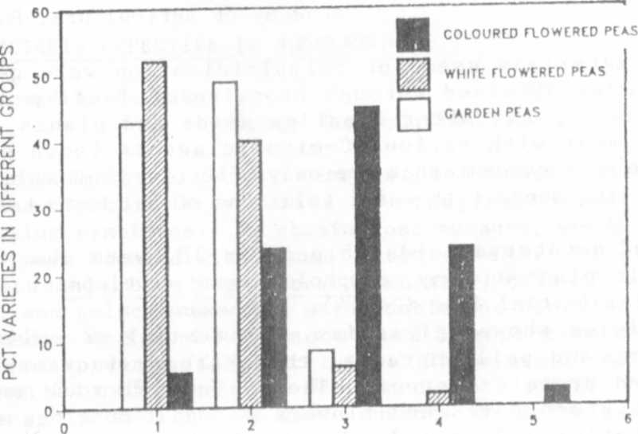
GROUPS OF NODULATION
Fig. 1. Nodulation of peas divided into groups.
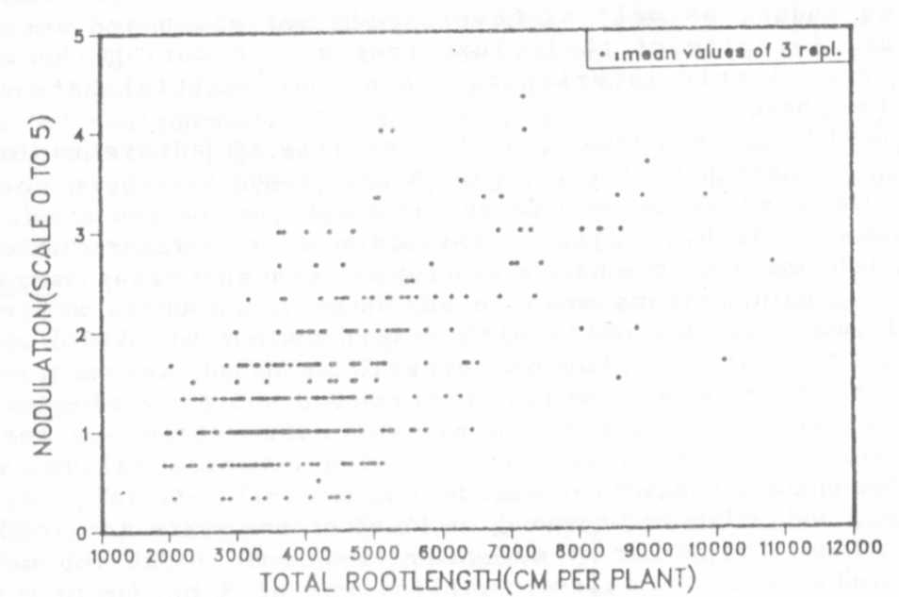
Fig. 2. Correlation between total root Length and Modulation.

1. Brockwell, J. 1980. In Methods for evaluating biological nitrogen
fixation. Bergersen, F. J., ed. pp. 417-488.
2. Gelin, 0. and S. Blixt. 1964. Agri Hort. Gen. 22:149-159.
3. Jensen, A. 1985. Report, Pajbjergfonden, 118 pp.
4. Newman, E. I. 1966. J. Appl. Ecol. 3:139-145.
5. Richter, E. 1974. Landwirtsch. Forsch. 27:330-342.
6. Rydberg, I., N. 0. Bertholdsson, and V. Stoy. 1985. Report, Svalof
AB, 65 pp.

* * * * *

