SEED PROTEIN PRODUCTION OF SOME PISUM MUTANTS AND RECOMBINANTS

Abou-Salha, A.
Institute of Genetics, University of Bonn
Federal Republic of Germany

Three mutants with apical stem bifurcation (37B, 157A, 1201A) and
seven recombinants (RM 20D, R 46C, R 177, RM 432, RM 836, RM 1126, RM 1128)
which not only show stem bifurcation but also other morphological charac-
ters, were investigated with regard to seed yield, seed size, protein
content, and protein production per plant in three consecutive years. The
protein yield was compared with the control values of 'Dippes Gelbe
Viktoria' (DGV) which was used as the Initial line for the radiation-
genetic experiments (Fig. 1). All the recombinants tested showed
dichotomous stem bifurcation due to the presence of gene bif-1 derived from
mutant 1201A. Only recombinant RM 432 showed stem fasciation.

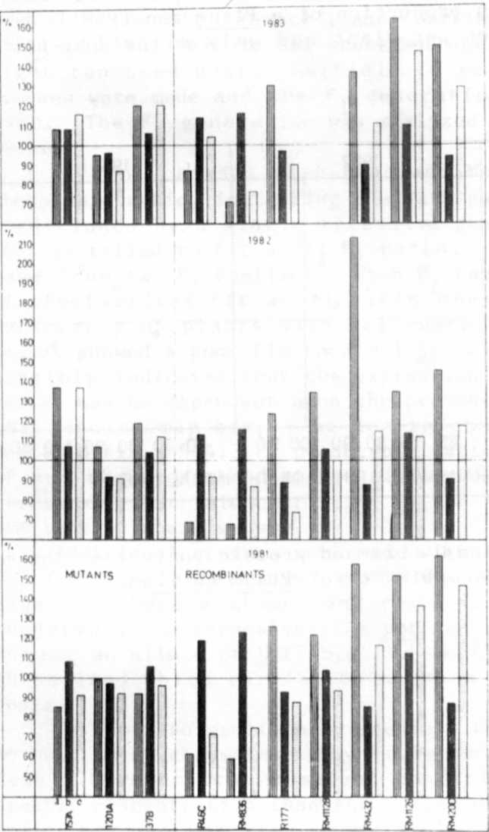

Fig. 1. Number of seeds per plant
(a), protein content of
the seed meal (b), and
protein production per
plant (c ) in three
mutants and seven recom-
binants of pea. A11
values are related to
control values of the
initial Variety 'Dippe
Gelbe Viktoria' (DGV) -
100%

In 1981, the protein production of the three mutants was lower than
that of DGV because of their lower seed yield. In 1982 and 1983, mutant
37B and 1 5 7 A had a higher protein production because of a favorable com
bination of high number of seeds per plant and high protein content of the
seed meal. This indicates that this trait is highly influenced by environ
mental factors. Recombinants R 46C and RM 836 showed an increased seed
protein content but the protein yield was lower than DGV because of the
decrease in seed yield per plant.
Recombinant RM 1126, on the other hand, had not only a higher protein
content than DGV but also higher seed production. The protein production
per plant was high in spite of its decreased seed size. Recombinant RM
1128 also had a higher protein content of the seed meal but the protein
production was not high, possibly because of the presence of gene sg for
small seeds. The increased protein production of the two recombinants RM
20D and RM 432 resulted from a very high seed production per plant, even
though the protein content of the seed flour was reduced. RM 20D has
normal seed size, whereas the seed size of RM 432 is reduced.
Figure 2 demonstrates that there is no clear correlation between seed
size and protein content of the seed meal in the material studied. These
findings contrast with the results obtained in cereals. Our investigations
show furthermore that the protein production of a Pisum genotype is mainly
correlated with the seed production per plant and only slightly with the
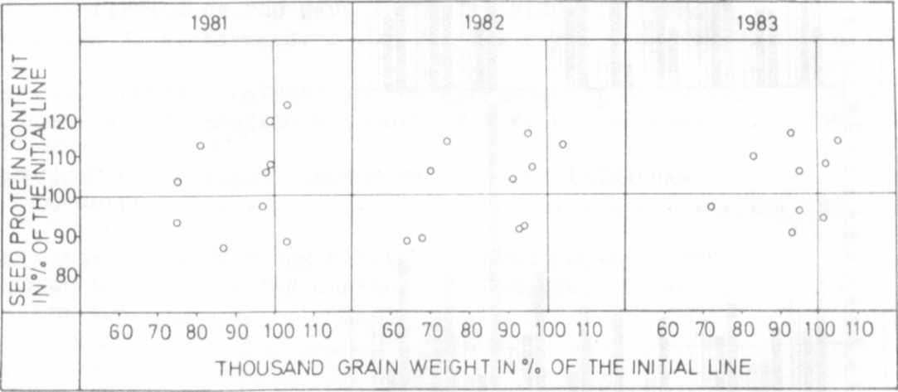
protein content of the seed meal.
Fig. 2. The relation between seed size and protein content of the seed
meal in 3 mutants and 7 recombinants of Pisum sativum.

