LOCALIZATION OF NITRATE REDUCTION IN SOME PISUM GENOTYPES

Jensen, E. S. Agricultural Research Department, Riso National Laboratory
DK-4000, Roskilde, Denmark

Pea plants assimilate nitrogen both by symbiotic nitrogen fixation and
by nitrate reduction. The location of nitrate reduction within a plant may
have an influence on the energy costs of nitrate metabolism. Apparently,
less energy is required if the nitrate reduction process occurs in il-
luminated green tissue than in the roots (5). In pea, most of the nitrate
taken up is reduced in the roots (4). Some studies (1,2) indicate,
however, that substantial amounts of nitrate may be reduced in the shoot.
The present study was conducted to determine if Pisum contains genetic
variability for within-plant activity and localization of nitrate reductase
(NR).
Uninoculated plants of 14 genotypes were grown in pots containing
vermiculite and were watered with a nutrient solution containing basic
nutrients and 5 mM KNO₃. The pots were arranged in a randomized block
experiment with four replicates in a growth chamber and exposed to a 16h
light/8h dark cycle at 20/13C. Plants were harvested 2 1 days after sowing.
The roots were washed in demineralized water and the shoots were separated
into two fractions: a leaf fraction (leaflets and stipules) and a "stem"
fraction (stem, petioles, and tendrils). Grams fresh weight (gfw) was
determined on each plant part. An In vivo NR activity (NRA) assay (3) with
minor modifications and including 0.1 M NO₃ in the incubation medium was
used to determine the potential NRA on samples from the different tissue
fractions (Table 1) and the distribution of total plant NRA (Fig. 1).
Potential NRA is considered to be an indicator of nitrate reduction in the
tissue when the substrate is not limiting.
Significant genetic variability for potential NRA per gfw was found
for all tissue fractions (Table 1). Root, stem, and leaf NRA varied 2.7-,
2.2-, and 1.7-fold, respectively, among the 14 genotypes. In ten of the 14
genotypes the NRA per gfw could be ranked as follows: leaf>root>s tern. In
'Afghanistan', 'Frison', and 'Sugarsnap, root NRA was higher than leaf NRA.
'Alaska' pea had the lowest root and stem NRA, but the highest leaf NRA
(Table 1). The capacity for nitrate reduction in the root as percent of
total plant activity varied between 38 and 64% (Fig. 1). Total plant
activity (Fig. 1) was positively correlated with the NR activity per gfw of
the leaf fraction (r=0.716**). The distribution of total plant NRA among
plant parts may depend on the level of nitrate in the growth medium. The
higher the level and plant uptake of nitrate the higher may be the con-
tribution from green plant parts to total plant NRA. No relationship was
found between total plant activity and the proportion of total NRA located
in the green plant parts (Fig. I). In the present experiment only a single
level of nitrate was used, since the genotype comparison was of prime
interest.
The results indicate that pea genotypes differ in their capacity for
nitrate reduction in the root and shoot system. The significance of these
differences in relation to the effect of nitrate on symbiotic nitrogen
fixation will be studied in more detail.
1. Andrews, M., J. M. Sutherland, R. J. Thomas, and J. I. Sprent . 1984
New Phytol. 98:301-310.
2. Beusichem, M. L. van. 1981. Neth. J. Agric. Sci. 29:259-272.
3. Crafts-Brandner, S. J. and J. E. Harper. 1982. Plant Physiol
69:1298-1303.
4. Pate, J. S. 1973. Soil Biol. Biochem. 5:109-119.
5. Schrader, L. E. and R. J. Thomas. 1981. _In : Bewly, J. D. (ed.f
Nitrogen and Carbon Metabolism. Martinus Nijhoff/Dr. W. Ju|
Publishers, The Hague. p. 49-91.

Table 1. Potential NRA in the root, stem and leaf tissue

of 14 pea genotypes.
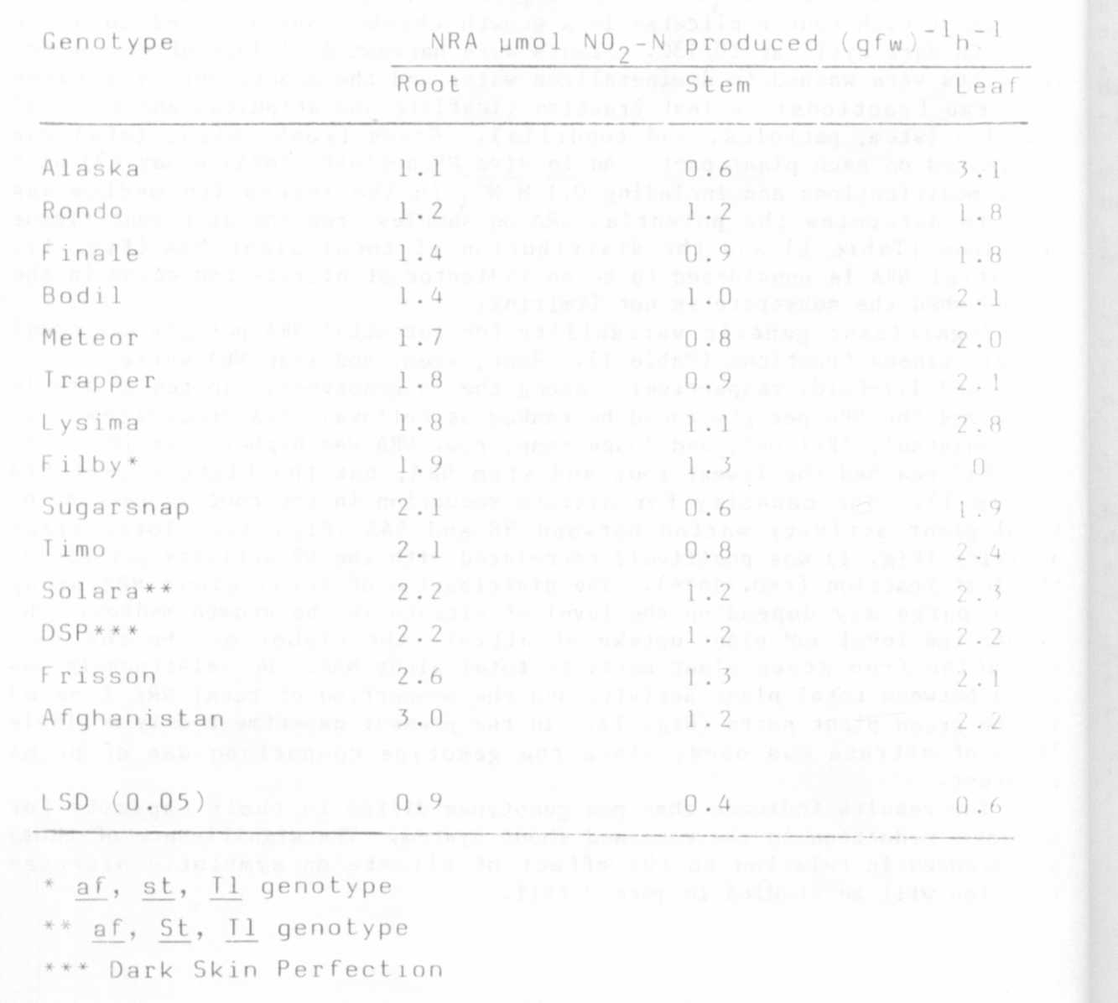
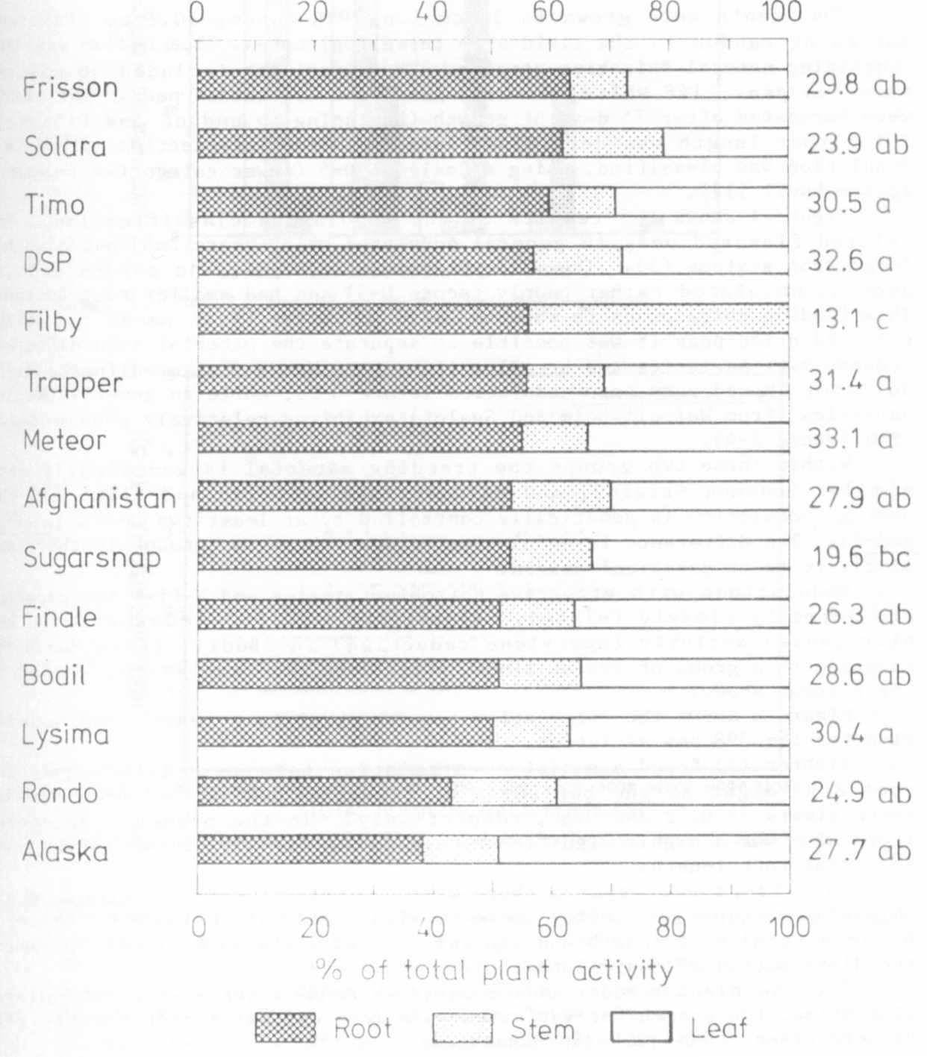
Fig. 1. Distribution of total NRA among plant. parts. Total plant NRA
(mcmol NO₂-N produced plant⁻¹ h⁻¹ ) are shown at the right side
of the figure. Means that are followed by the same letter are
not significantly different at the 5% level of probability.
* * * * *

