GEOGRAPHIC ORIGIN OF PEA SEEDBORNE MOSAIC VIRUS: AN HYPOTHESIS

Hampton, R. 0.
USDA, Agricultural Research Servia
Oregon State University, Corvallis, OR US

It was previously reported (4) that the USDA Plant Introduction (P.I.)
Pisum collection contained at least 420/1835 pea seedborne mosaic virus
(PSbMV)-infected seedlots, 40% of which ( 168/420) had originated in India.
Moreover, original seeds of many recent accessions from northern India were
tested and found to transmit PSbMV. Fortuitously, 23 seedlots simul-
taneously introduced from northern India were found to contain PSbMV-immune
germplasm. This unparalleled concentration of PSbMV inoculum and PSbMV-
immune Pisum germplasm in northern India caused us to wonder whether this
region may have been the center of origin for this virus, and consequently
also the center of PSbMV-immune germplasm; hence, the subject of this
paper.
Origin of PSbMV inoculum. Of 472 Pisum accessions introduced from
India in 1969-70 and tested (4) for seed transmission of PSbMV, introduced
seeds of 138 transmitted the virus to 3% to 2 5% of their seedlings. In the
P.I. number sequence between PI 356858 and 356978 ( 120 accessions), seed-
transmission of PSbMV occurred in at least 5 3 ( 44%). Among these 138
infected accessions from India, exact locations could be mapped for 45
(Fig. 1). Of these 45 infected accessions, 35 (78%) had originated within
the state of Uttar Pradesh or very near its border, with 7 of the remaining
10 originating in other states of northern India.
More 1969-70 Pisum accessions (472/672, 70%) had been introduced from
Uttar Pradesh than from all other regions combined (Table 1), this single
factor accounting for the predominance of infected seedlots from this
state. The preponderance of collections (453/472, 97%) from northern India
is significant, I believe, indicating a greater degree of Pisum adaptation
and cultivation in this temperate region of the subcontinent. Wherever
limited collections were made in the tropical south, however, at least 2 51
of the accessions were found to contain PSbMV. All nine accessions from
Tamil Nadu, in SE India, contained PSbMV.
Origin of PSbMV-immune germplasm. Of 672 Pisum accessions introduced
from India in 1969-70, 509 were tested for immunity by PSbMV-inoculation in
1979 (4), identifying 23 sources of immunity. Thereafter, the remaining
163 accessions were also tested, revealing another 12 accessions containing
plants that were PSbMV-immune (neither approximately 300 commercial pea
lines from developed countries nor 200 P.T. accessions from developed
countries was found to contain PSbMV-immune germplasm). Whereas these
accessions had originated from 2 1 countries, 34/35 accessions containing
PSbMV-immune plants originated in India. Of these, 33/34 came from north-
ern India, the majority from Uttar Pradesh (8 locations shown in Fig. 1).
The remaining 1/34 from India came from Maharashtra (W. India). The only
PSbMV-immune accession (1/35) originating outside of India came from
Malaysia, an area into which immigrations from India occurred after 800
A.D.
Hypothesis. Thus, these investigations indicate that the geographic
concentration of PSbMV inoculum and the coincidence of PSbMV-infected Pisum
seedlots and PSbMV-immune germplasm in northern India is a unique associa-
tion, probably not occurring in any other region in the world.
Notwithstanding the inadequacy of supplementary, definitive information, I
hypothesize that northern India indeed represents an original epicenter of
PSbMV from which the virus was disseminated to other parts of the world in
infected Pisum seeds.
Properties of present PSbMV strains suggest that an acquired viral
genetic ability to induce its transmission through host seeds would have
greatly favored survival of the virus. For instance, there are no known
non-Pisum, persistent inoculum-reservoir hosts of PSbMV from which disease
spread (by aphids) could occur, i.e., the virus perennates exclusively in
infected seeds. Without seedborne inoculum, therefore, survival of the
virus would have been dependent upon spread from a continuous supply of
infected annual host plants. The probability of occasional inoculum dis-
continuities, causing breaks in the disease cycle and loss of PSbMV, is
substantial. This deficiency would have been further aggravated bv a very
narrow host range, characteristic of present-day PSbMV strains. Survival
of PSbMV in its center of origin, then, would certainly have been favored
by seed-transmissibility in Pisum.
Development and proliferation of PSbMV-immune Pisum lines in northern
India (genotype sbm.sbm) (5) suggests that in some cases PSbMV immunity
conferred a yielding-ability advantage, compared to PSbMV-susceptible
lines. Such lines likely would have been noticeable to aboriginal growers
and could have been chosen for superior yields, without knowledge of cause.
At the same time, other Pisum lines providing continuous seedborne inoculum
may have tolerated infection and yielded satisfactorily despite the
presence of PSbMV. Both mechanisms proceeding simultaneously would thus
have accounted for the perpetuity of both PSbMV inoculum and PSbMV-immune
lines, to the time of Pisum germplasm collections in 1969-70.
Discussion. The antiquity of peas in northern India must be regarded
as relevant to the possible origin of PSbMV in that area. Centers of
earliest old-world occurrence of Pisum are still partially and only
generally defined (2, 6, 7). The general region of Afghanistan and India
is proposed as an "Eastern subcenter" of earliest occurrence, with Iraqi
Kurdistan, southern Turkey, and Ethiopia as a "Western subcenter". It is
therefore conceivable that Pisum could have occurred naturally in northern
India, in very early times. Ashraf (1) believes that if peas had been
introduced into northern India, such introduction may have been as long as
1,200 years ago, and is currently searching ancient Sanskrit manuscripts
for mention of pea-like plants. Peas could have been transported from
Turkey or Kurdistan through Afghanistan to India via established trade
routes in ancient times. However, knowledge of pea seeds in ancient trade
is either non-existent or very obscure. There appear to have been no
archeological investigations capable of indicating ancient food-use of peas
in India, certainly nothing equivalent to those (3) suggesting food-use of
peas in 7,000 BC in Iraqi Kurdistan.

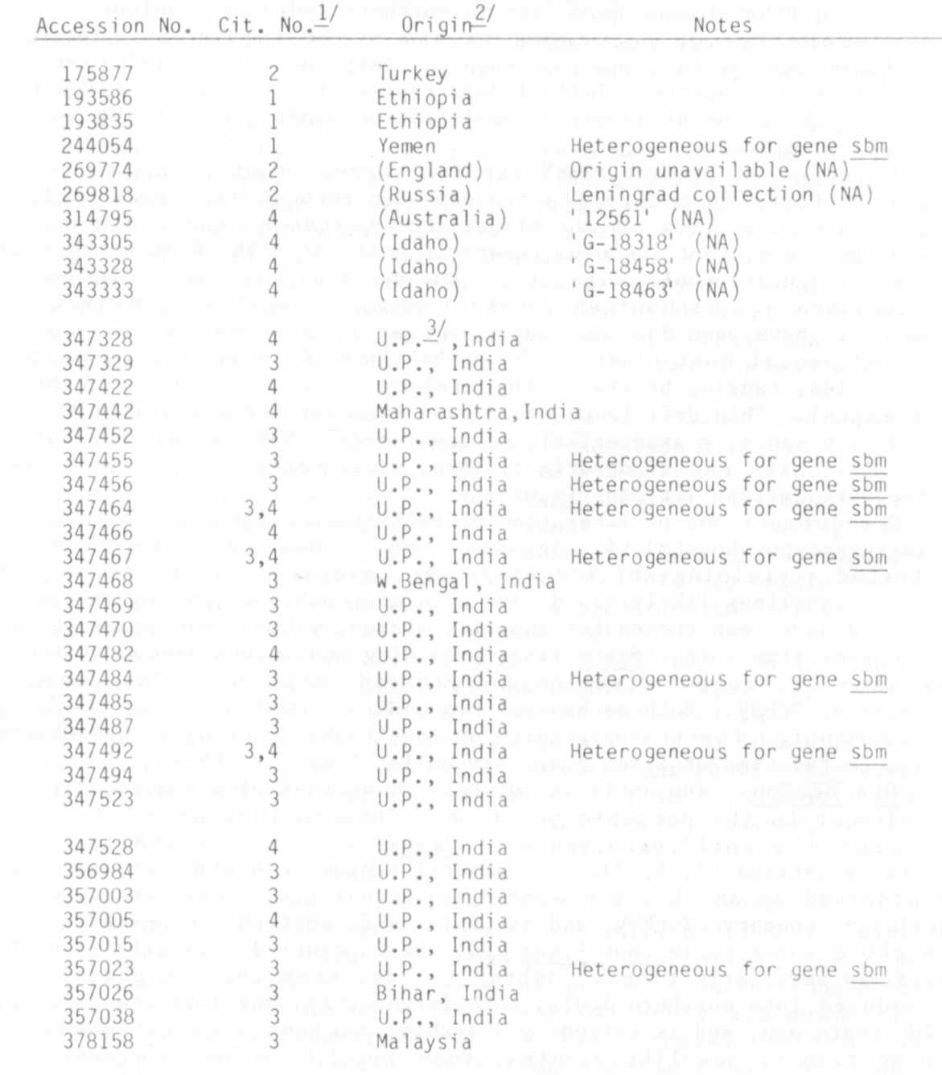
1/ P.I.'s reported in the following citations:
Table 1. Record of all US Pisum plant introduction accessions reported to contain PSbMV-imniune plants (1971-1981).
1. Plant Dis. Reptr. 55:408-410. 1971.
2. Plant Dis. Reptr. 56:131-132. 1972.
3. Plant Dis. Reptr. 63:95-99. 1979.
4. Pisum Newsletter 12:27-28. 1980.
5. Neth. J. PI. Path. 87:1-10. 1981.
2/ Of 39 Pisum accessions reported to contain PSbMV-immune germplasm, 36 had identifiable origins. The first four, introduced in 1949-57, came from the "Western subcenter" of Pisum origin; the remainder, introduced in 1969-70, were from the "Eastern subcenter".

3/ U.P. - Uttar Pradesh

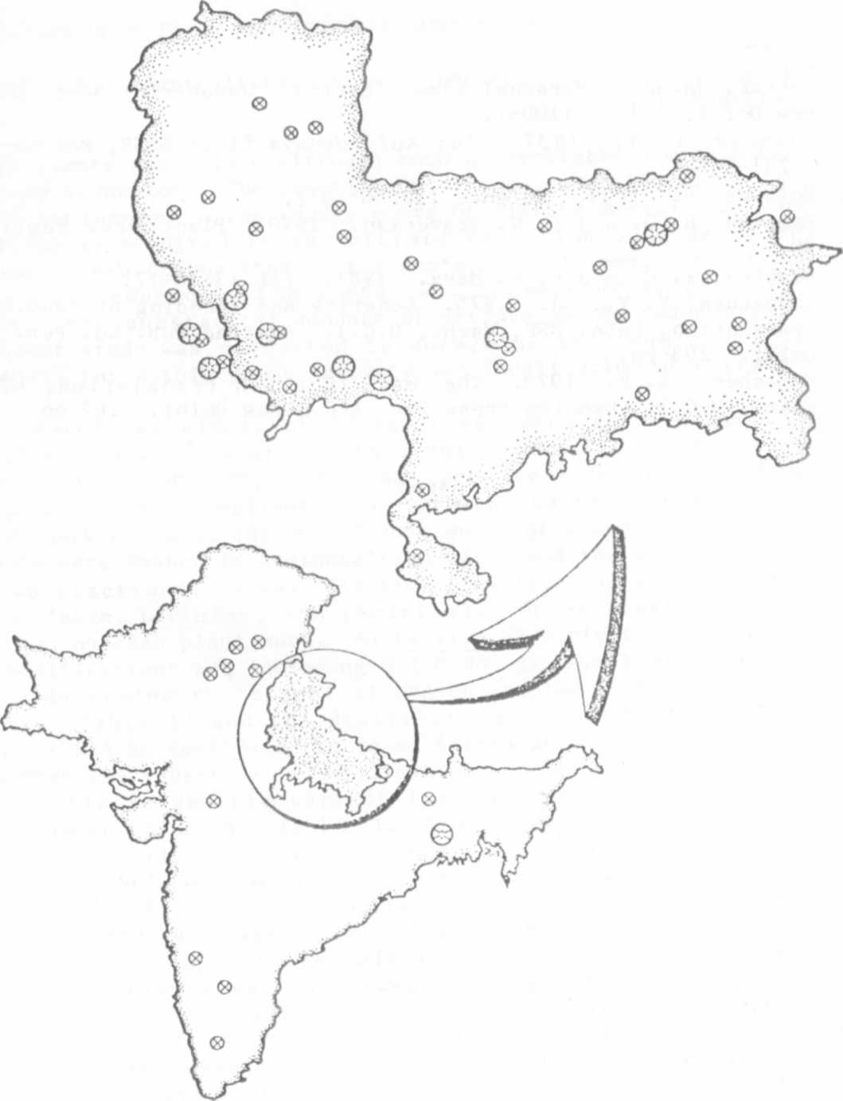
Fig. 1. Locations on the Indian subcontinent at which PSbMV-infected
(small circles) and PSbMV-immune Pisum (large circles) germplasm
originated. The state of Uttar Pradesh is shown in expanded
scale. Adapted from ISBN 0 85152 637 3, 1:4,000,000 scale map.

1. Ashraf, Jaweed. Personal communication. Jawaharlal Nehru University,
New Delhi, India 110067.
2. Govorov, L. I. 1937. In: Kul'turnaya flora SSSR, Moscow-Leningrad 4:231-336.

3. Helbaek, H. 1959. Science 130:365-372.
4. Hampton, R. 0. and S. W. Braverman. 1979. Plant Dis. Reptr. 6 3:95- 99.

5. Hampton, R. 0. and G. A. Marx. 1981. PNL 13:16-17.
6. Khvostova, V. V., Ed. 1975. Genetics and Breeding of Peas. (English
translation, USDA, NSF, Wash., D.C.). Amarind Pub. Co. Pvt. Ltd., Nei
Delhi. 293 pp.
7. Makasheva, R. R. 1973. The Pea. (English translation, USDA, NSK,
Wash., D.C.). Oxonian Press Pvt. Ltd., New Delhi. 267 pp.

*****

