PNL Volume 18 1986 RESEARCH REPORTS
1

HFP 4, A HIGH YIELDING LEAFLESS STRAIN OF PEA

Gupta, K. R., Rice Research Station, Kaul (Kurukshetra), India
S. Lal, Indian Council of Agricultural Research
Krishi Bhavan, New Delhi, India
V. P. Singh, and B. S. Dahiya Haryana Agricultural University
Hissar, India

Pea 'HFP 4' has been developed from a cross EC 109196 x T 163 made by
the second author at Indian Agricultural Research Institute, New Delhi.
EC 109196 is a dwarf and leafless strain introduced from U.K., whereas
T 163 is a tall, late maturing, powdery mildew susceptible variety released
long ago. The comparative performance of new strain HFP compared with
T 163 is given in Tables 1 and 2.
Table 2. Seed yield of HFP 4 and T 163 (q/ha).
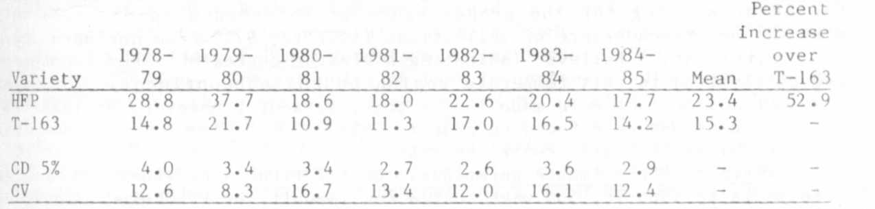

Table 1. Plant characters of HFP 4 and T 163.
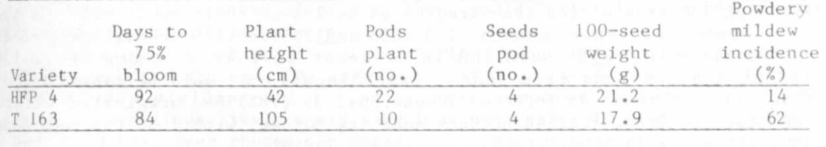
Strain HFP 4 is leafless, white flowered, dwarf, and produces large,
white, round, and smooth seeds. The stipules are normal with wavy margins.
It is fairly tolerant to powdery mildew disease and to leaf miner. Its
higher yield over T 163 may result from its larger seed size and larger
number of pods per plant. Being dwarf it responds to high fertility and
plant population. By virtue of its high yield and tolerance to powdery
mildew it has been identified for release in 1985.

A A -k -k >'c

