RESEARCH REPORTS
1
PNL Volume 18
1986

THE REACTION OF PISUM GENOTYPES TO EXTREME SHORT DAY CONDITIONS

Gottschalk, W.
Institute of Genetics, University of Bonn
Federal Republic of Germany

Three mutants and 29 recombinants of our Pisum collection were grown
together with their mother variety 'Dippes Gelbe Viktoria' (DGV) in the
phytotron under extreme short day (SD) conditions with only 6h light per
day. All the other environmental conditions were the same as in our former
trials (2 5C day, 1 5C night; 60% humidity). Ten plants of each genotype
were grown in Mitscherlich pots. Flowering behavior, plant height, number
and length of internodes were evaluated. The material may be subdivided
into two groups. All the genotypes of the first group are homozygous for
efr, a gene for earliness derived from recombinant R 46C. In addition, the
recombinants of this group contain one or several other mutant genes. The
second group of genotypes do not contain gene efr.
Only three of 20 plants of DGV reached the flowering stage; all others
died earlier in development. A similar behavior was observed for two
mutants and five recombinants, four of them containing gene ef r for
earliness. All these genotypes showed abnormal development under the
unfavorable light conditions. In another group of six recombinants, flower
buds appeared but did not develop further. Four recombinants of this group
are homozygous for efr. The fasciated mutant 489C and recombinant R 142F
were still in a purely vegetative stage when the trial was terminated 83
days after sowing.
The flowering behavior of the other recombinants tested is shown in
Fig. 1. Out of ten plants of R 46C, the donor of gene efr for earliness,
only a single plant formed some fully developed flowers whereas the others
had undeveloped flower buds or they died in earlier stages. Thus, this
recombinant showed the same negative reaction to the low amounts of light
as its mother variety DGV. A completely different behavior was observed
for the recombinants R 840, R 42 7, and R 430, likewise homozygous for efr.
Their development was relatively normal and they produced small amounts of
seed, thus demonstrating a high degree of tolerance to the unfavorable
light conditions.
The table below shows the comparison of the flowering behavior of
these genotypes under normal and under extreme SD conditions.
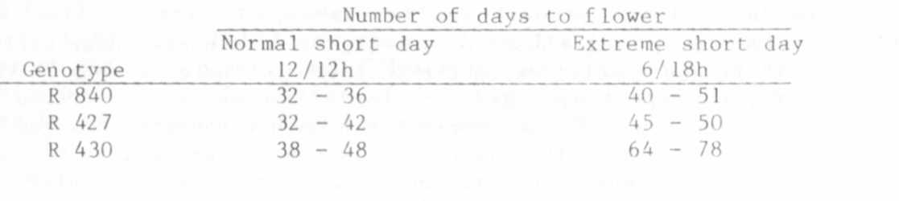

PNL Volume 18 1986 RESEARCH REPORTS
4

As expected, a considerably longer time was required to reach the flowering
stage in extreme SI) as compared to normal SD. The difference was espe
cially great in R 430. The significant point, however, is that the;
recombinants were at all able to survive and to produce seeds under these
unfavorable conditions.
The results show that the selection value of specific genotypes, in
our case the cultivar 'Dippes Gelbe Viktoria' and the early flowering
recombinant R 46C, can be considerably improved under the influence of
distinct mutant genes even under extremely unfavorable environmental
conditions.
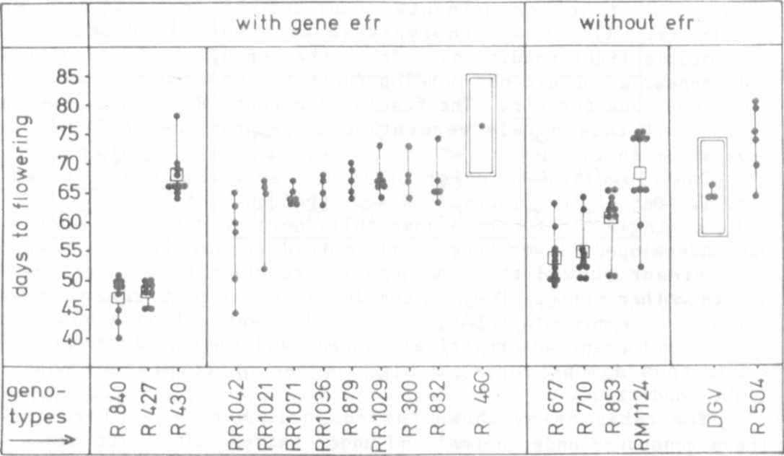

Fig. 1. The flowering behavior of 17 Pisum recombinants under extreme
short day conditions in the phytotron. The genotypes of the
first group contain gene efr for earliness derived from R 46C.
The genotypes of the second group do hot contain this gene.
DGV ('Dippes Gelbe Viktoria') is the mother variety of our
radiation genetic experiments. Each dot gives the value for
one plant.

