FLOWERING OF FASCIATED RECOMBINANTS UNDER SHORT DAY PHYTOTRON CONDITIONS

Gottschalk, W. Institute of Genetics, University of Bonn
Federal Republic of Germany

Some Pisum mutants with apical stem fasclation yield very well under
field conditions in Germany because they have a large number of flowers and
pods in the fasciated region. Unfortunately, some of these genotypes are
too tall and later than their mother variety ('Dippes Gelbe Viktoria',
DGV); moreover, they have small seed size.
Mutant 489C of this group, homozygous for more than 2 0 mutant genes,
has been studied for many years, not only in Bonn but also in countries
with different climates. Plants of this genotype failed to flower in
Brazil, Egypt, and in five different locations of India. In Ghana and
Uganda, a few plants flowered extremely late without producing seed. Most
plants did not flower at all.
We have tested this genotype in the phytotron under long (LD) and
short day (SD) conditions. In long day (18h/6h), the plants formed flowers
considerably later than DGV whereas they did not flower at all in SD.
Plants cultivated under SD conditions (12h/l2h) produced flower buds about
two weeks after the phytotron had been changed from SD to LD. Thus, a gene
controls the photoperiodic reaction of the mutants in a wav that flowering
occurs only in LD.
For breeding purposes it would be desirable to maintain stem fascia-
tion and high seed production but remove the gene(s) for photoperiodism so
that the lines would flower under SD. Therefore, mutant 489C was used in
crosses with other genotypes and from these crosses many recombinants of
different genotypic constitution were selected. Forty-one of them were
tested under SD phytotron conditions for flower behavior in order to make a
pre-selection for further tests in India. Eighteen of them did not flower.
A small group of fasciated recombinants, however, flowered as early or
earlier than the non-fasciated mother variety DGV (Fig. 1). This was
particularly true for recombinant R 27 selected in F5 from the cross 489C x
R 46C (the early flowering recombinant). The plants of R 27 are tall and
linearly fasciated. They flowered ten days prior to DGV and their seed
production was essentially better than that of the mother variety.
Recombinant R 630 was four days earlier than DGV. This genotype was
selected In F^ from the cross 489C x mutant 122. The plants are tall,
weakly fasciated with narrow leaflets.
These genotypes will be tested for yield in field trials in countries
with short-day climate (India, Egypt). In the meantime, additional fas-
ciated recombinants of our collection will be pre-selected in the phytotron
for later use in field trials.

PNL Volume 2 1986 RESEARCH REPORTS
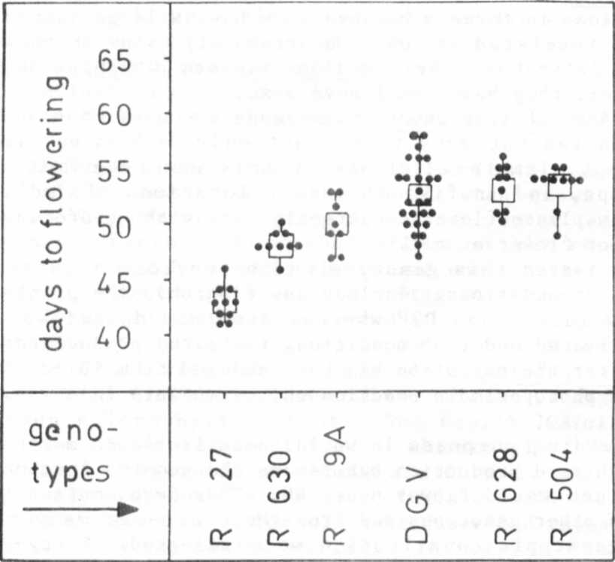

The flowering behavior of five fasciated recombinants and
their mother variety 'Dippes Gelbe Viktoria' (DGV) under
short day conditions in the phytotron. Each dot gives the
value for one plant; the squares are the mean values for
the respective genotypes.

* * * * *

