RESEARCH REPORTS
PNL Volume 18
1986
11

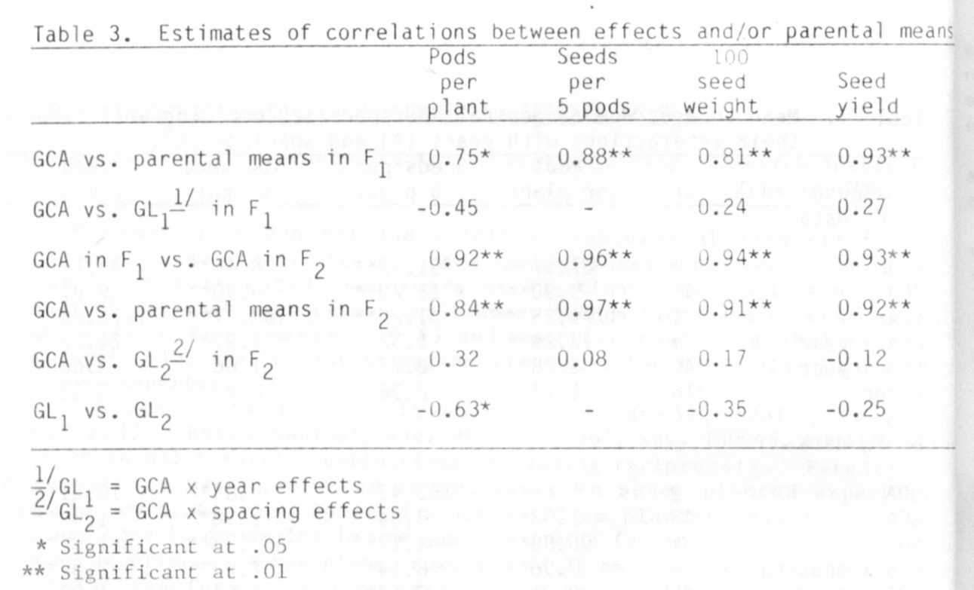

BRANCHING IN PISUM: EFFECT OF THE FLOWERING AND LENGTH GENES

Floyd, R. S. and I. C. Murfet
University of Tasmania
Hobart, Tasmania, Australia

Several flowering genes are reported to influence branching in peas,
Photoperiodic lines have a much greater tendency to produce basal laterals
than day neutral lines (1) and this holds whether they initiate flowers at
a high or low node. The ability to respond to photoperiod is conferred by
genotype Sn Dne (2) and the effect of this gene combination on both flower-
ing and branching is further increased by gene jir (3,10). Compared with
Sn Dne stocks, day neutral Pisum stocks of genotype sn Dne or Sn dne reduce
outgrowth of basal laterals from photoperiodic Lathyrus odoratus scions
(11). The Sn Dne combination also delays the appearance of aerial laterals
from the upper nodes in veg plants (8). It is suggested the Sn Dne system
may achieve these effects by producing in short days a graf t-transmissible
substance whose primary role is to direct assimilate flow (4,8,11).
contrast, flowering genes Lf-d and veg have a less basic effect. Both
result in increased production of aerial laterals (6,8). By delaying (Lf-d)
or preventing (veg) flower initiation they increase the number of potential
sites for lateral outgrowth and the underlying changes which take place
during this delay result in lateral outgrowth. In lf sn segregates seed
yield was found to be derived wholly from pods borne on the main shoot
while in the latest Lf-d sn segregates yield was derived partially or wholly
from pods on lateral branches (6).

The genes Le/le, La/la, Cry/cry-c /cry-s and Na/na determine several
internode length classes ranging in size from the extremely short nana type
through dwarf, cryptodwarf , tall and slender (reviewed 9). The present study
was designed primarily to examine the effect of these length genes on
branching by the use of segregating progenies and near iso-lines. However,
some additional data on the effect of flowering genes is also presented.
Several other length loci have been established including lk and ls (7).
Gene lk results in the erectoides phenotype characterized by short Inter-
nodes, thick brittle stems, and other features including increased apical
dominance while gene ls results in a nana phenotype (7). A nana line
carrying ls (line K202) was included in this study but it should be noted
that K202 also differs from its initial line 'Torsdag' in respect of a
second unnamed length mutation (7).
All plants were grown in the phytotron, one plant per 14 cm pot, in a
1:1 mixture of vermiculite and dolerite chips. Nutrient solution
(Hoaglands) was applied once a week. Temperatures were approximately 20-
26C day and 17C night. The short day (SD) photoperiod consisted of 8h of
natural light. A long day (LD) photoperiod of 24h was obtained by use of
the natural day extended by light from a mixed fluorescent/incandescent
source giving approximately 10 Wm at pot top.
Effect of flowering genes. All photoperiodic (Sn Dne) lines studied
produced more basal laterals in SD than LD. In many such lines a 24h
photoperiod completely suppressed outgrowth of basal laterals, e.g. in
Torsdag (Table 1) or WL1770 (Table 2). Other photoperiodic lines with a
very strong tendency to form basal laterals in SD also produced some basal-
laterals in a 24h photoperiod, e.g. WL 1766 (Table 2). SD also caused a
marked upward shift in the zone of aerial laterals in Torsdag (Table 1).
We attribute this upward shift and increased basal lateral production in SD
to activity of the Sn Dne system. In continuous light, activity of this
system is suppressed (5). Again in K218 (Sn dne) a day neutral isoline to
Torsdag (see 2), activity of the system is largely blocked by dne (2) and
basal lateral production did not occur in 8h or 24h conditions. K218 also
was devoid of significant aerial laterals.
Segregation for the flowering gene pair E/e in cross (8xI₃) F2 in SD
gave 15 tall early photoperiodic (E) and 6 tall late photoperiodic (e)
segregates with mean flowering nodes of 13.9 and 23.8, respectively. The
late plants produced over ten times as many aerial laterals as the early
plants (Table 2). Thus the greater potential for aerial lateral production
in plants with a high flowering node can be realized, at least partially,
and gene e, in these specific circumstances, achieves an end effect on
aerial branching similar to Lf (6) or veg (8). The underlying mechanism
is of course quite different.
Effect of the length genes. From a comparison of the pairs
slender/dwarf, tall/dwarf, cryptodwarf/dwarf, tall/nana, and dwarf/nana
(Table 2) it is clear that the shorter internode type generally displays
the stronger tendency to produce basal laterals. The tendency was so
strong in the na nana types that they often bore basal laterals on basal
laterals while the first order laterals on average exceeded the main shoot
in total length. The one marked exception to the general pattern concerns
the nana line K202 which displays a much lower tendency to produce basal
laterals than its tall initial line Torsdag, although their lengths dif-
fered by a factor of 9. The lack of branching in K202 cannot be attributed

PNL Volume 18 1986 RESEARCH REPORTS
8

to poor growth since vigor in K202 was comparable with that of na nana
lines or to gene ls alone since a second length mutation is also present in
K202 (see 7). Moreover, the _ls type line, M26 (nana habit), shows profuse
basal branching (J. B. Reid, personal communication) in accord with the
pattern established for the na_ nana plants (Table 2).
No general trend was apparent for the effect of the length differences
on aerial laterals except for the paucity of such laterals in nana types
(Table 2).
We suggest that the length genes may influence branching in Pisum by
altering the level of available nutrients. One thing is certain, the
flowering and length genes have major effects on branching and the back-
ground for these genes and environmental factors such as photoperiod should
be taken into account in any study of branching per se although some genes
with specific effects on branching may be expressed regardless of these
factors.

1. Doroshenko, A. V. and V. [. Rasumov. 1929. Tr. Prikl. Bot. Oenet.
Sel. 22 :2 19-2 76.
2. King, W. M. and I. C. Murfet. 1985. Ann. Bot. 56:815-846.
3. Murfet, I. 1973. Heredity 31:157-164.
4. Murfet, I. 1985. Pp. 97-126 in Handbook of Flowering, Vol. IV. Ed.
A. H. Halevy, CRC Press.
5. Murfet, T. C. and J. B. Reid. 1974. Z. Pflanzenohysio1. 71:323-331.
6. Murfet, I. C. and J. B. Reid. 1985. pp. 67-80 in The Pea Crop: A
Basis for Improvement. Eds. P. D. Hebblethwaite, M. C. Heath, and T.
C. K. Dawki n s, Butter wo r t h s.
7. Reid, J. B. 1986. Ann. Bot. (in press).
8. Reid, J. B. and I. C. Murfet. 1984. Ann. Bot. 53:369-382.
9. Reid, J. B., 1. C. Murfet, and W. C. Potts. 1983. J. Exp. Bot.
34:349-364.
10. Ross, J. J. 1983. PhD Thesis, Univ. of Tasmania.
11. Ross, J. J, and 1. C. Murfet. 1985. Ann. Bot. 56:847-856.
