EFFECT OF YEAR AND SPACING ON COMBINING ABILITY IN PEA

Csizmadia, L.
Research Station of Vegetable Crops Research Institute
Ujmajor, Hungary

Estimates of general and specific combining ability effects and variances are generally obtained from space planted experiments and in most

cases are not repeated over years or locations. Little is known of the extent of different genotype x environment interactions and to what extent they affect the general ( GCA) and specific combining ability
(SCA) variances. The present investigation was undertaken to provide information off these aspects.

Ten pea varieties and lines (RS-455, Br-52, 'Jof', 'Puget',
'Multipod', 'Extra Rapide', Wav. 01, 'Skinado', Wav. 180045, FJ-111) were
crossed in all possible combinations, excluding reciprocals. Parents and F1 progenies were evaluated in two years in space planted experiments

(single row plots, rows spaced 1 m apart, 20 cm plant-to-plant spacing), parents, and F2 progenies in one year in a wide (as in F1 ) and in a narrow

spaced experiment (4-row plots, rows spaced 15 cm apart with 10 cm plant-to-plant spacing). Each experiment was arranged in a randomized block design with three replications. Plot means were subjected to analysis of variance and significant interaction variances were analyzed following Griffing's method II (both fixed and random effects models were studied) as detailed by Singh ( 1 ).

Analysis of variance for combining ability showed that the mean
squares due to GCA, SCA, year effect (in F1), and spacing effect (in F2)
were highly significant for all traits. GCA x year and GCA x spacing
components of interaction variances were significant for all characters
except for seeds per 5 pods. SCA x year was significant only for pods per plant and SCA x spacing only for seeds per 5 pods (Table 1).

Estimates of various genetic parameters and heritabi1ities are shown
in Table 2. In accordance with the data of Table 1, estimates of s² and H_{n}
were higher for seeds per 5 pods and 100 seed weight both in F1 and F2.

Due to space limitations, estimates of various effects are not
presented here, only correlations between GCA; means of parents and CGA x L are recorded in Table 3. There are significant correlations between GCA vs. means of parents (both in F1 and F2), GCA in F1 vs. GCA in F₂ for each character. In spite of the significant interactions estimates of general combining ability seem unbiased.

1. Singh, D. 1973. Indian J. Genet. 33:469-481

PNL Volume 18 1986 RESEARCH REPORTS
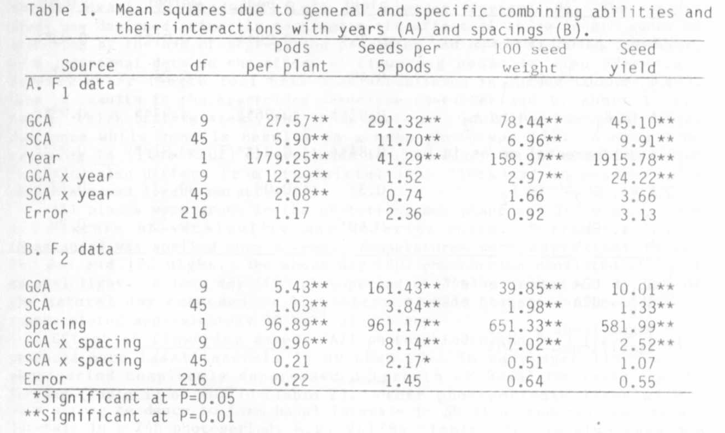
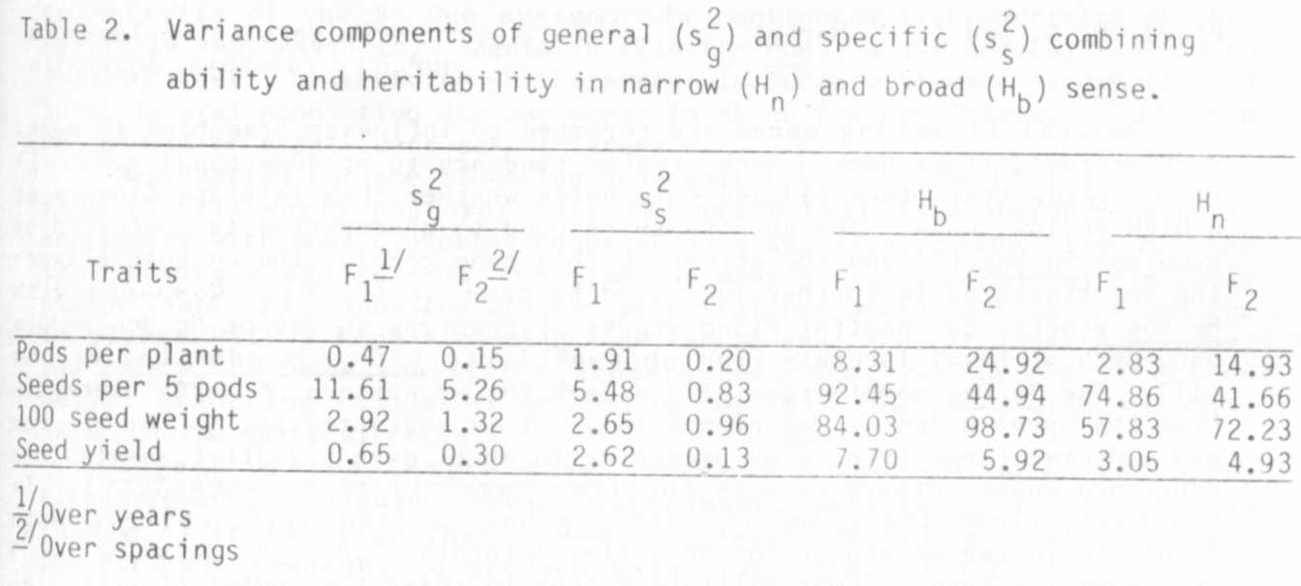
RESEARCH REPORTS
PNL Volume 18
1986
4

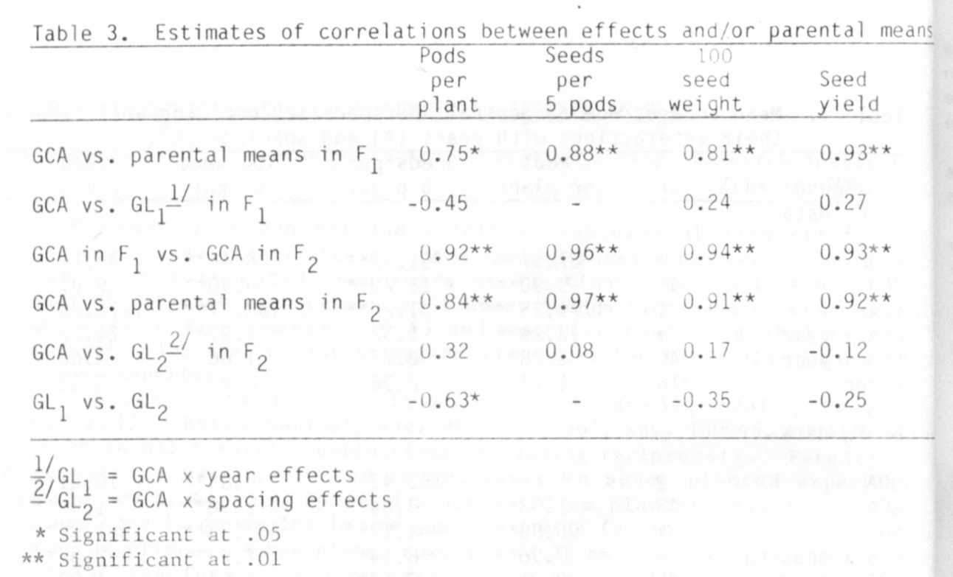

BRANCHING IN PISUM: EFFECT OF THE FLOWERING AND LENGTH GENES

Floyd, R. S. and I. C. Murfet
University of Tasmania!
Hobart, Tasmania, Australia

Several flowering genes are reported to influence branching in peas,
Photoperiodic lines have a much greater tendency to produce basal laterals
than day neutral lines (1) and this holds whether they initiate flowers at
a high or low node. The ability to respond to photoperiod is conferred by
genotype Sn Dne (2) and the effect of this gene combination on both flower-
ing and branching is further increased by gene jir (3,10). Compared with
Sn Dne stocks, day neutral Pisum stocks of genotype sn Dne or Sn dne reduce
outgrowth of basal laterals from photoperiodic Lathyrus odoratus scions
(11). The Sn Dne combination also delays the appearance of aerial laterals
from the upper nodes in veg plants (8). It is suggested the Sn Dne system
may achieve these effects by producing in short days a graf t-transmissible
substance whose primary role is to direct assimilate flow (4,8,11).
contrast, flowering genes Lf-d and veg have a less basic effect. Both
result in increased production of aerial laterals (6,8). By delaying (Lf-d)
or preventing (veg) flower initiation they increase the number of potential
sites for lateral outgrowth and the underlying changes which take place
during this delay result in lateral outgrowth. In lf sn segregates seed
yield was found to be derived wholly from pods borne on the main shoot
while in the latest Lf-d sn segregates yield was derived partially or wholly
from pods on lateral branches (6).

