PREFACE

Membership

United
We
Stand

Thanks
The Pisum Genetics Association (PGA) is a non-profit,
unincorporated organization established to facilitate the
exchange of information and to ensure the preservation of
valuable genetic stocks. The number of PGA members now
stands at 218-
Membership in the PGA is open to all interested per-
sons. Dues are $10.00 for two years (U.S. currency) and are
used to help defray the costs of publishing the PNL. Mem-
bers are encouraged to pay dues for two or more years to
simplify bookkeeping. Please make prime banker's check or
money orders payable to PISUM GENETICS ASSOCIATION and send
to G. A. Marx, Department of Horticultural Sciences, New
York State Agricultural Experiment Station, Geneva, NY
14456, U.S.A. The PNL will be sent upon receipt of dues.
Response to the letter from the editor which appeared
last year (Volume 16) has been gratifyingly positive.
Individual members have willingly accepted the increase in
dues and have graciously consented to pay their dues for
two years or more in advance. A few have even contributed
something extra, a gesture that gives us a warm glow of
reassurance. I interpret this overall reaction to mean that
members feel that the PNL has value, serves a need, and
should endure.
Although members' dues are essential, contributions of
an extraordinary kind are also vital if the PGA is to sur-
vive. I am delighted to report that the Del Monte Corpora-
tion has made such an extraordinary, PGA-saving, contribu-
tion in the amount of $1,000. Our hearty thanks to Del
Monte for this special gift and for its generous support in
the past.
One need only scan the articles published in the PNL
over the years since the initial issue in 1959 to see that
the nature and content of the articles has undergone a
transformation or evolution of sorts. The advent in recent
years of electrophoresis and other powerful analytical
techniques has allowed researchers to probe ever more
deeply into life's processes and the results of these
investigations have appeared on the pages of the PNL. This
is a favorable trend but for your editor, who is none too
bright in the first place, it poses a particular challenge.
There is an inverse relationship between his ability to
render a fair and critical review and the incidence of
articles dealing with esoteric subjects or techniques. It
is for that reason I gratefully acknowledge the editorial
assistance of the following colleagues: Drs. K. Mudge,
N. D. Polans, S. Shannon, and N. F. Weeden.

1 PNL Volume 17 1985
PREFACE

The lady affectionately known as our "Clerk", having
retired and no longer a Cornell employee, remains as a
faithful ally. Mrs. Van Kirk has purchased a microcomputer
and a printer and single handedly has prepared all the copy
for PNL Volume 17. Moreover, she continues to perform all
the bookkeeping and most of the organizational tasks
associated with keeping our enterprise afloat. To her goes
the credit for getting the PNL into your hands at a
reasonable time. We tip our collective hats for a job well
done.
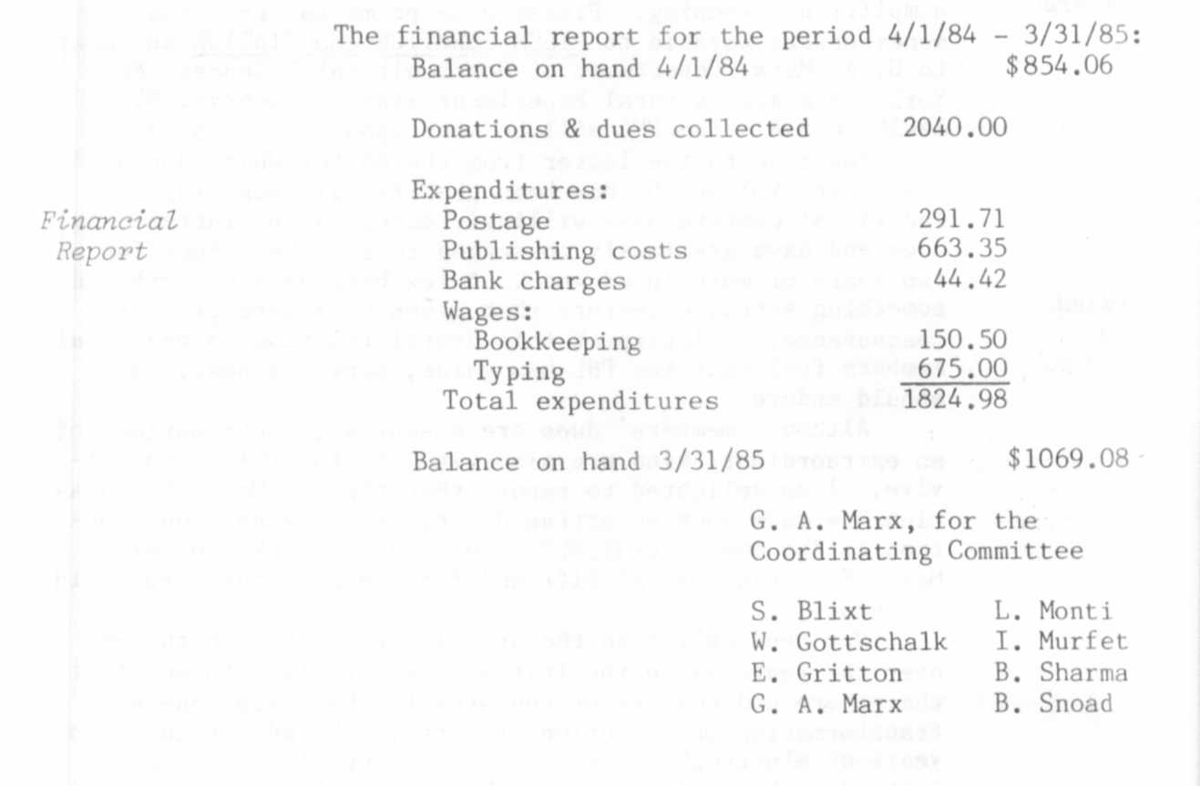

COVER

The retirement of Professor Dr. W. Gottschalk from the
Chair of Genetics in the Faculty of Sciences, University of
Bonn, in 1985 prompts us to recognize his many contributions
to Pisum genetics and cytology published in the PNL and
elsewhere. He has been a member of the Coordinating Commit-
tee since the inception of the PGA in 1969. He is well known
the world over, has acted as a consultant outside his native
Germany, and has participated in several international re-
search programs, e.g. EURATOM, IAEA. A leader in the field
of mutation genetics, he has always stressed the potential of
higher plants as research tools for solving problems, basic
and applied, which cannot easily be accomplished with other
organisms, if at all. His unique collection of pea mutants
and recombinants is well suited to study questions ranging
from biochemistry and developmental biology to ecology and to
breeding. Ever energetic and committed, Dr. Gottschalk has
over the years guided and supported a staff of creative and
productive associates at his Institute. We hope that his
years of dedicated commitment to science will be rewarded by
many more years of pleasant personal activity (at a pace con-
trolled more by him than by others or events). The papers
contributed to this issue of the PNL by coworkers of the
Institute of Genetics are respectfully dedicated to him.
(Cover picture drawn by Elaine Gotham from a photo sup-
plied by Prof. Dr. H. P. Muller.)

