a b
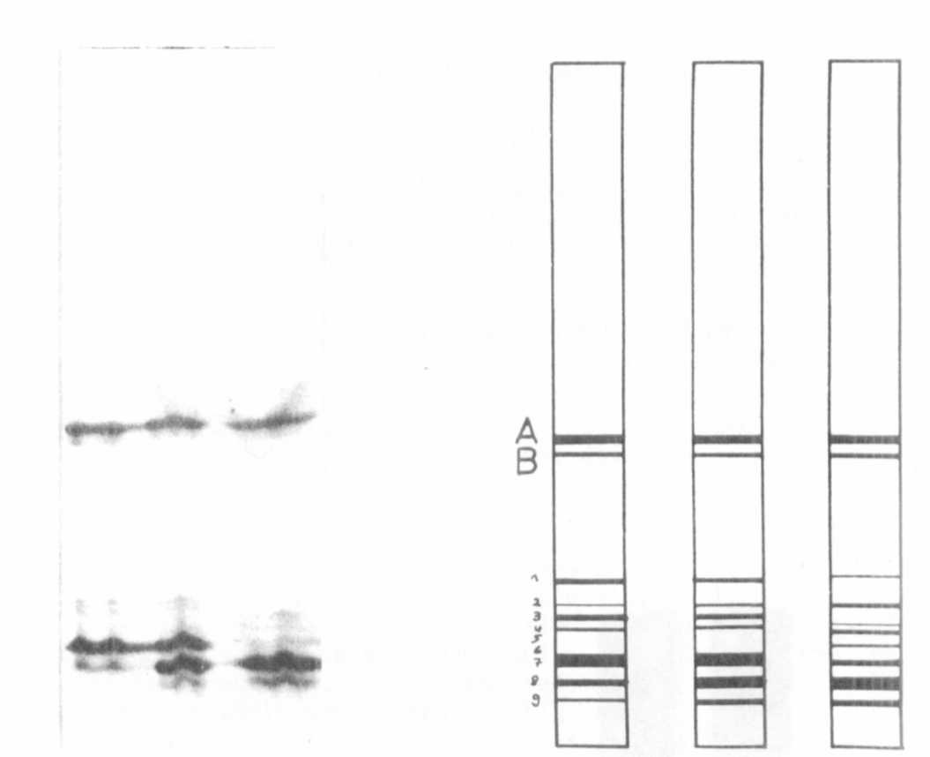

Fig. 3a. Electrophoretic banding pattern of leucine-amino-peptidase.
Left: DGV Right: Mutant 157 Middle: DGV x 157

3b. Schematical drawing of the electrophoretic banding pattern
of leucine-amino-peptidase.

LEUCINE AMINOPEPTIDASE (LAP-2) VARIABILITY IN THE GENUS PISUM

Wolko, B., Plant Experiment Station, Wiatrowo, Poland
M. Krzakowa, Adam Mickiewicz University, Poznan, Poland
and W. K. Swiejcicki Plant Experiment Station, Wiatrowo, Poland

Two major aminopeptidase (LAP) activity zones detectable after
electrophoresis can be observed in many tissues and developmental stages
of Pisum sativum. The two forms were described for the firs) time by
Scandalios and Espiritu (6) as AmP-1 and AmP-2. Later investigations I,
Scandalios and Campeau (7) showed that the faster migrating polymorphic
locus LAP-1 is composed of two alleles AmP-lF and AmP-lS. Appropriate
crosses made between LAP-1 pea lines differing with respect to the
mobility of the two LAP-1 forms demonstrated that the LAP-1 locus in
Pisum is controlled by two alleles exhibiting codominant expression.
Other investigators (1) confirmed these results and Przybylska ap-
pears to have detected a third allele at this locus in P. humile from
Jerusalem, described by her as a phenotype "c". A tight linkage between
the locus LAP-1 and the gene B on chromosome 3 was described for the
first time by Almgard and Ohland (1). Only two alleles at LAP-1 locus
have been detected in our investigations. We called them alleles A1 and
A2 (Fig. I) but they are not the subject of our interest in this paper.
The LAP-2 locus was mentioned by Scandalios and Espiritu (6) as
monomorphic. Polymorphism at this locus was described by Przybylska et
al. (3, 4) as well as by Gottschalk and Muller (2), who dealt with seed
protein analysis, and recently by Weeden and Marx (10).
Ninety-five pea lines of the Wiatrowo Pea Gene Bank (8) belonging
to different Pisum taxa (P. sativum s.l. - 34 lines; P. abyssinicum - 8
lines; P. e1atius - 8 lines; P. fulvum - 3 lines; P. syriacum - 8 lines;
and 34 lines of the mutation group) were analyzed in this study. All
plants were cultivated in uniform greenhouse conditions for four weeks.
Crude extract from one leaf (usually the third) was absorbed onto paper
wicks (Beckman No. 319329) and electrophoresis was conducted in 9%
starch gel (SERVA, W. Germany) in the continuous lithium-boric buffer
system (5). Afterwards, nine lines representing different phenotypes
were selected for further studies (Table 1).
So tar our investigations have revealed four LAP-2 variants, desig-
nated a1 to a4 in decreasing order of their electrophoretic mobility. A
large number of individuals examined within particular lines has demon-
strated that each line is monomorphic. As can be seen from Fig. 1, one
banded homozygous genotypes as well as two banded "heterozygous" ones
are easily recognized. Moreover, some lines retain their "heterozygo-
sity" for a tew progenies. The interesting nature of this variability
encouraged us to carry out more extensive investigations, the results of
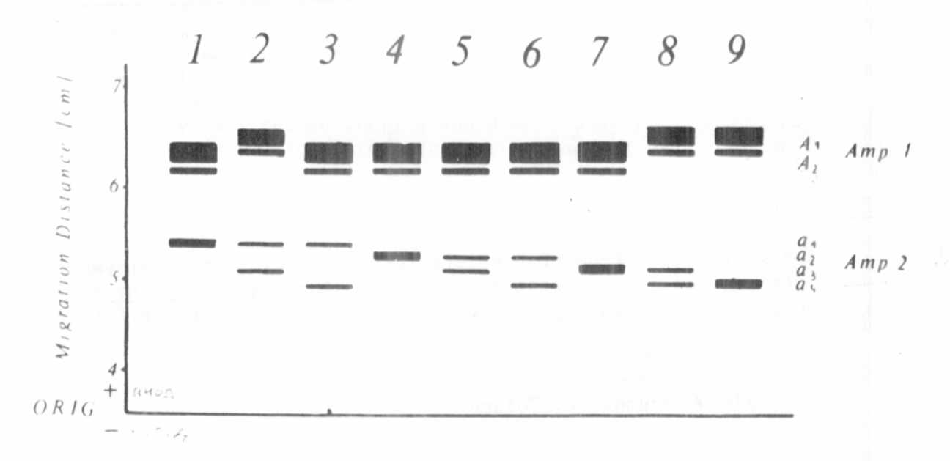
Fig. 1. Diagram of banding patterns in the Amp-1 and Amp-2 Pisum
forms: 1-Wt 18, 1-Wt301, 3-Wt 4390, 4-Wt 403, 5-Wt 113,
6-Wt 504, 7-Wt 4355, 8-Wt 4348, 9-Wt 4343.
which will be published soon.
1. Almgard, G. and K. Ohlund. 1970. PNL 2:9.
2. Gottschalk, W. and H. P. Muller. 1982. Qual. Plant Foods Hum.
Nutr. 31:297-306.
3. Przybylska, J., H. Parzysz, and S. Blixt. 1981. PNL 13:42-43.
4. Przybylska, J., S. Blixt, H. Parzysz, and Z. Zimniak-Przybylska.
1982. Genetica Polonica 23:103-121.
5. Scandalios, J. G. 1969. Biochem. Genet. 4:279-310.
6. Scandalios, J. G. and L. G. Espiritu. 1969. Molec. Gen. Genet.
105:101-112.
7. Scandalios, I. G. and M. A. Campeau. 1972. Mutation Res.
14:397-403.
8. Swiecicki, W. K., W. Swiecicki, and S. Czerwinska. 1981. The
catalogue of Pisum lines. PWRil. Poznan.
9. Weeden, N. F. and G. A. Marx. 1983. PNL 15:54.
10. Weeden, N. F. and G. A. Marx. 1984. J. Hered. 75:365-370.
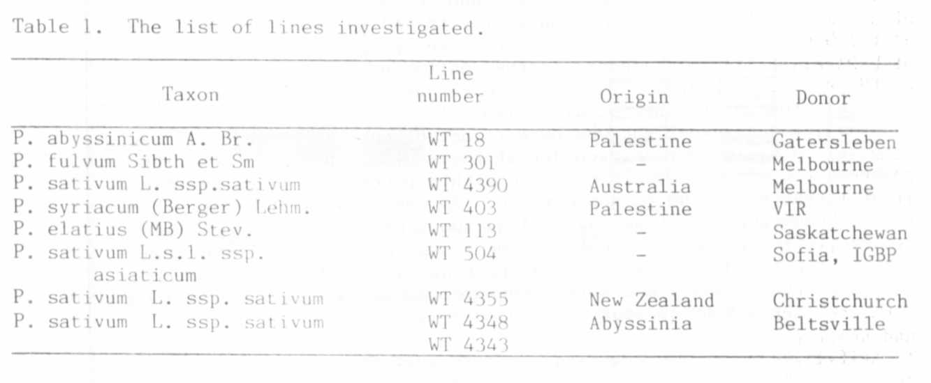

STOCKS REQUESTED

The cooperating team of breeders (dry peas) from Czechoslovakia,
East Germany, and Poland seeks sources of resistance to Ascochyta pisi,
A. pinodes and A. pinodella. Seed samples are welcome at the following
address:
W. K. Swiecicki
PES Wiatrowo
62-100 Wagrowiec, Poland

